**Q1. Install Virtual box and making Ubuntu And Window Virtual Machine.**

**Ubuntu:**

**Step-1**: Download VirtualBox for Windows and install it on your computer

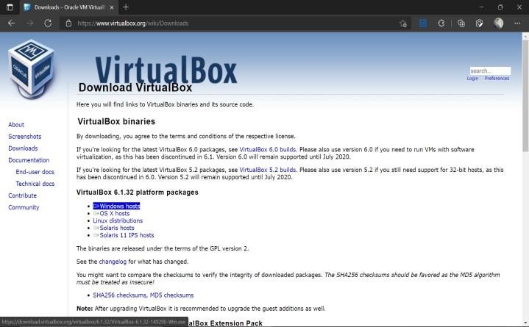

[https://www.virtualbox.org/wiki/Downloads **S**](https://www.virtualbox.org/wiki/Downloads)**tep-2**: Download

the Ubuntu ISO file you want to install from the Ubuntu download page.

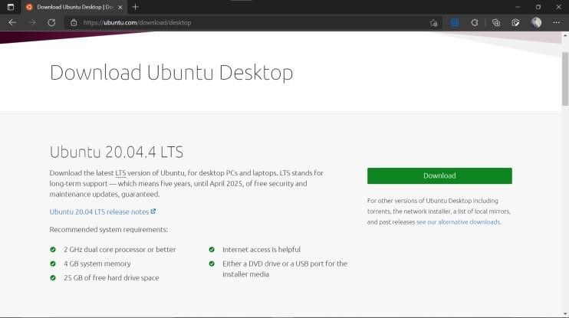

Note: The current version of Ubuntu only works on 64-bit machines. **Step-3:** Open VirtualBox and select New in the top taskbar.

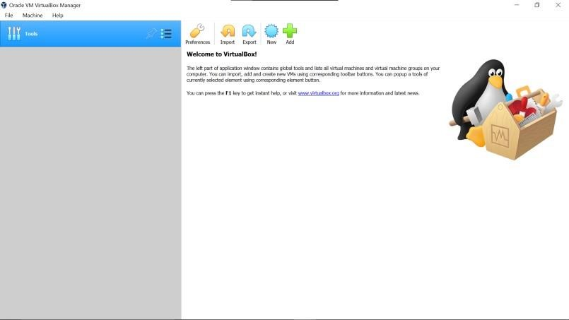

**Step-4:** Give your VM a name, choose Linux as the Type, then choose Ubuntu as the Version and select Next.

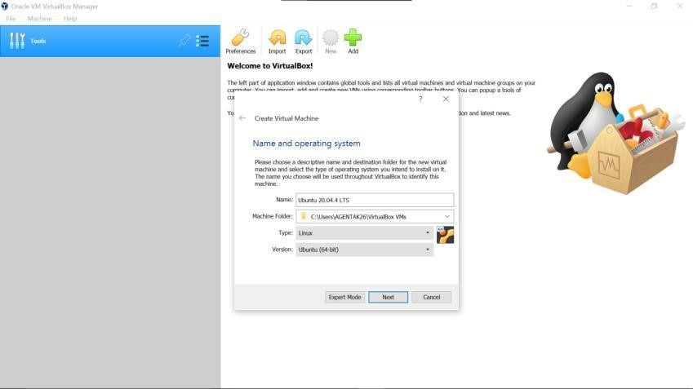

**Step-5:** Choose how much RAM you want to assign to the virtual machine and select Next. The recommended minimum is 1024 MB.

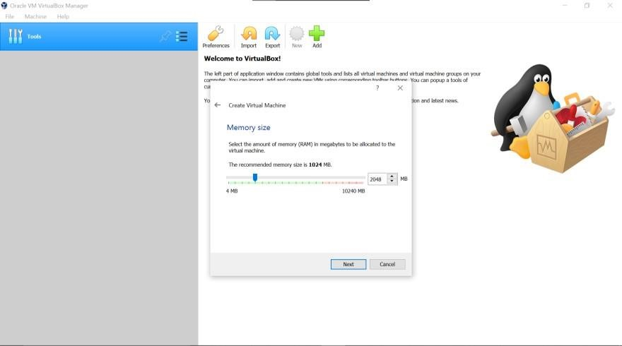

**Step-6:** Choose Create a virtual hard disk now and select Create.

**Step-7:** Choose VDI (VirtualBox Disk Image) and select Next.

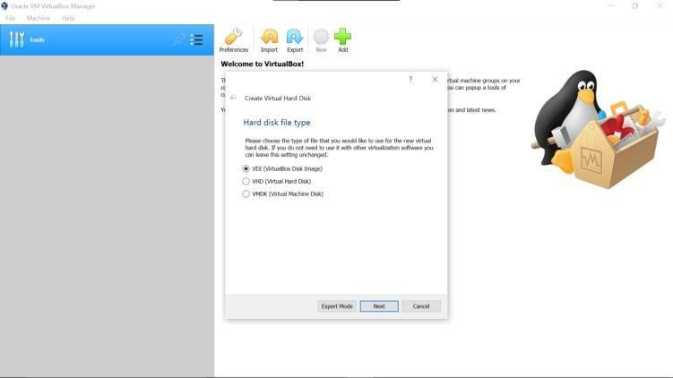

**Note on (VDI):** Normally, Oracle VM VirtualBox uses its own container format for guest hard disks. This is called a Virtual Disk Image (VDI) file. This format is used when you create a new virtual machine with a new disk.

S**tep-8**: Choose Dynamically allocated or Fixed size for the storage type and select Next.

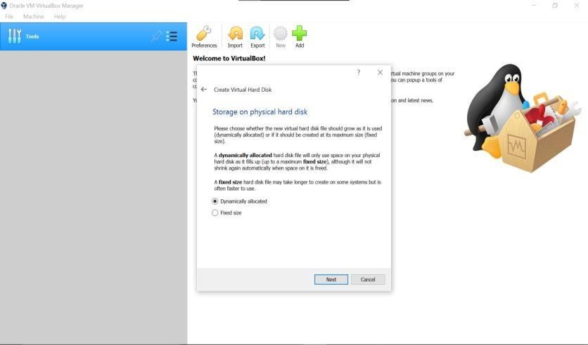

Tip: A fixed size disk performs better because the virtual machine doesn’t have to increase the file size as you install software.

**Step-9:**  Choose how much space you wish to set aside for Ubuntu and select Create.

**Note:**  The amount of space you allocate for your virtual machine determines how much room you must install applications, so set aside a sample amount.

**Step-10:** The name of your virtual machine will now appear on the left side of the VirtualBox manager. Select Start in the toolbar to launch your VM.

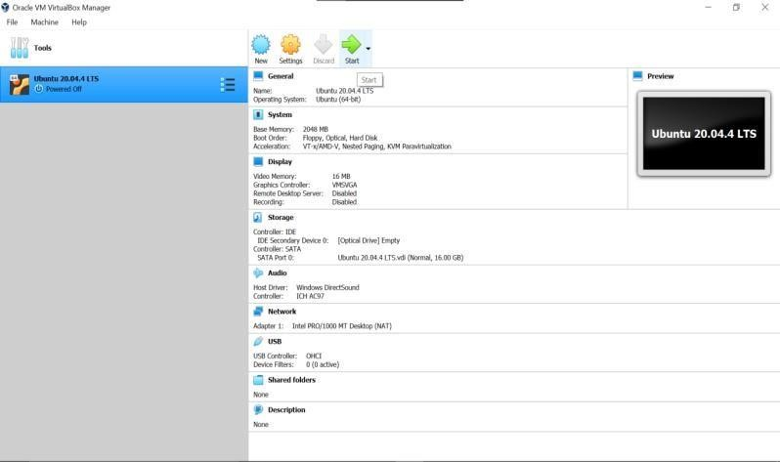

**Step-11:** This is the point where you need to choose the Ubuntu ISO file you downloaded earlier. If the VM doesn't automatically detect it, select the folder next to the Empty field.

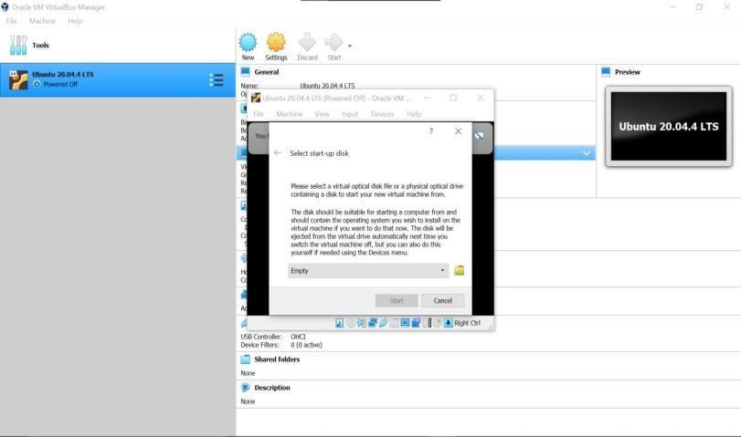

**Step-12:** Select Add in the window that pops up.

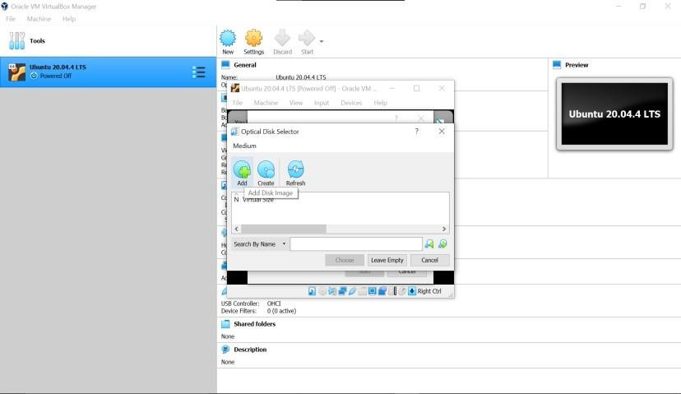

**Step-13:** Choose your Ubuntu disk image and select Open.

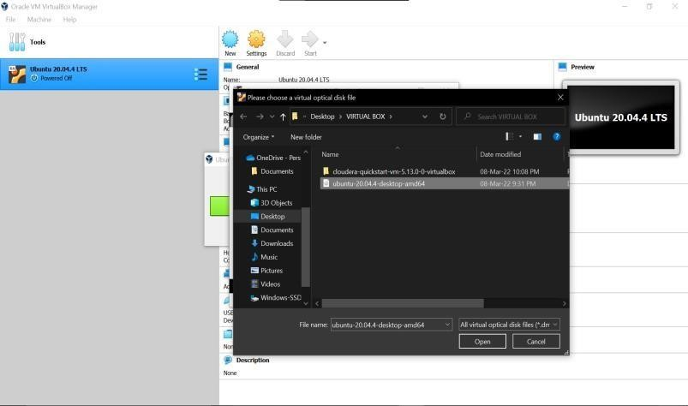

**Step-14**: - Select Choose

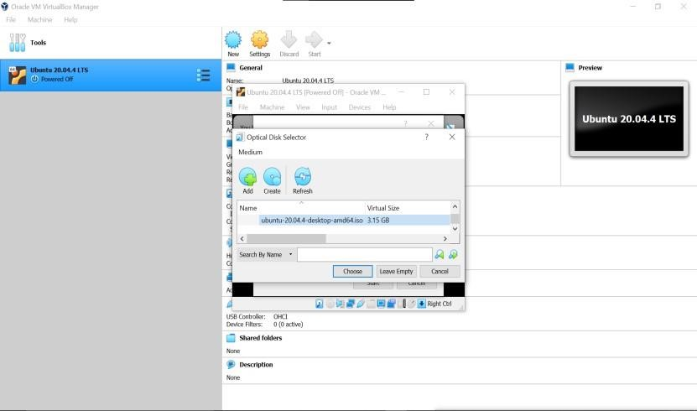

**Step-15:** Select Start.

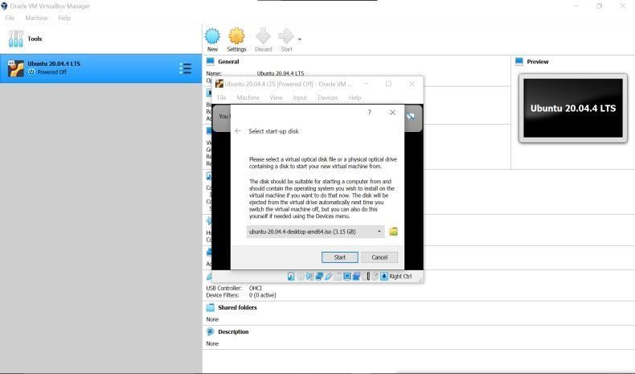

**Step-16:**  Your VM will now boot into a live version of Ubuntu. Choose your language and select Install Ubuntu

u. 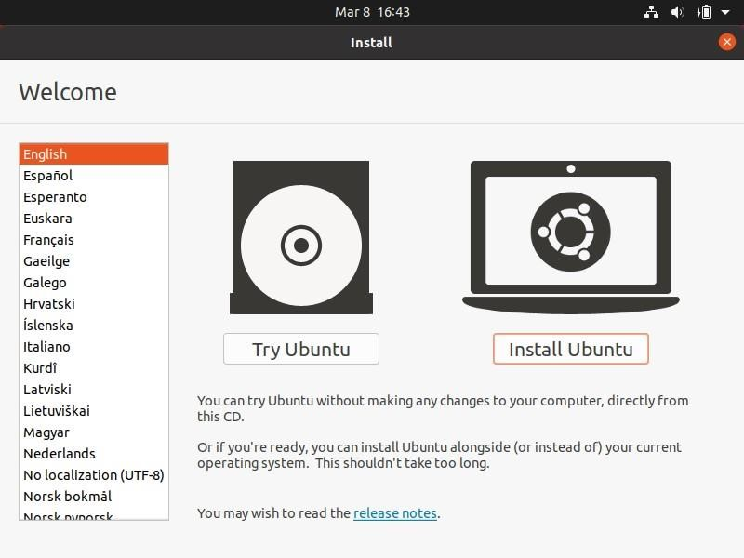

**Step-17:** Choose your keyboard layout and select Continue.

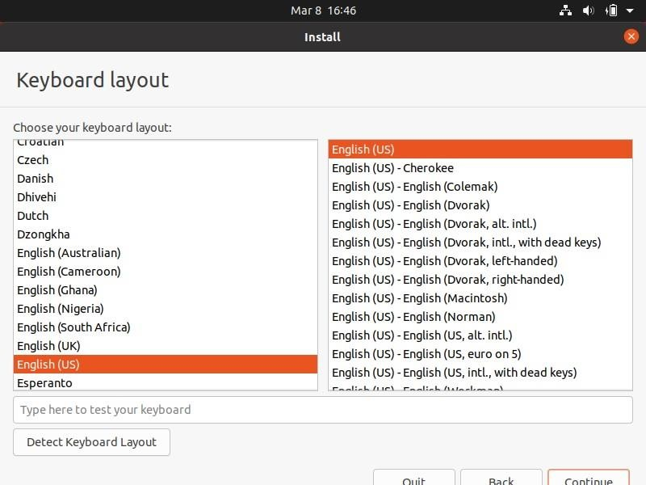

**Step-18:** Choose Normal installation or Minimal installation, then select Continue.

**Step-19:** Choose Erase disk and install Ubuntu and select Install Now, then select Continue to ignore the warning.

Note: This step will not erase your computer’s physical hard drive; it only applies to the virtual machine.

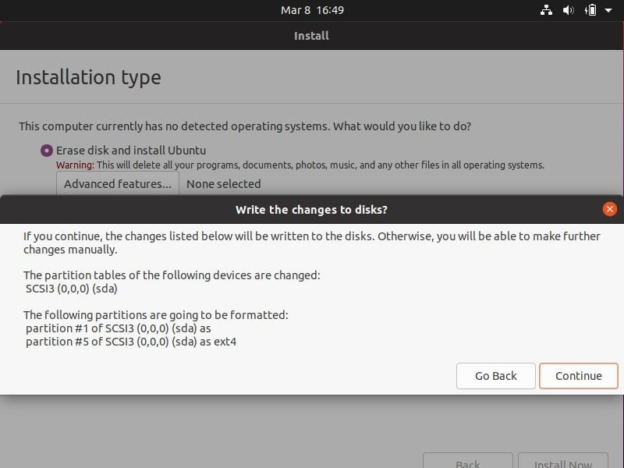

**Step-20**: - Choose your time zone on the map, then select Continue.

**Step-21**: - Set up your user account and select Continue.

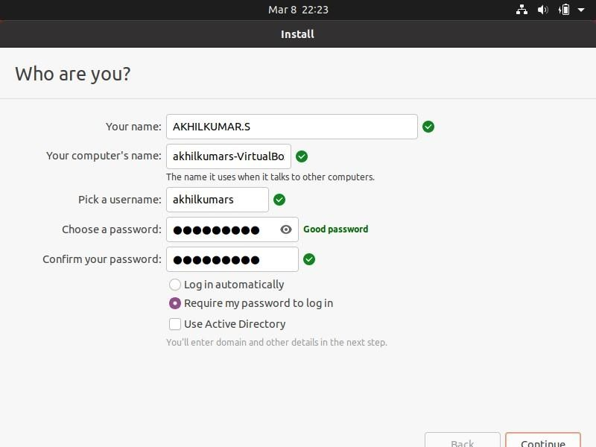

**Step-22**: - Select Restart Now.

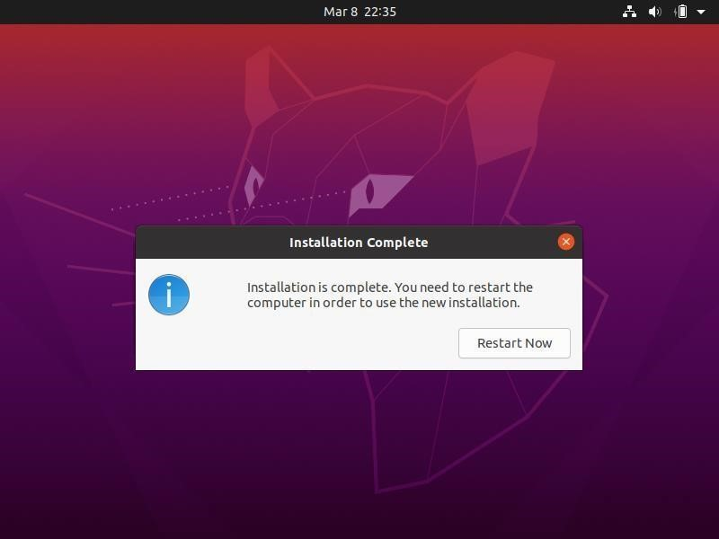

**Step-23**: - After restarting your VM and booting into Ubuntu, you may notice that the desktop doesn’t scale correctly if you choose to view it in full-screen mode. You can fix this problem by selecting the VBox_Gas icon to install VirtualBox Guest Additions.

**Output:**

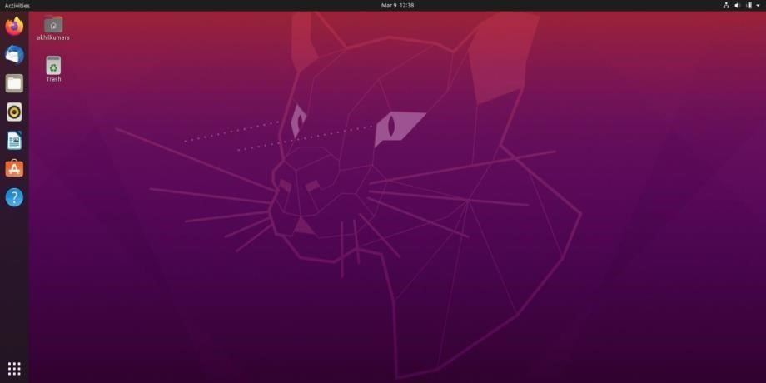

**Windows:**

Similarly, Follow the same steps above to Build Windows Virtual Machine.

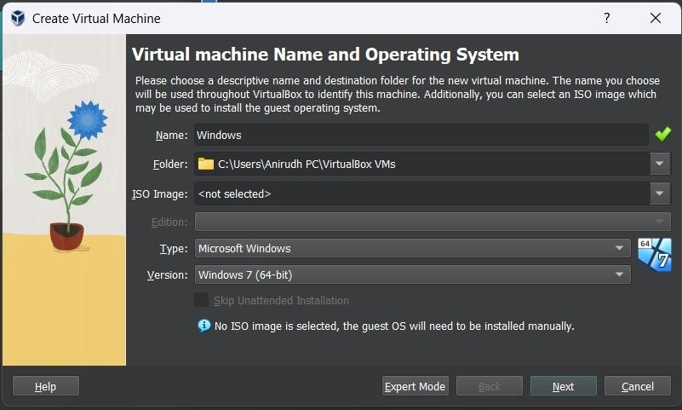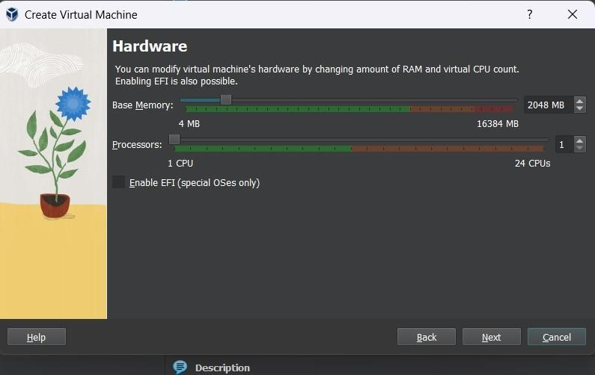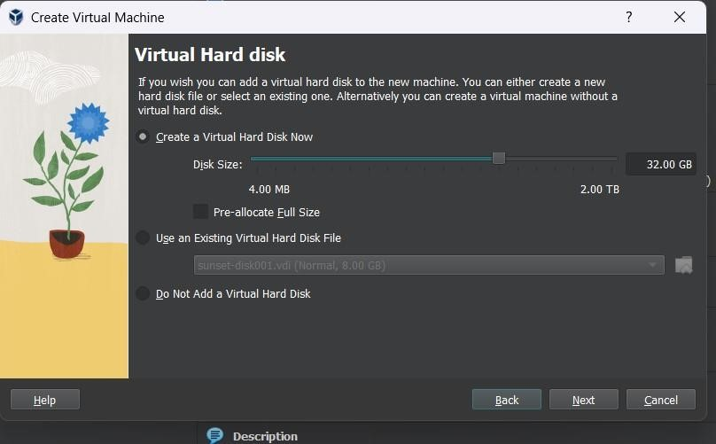

**Output:**

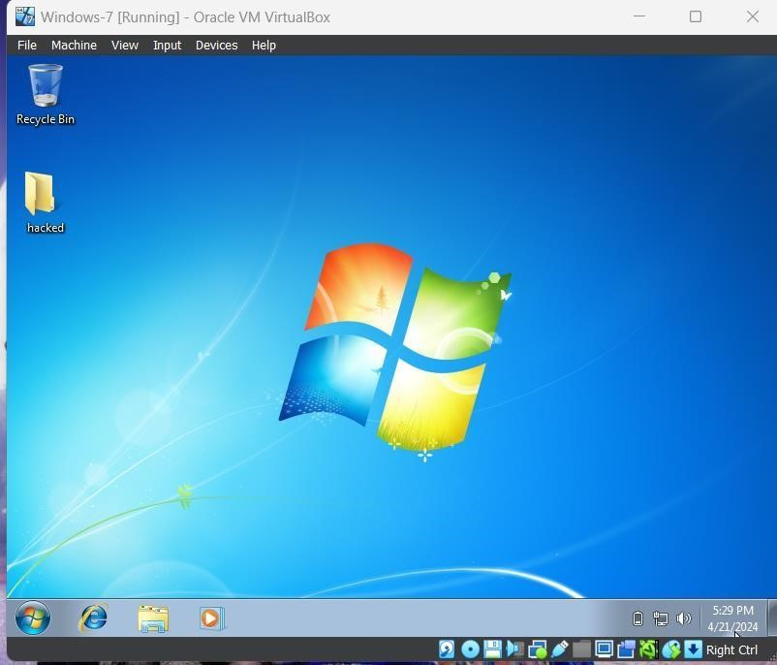

**Output: The above experiment was completed and executed successfully.**

**Q2) Create a Windows Virtual Machine in Microsoft Azure**

**Step-1:** Sign in to your Microsoft Azure account.

**Step-2:** Go To Virtual machine, and click on “Create” to create a window virtual machine.

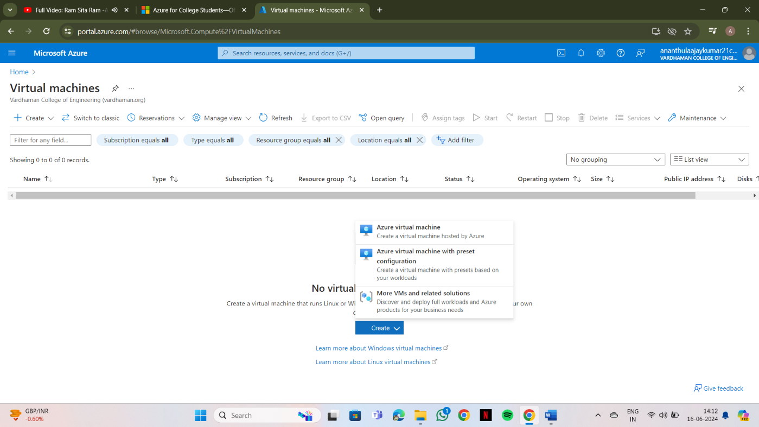

**Step-3:** Fill the details in that window by creating a “Resource Group”, Zone: Asia, Image: window,

Select the disk storage and so on. After that click on “Create + Review”. And Finclick on create

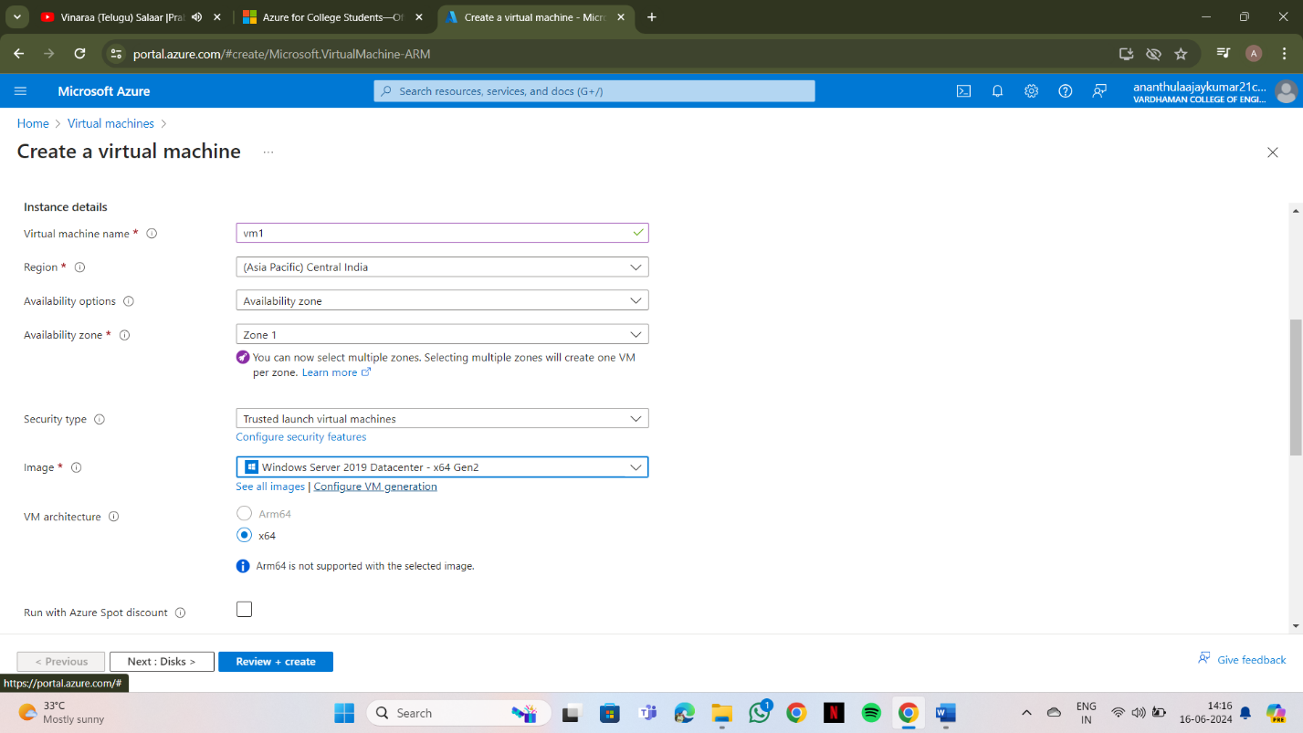

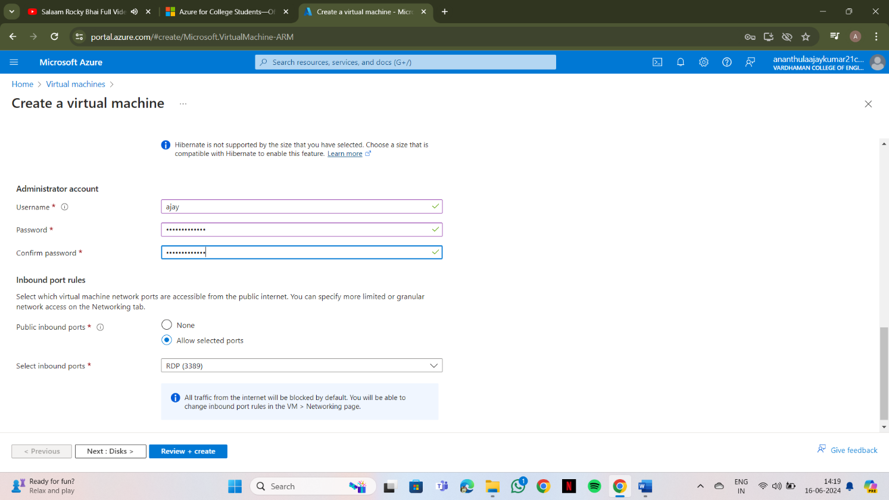

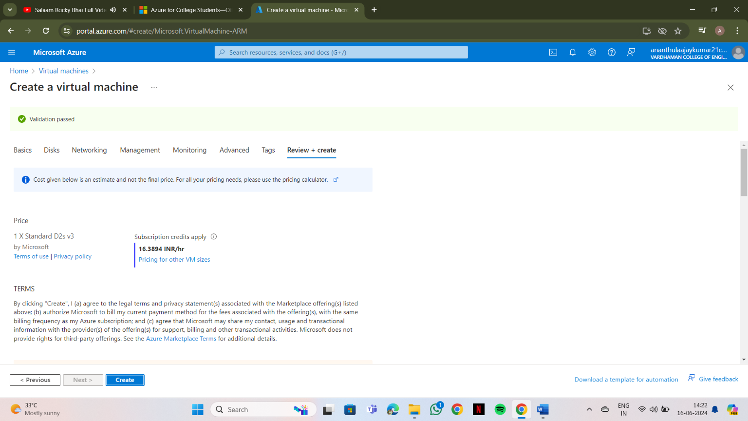

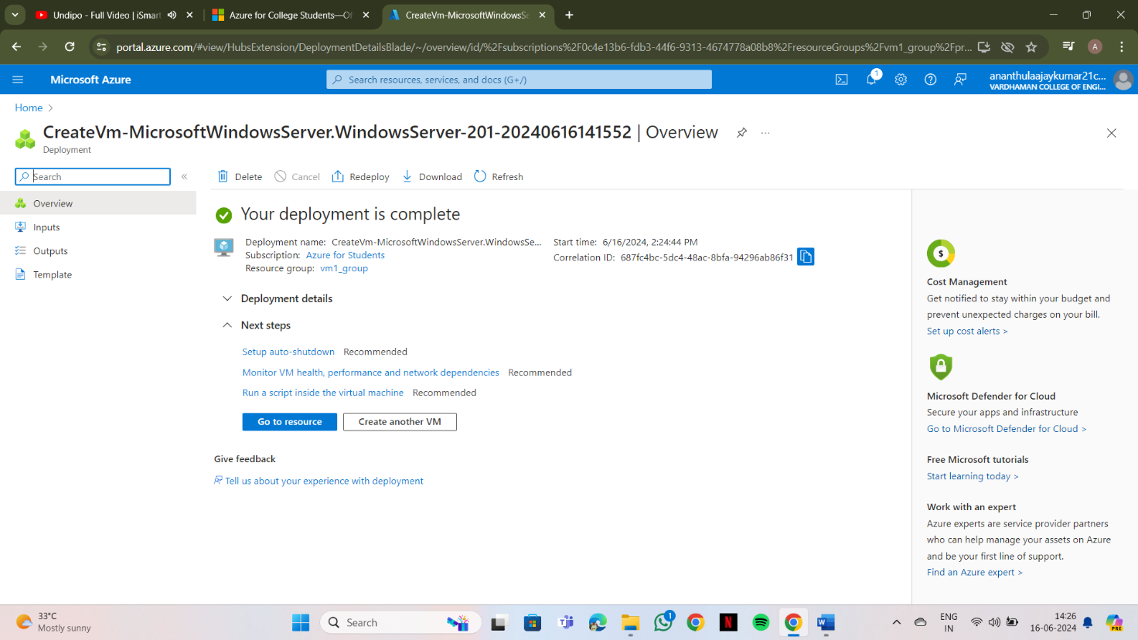**Step-4:** After Deployment is over, Go to the remote desktop connection.

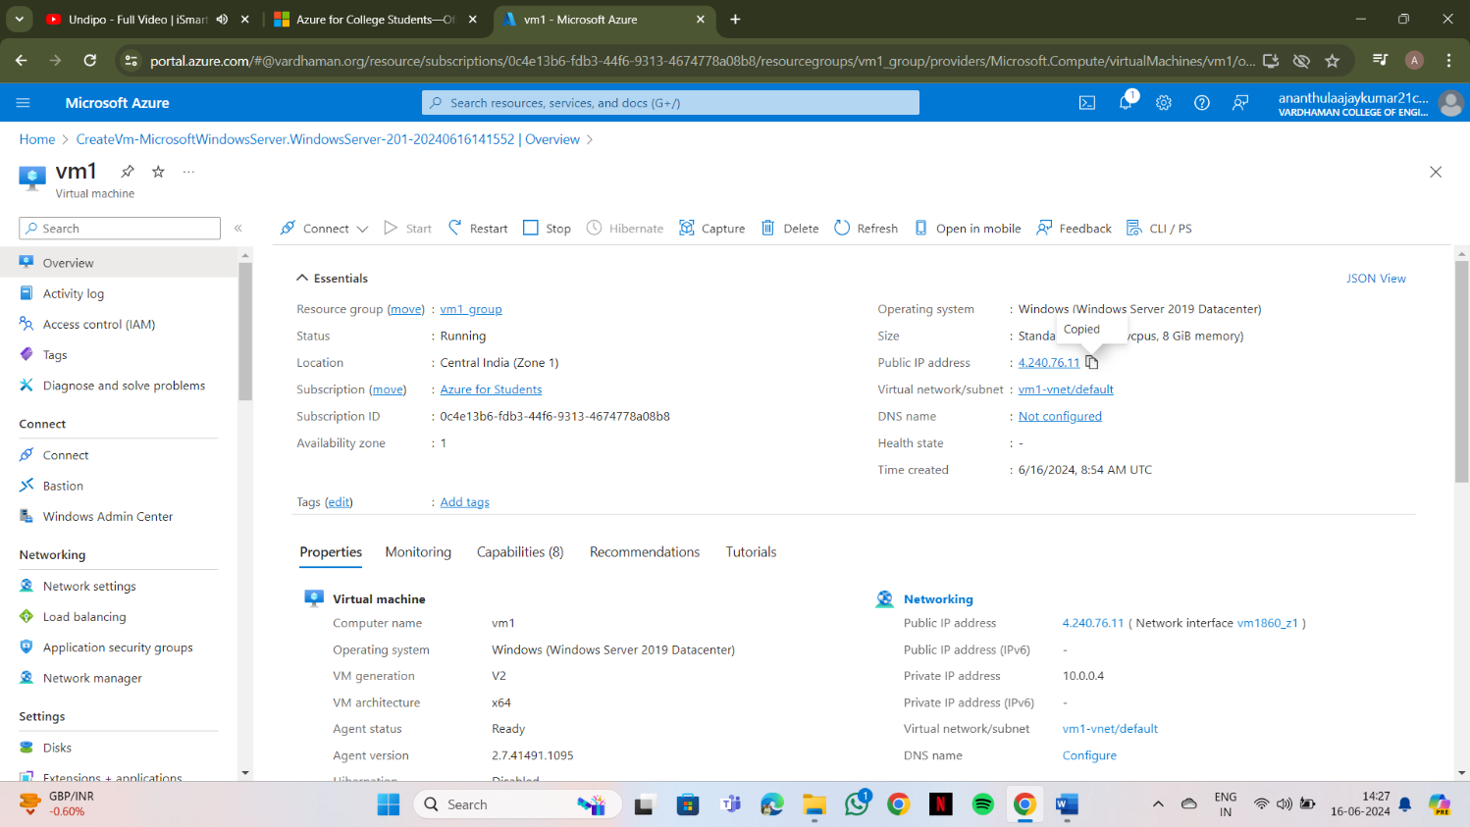

**Step-5:** Firstly, copy the public IP Address of that created virtual machine.

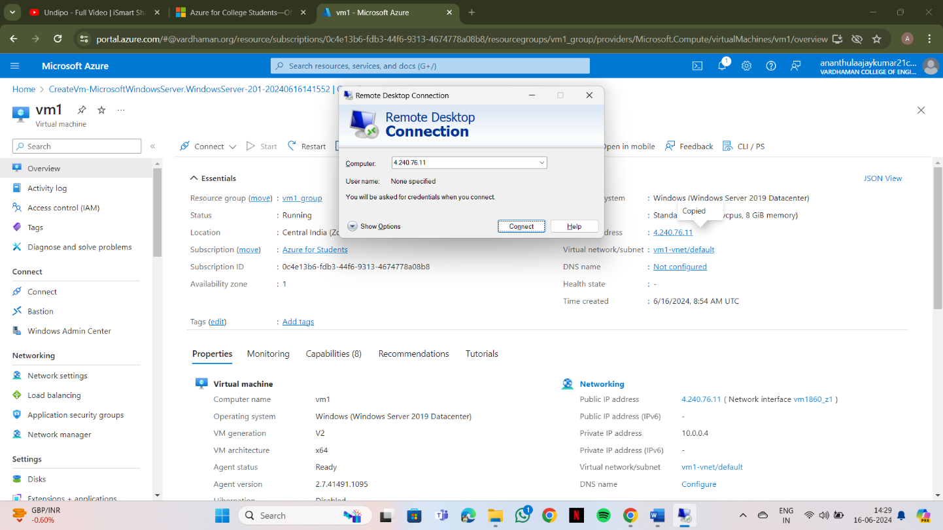

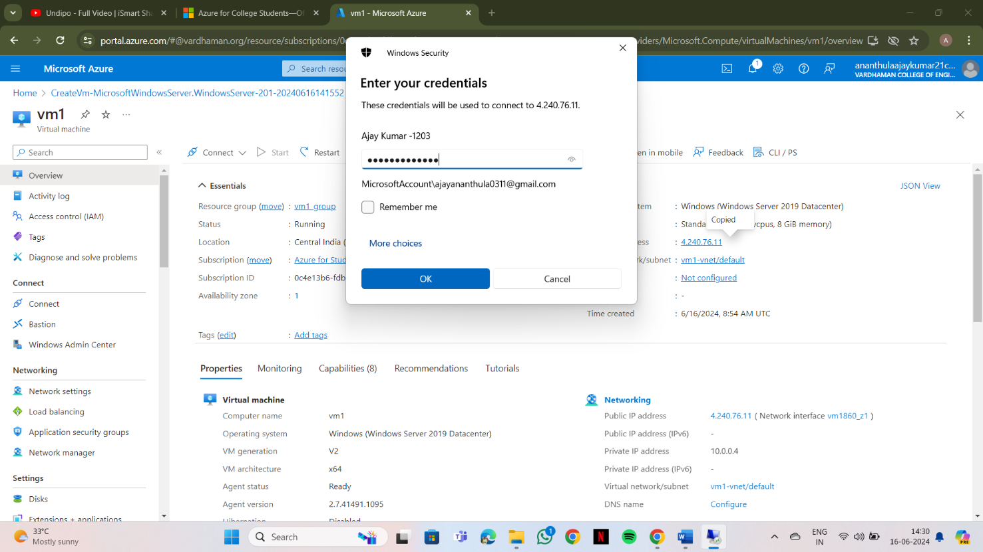

**Step-6:** By using that copied IP Address open the window virtual machine through remote desktop connection.

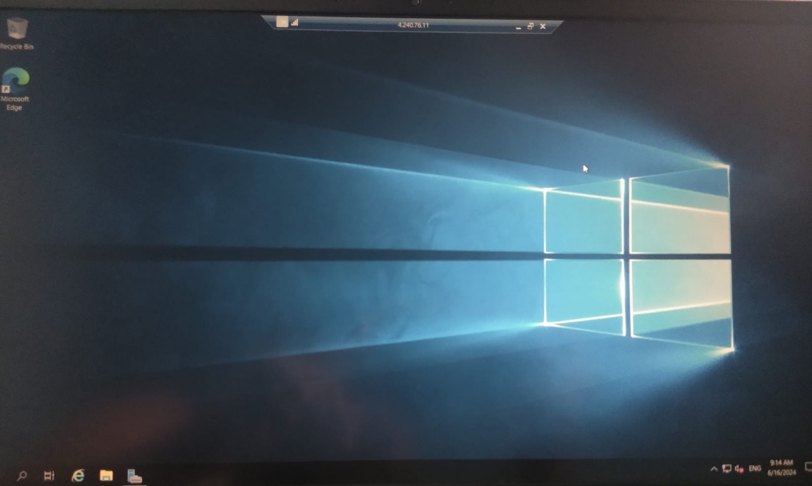**Output:**

**Output: The above experiment was completed and executed successfully.**

**Q3) Create a Ubuntu Virtual Machine in Microsoft Azure**

**Step-1:** Sign in to your Microsoft Azure account.

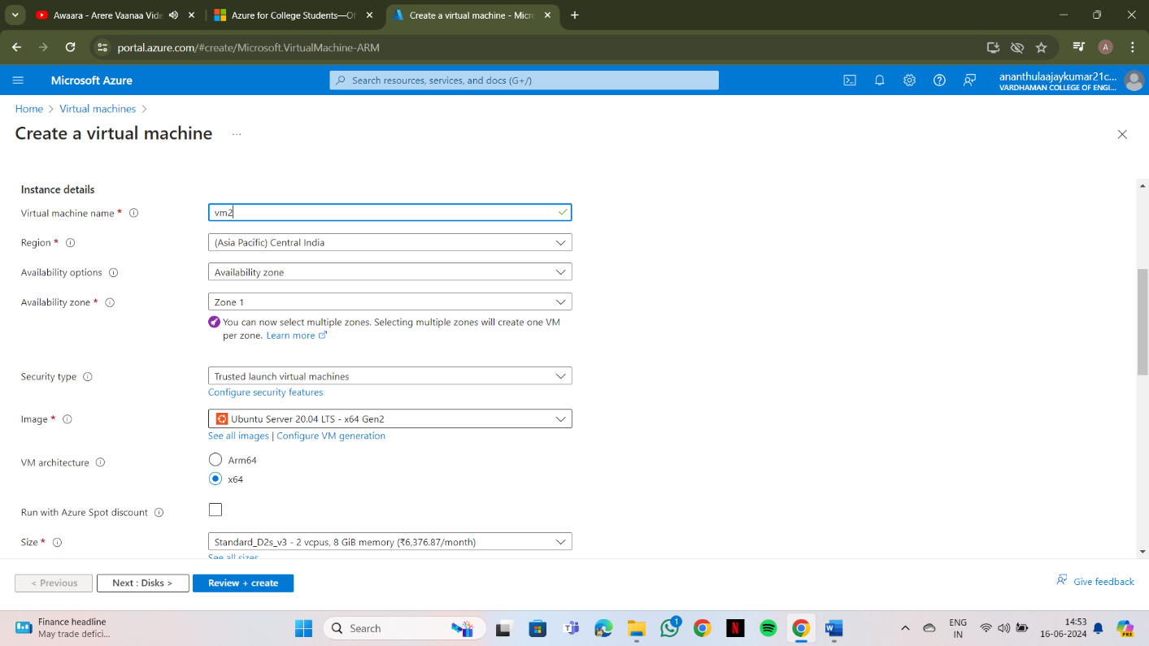**Step-2:** Go To Virtual machine, and click on “Create” to create a window virtual machine.

**Step-3:** Fill the details in that ubuntu by creating a “Resource Group”, Zone: Asia, Image:

ubuntu, select “SSH”, Select the disk storage and so on. After that click on “Create + Review”. And Finally click on “Create”.

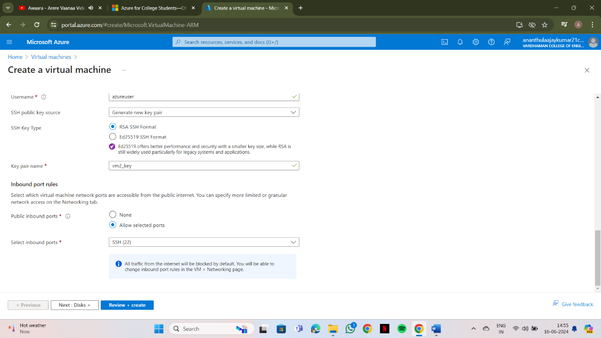

**Step-4** Firstly, copy the public IP Address of that created virtual machine

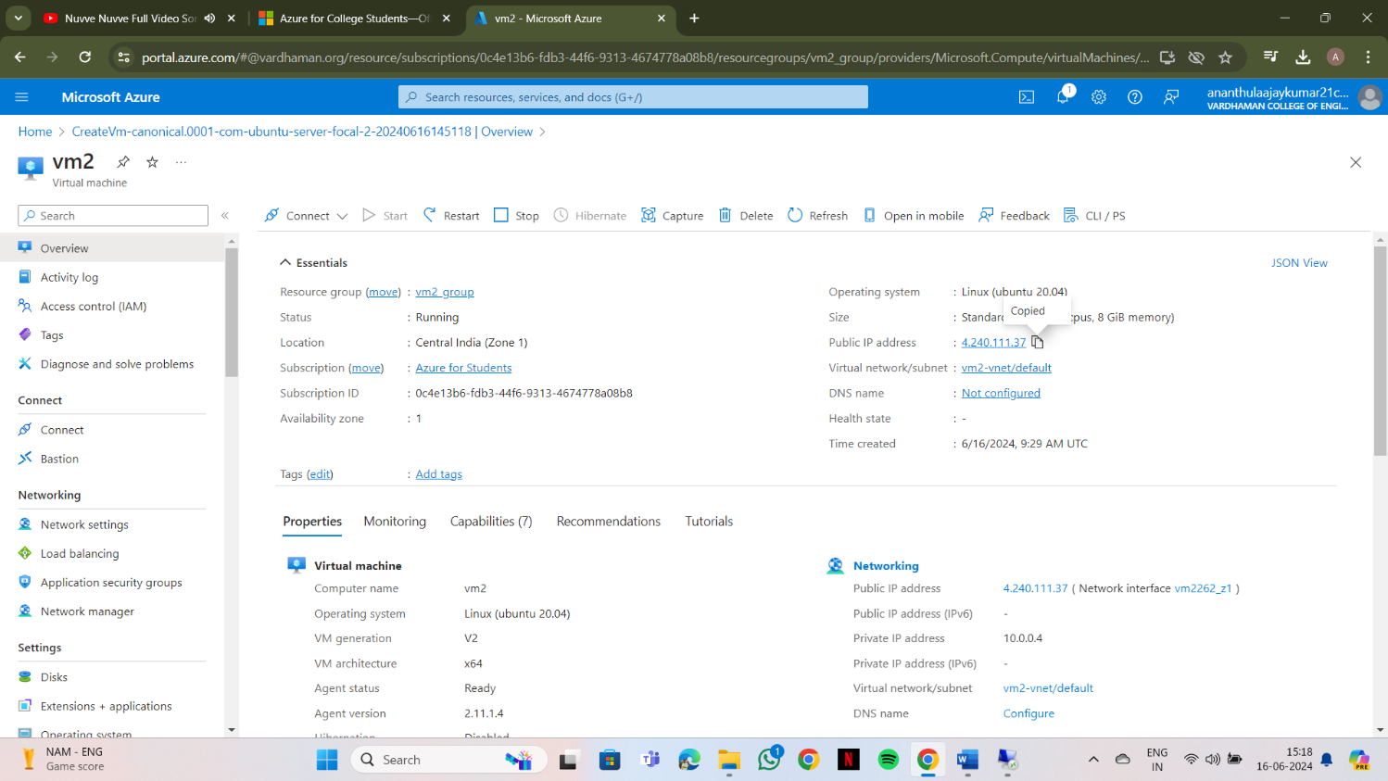

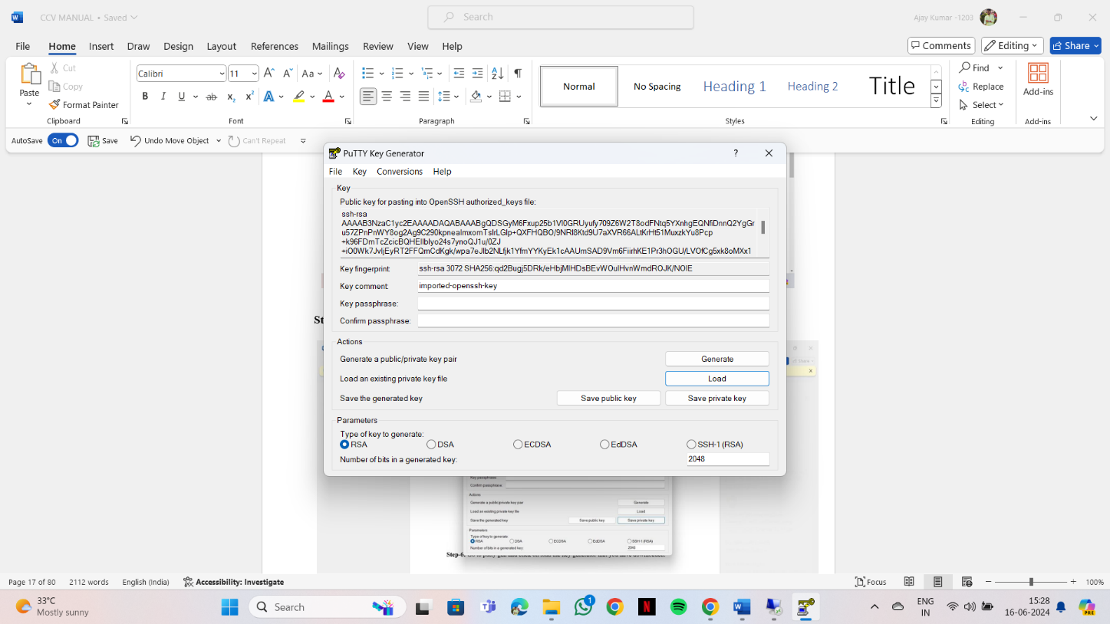**Step-5:** Go to putty gen and click on load the key generator that you have downloaded.

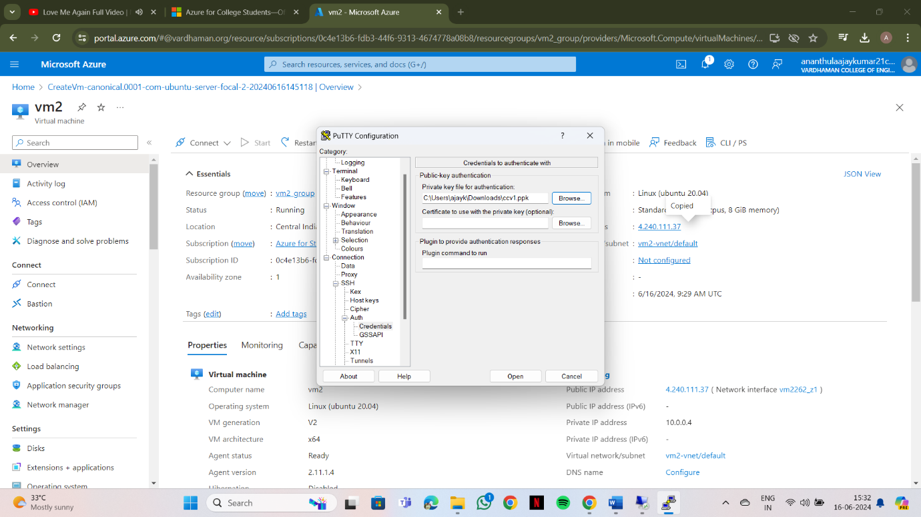**Step-6:** In putty, put the Copied IP Adress into it, and then go to ssh->auth->credentials And the put the generated private key.

**Step-7:** A login page will be opened in that type your username and you will be into the ubuntu.

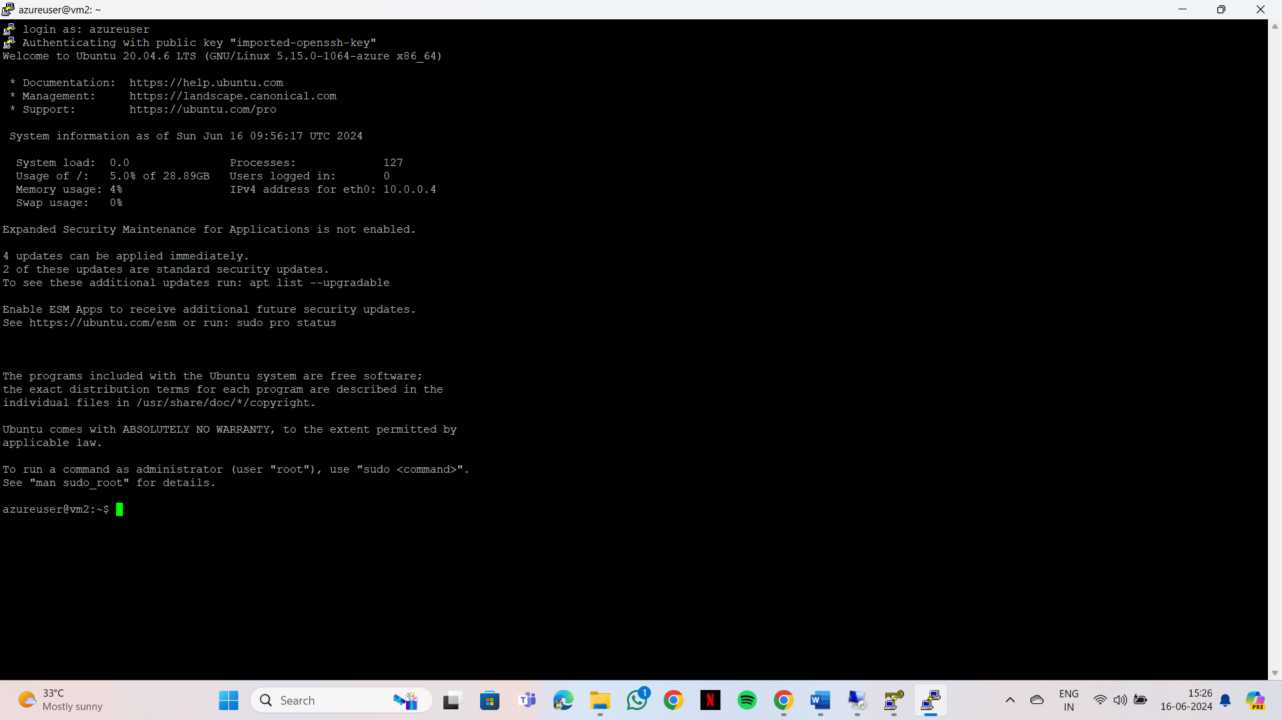**Output:**

**Output: The above experiment was completed and executed successfully.**

**4Q) Create a Virtual machine and do scale up in Azure.**

**Step-1: Create a virtual machine (ubuntu or windows).**

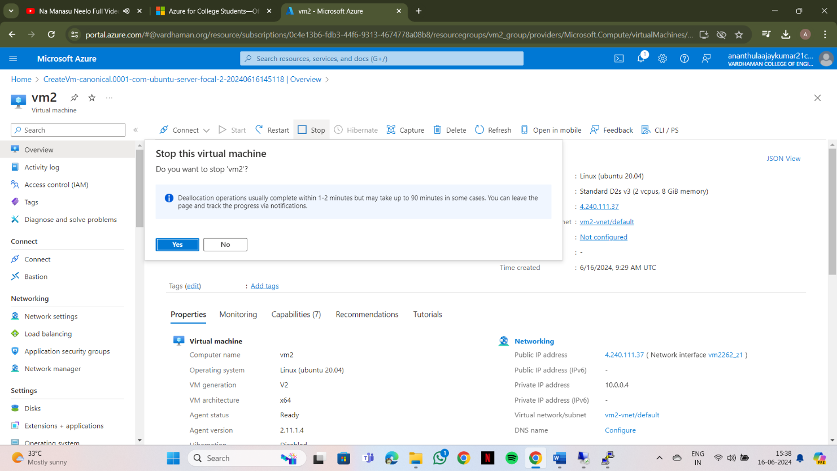

**step-2: After deployment of VM stop VM for scaling**

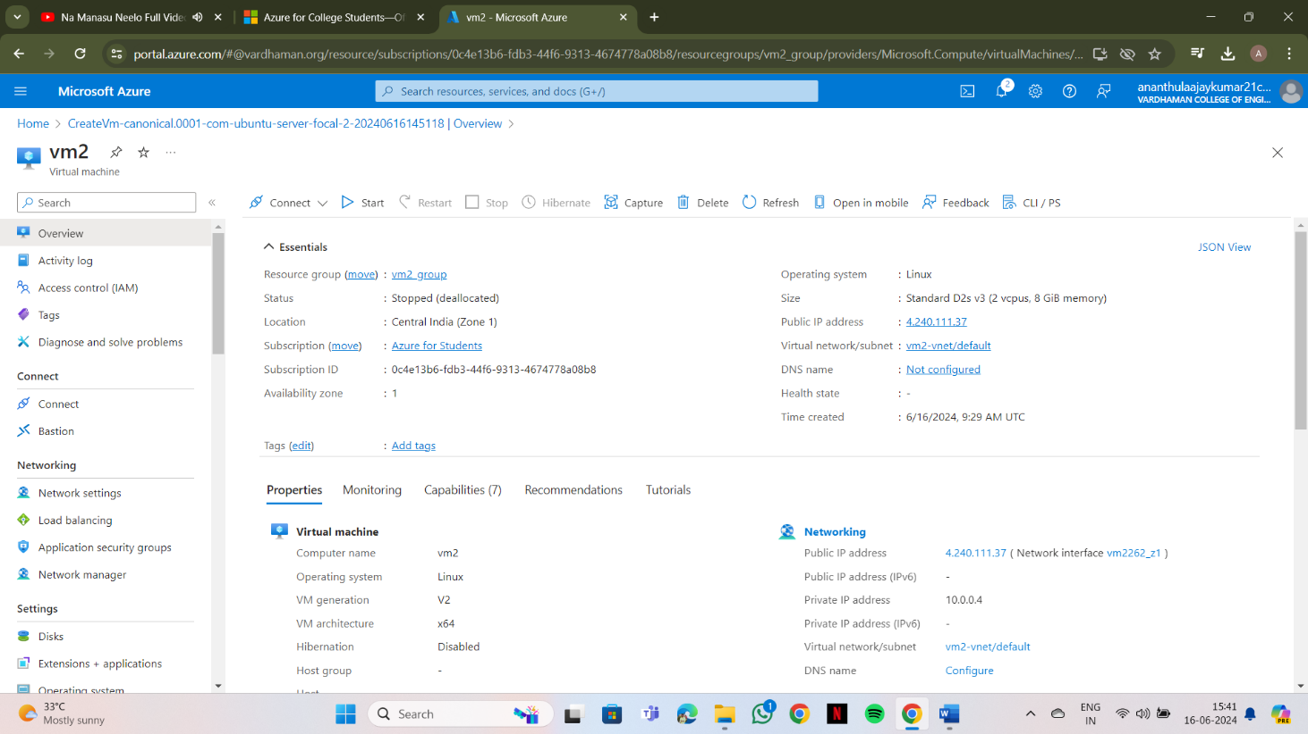

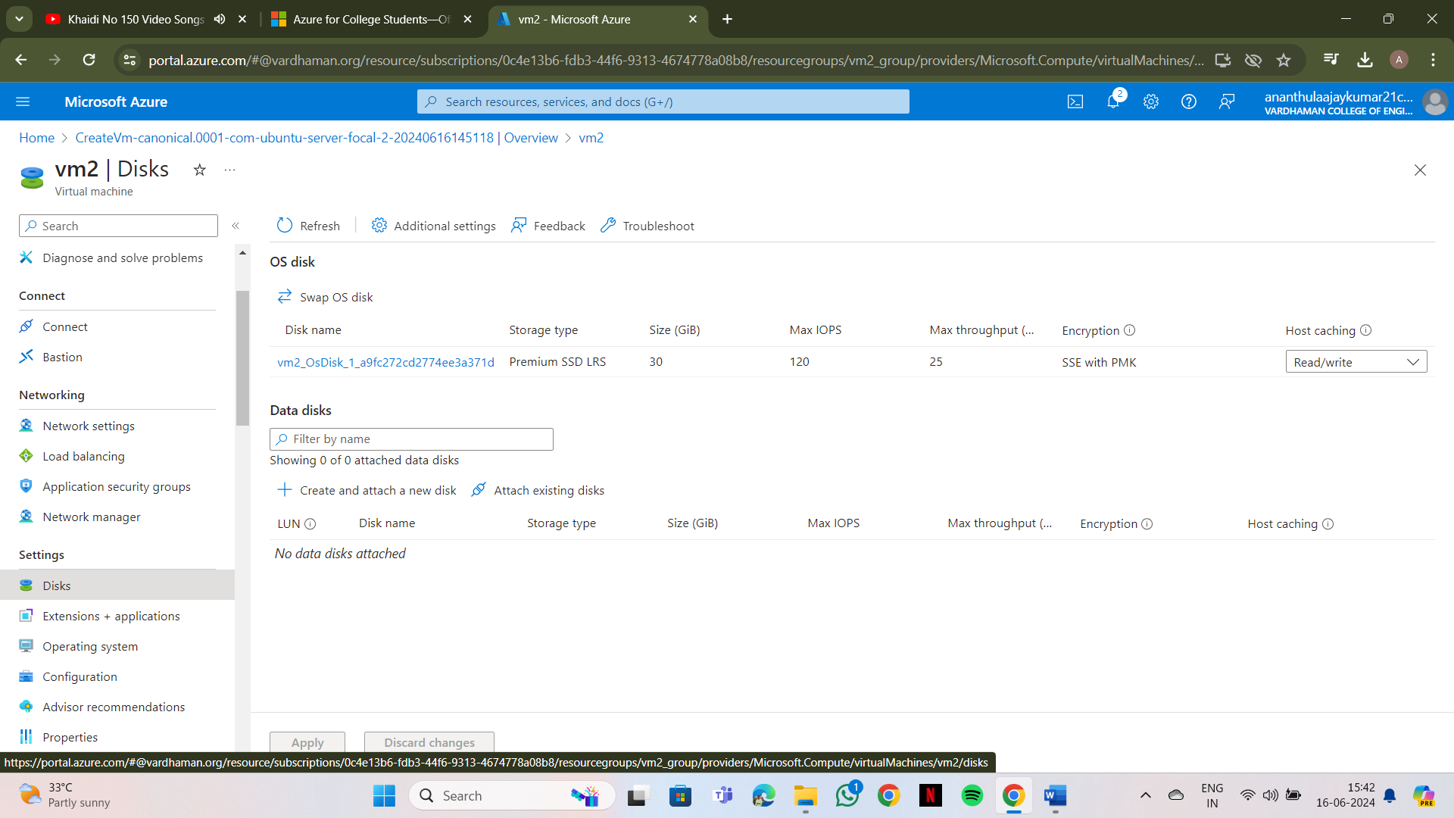**Step-3: On the left side there will be settings and click on disks.**

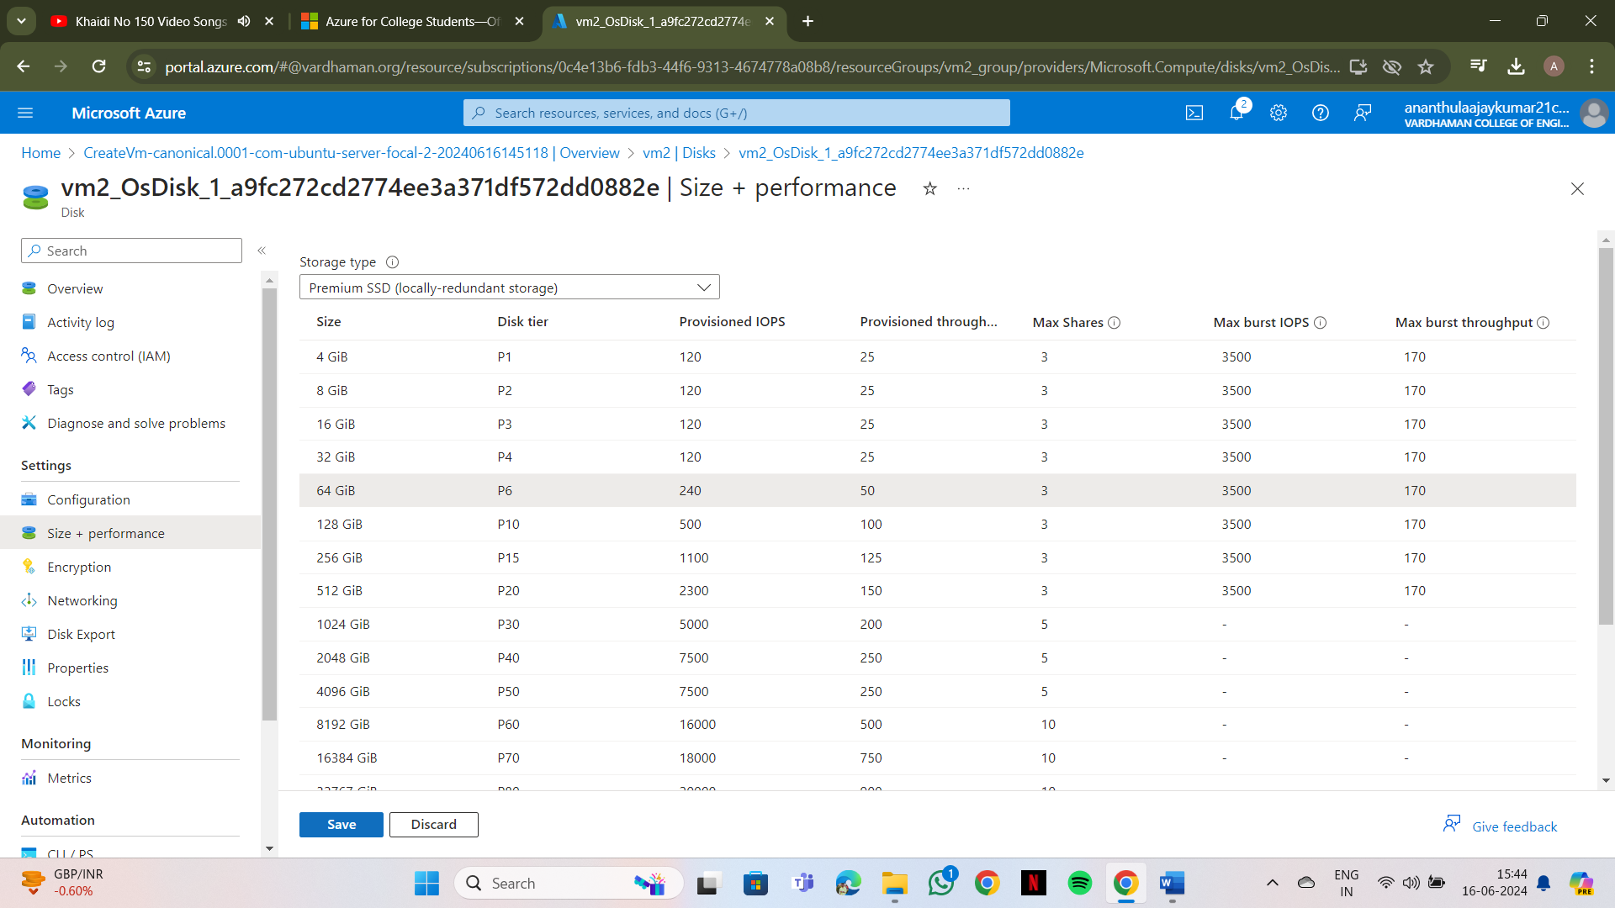**Step-4: click on disk name and select your preferred size, save it.**

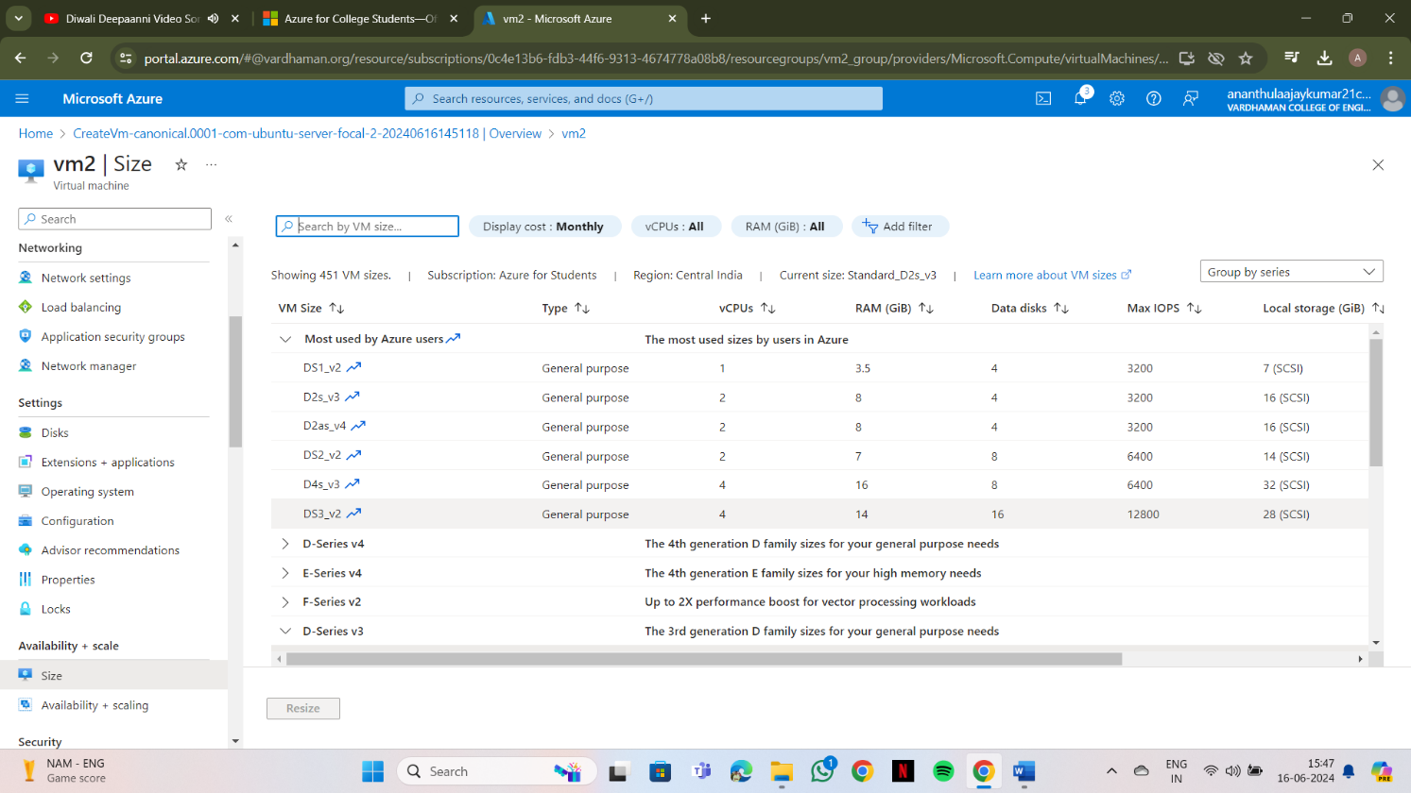**Step-5: On the left side there will be select + performance and click on size.**

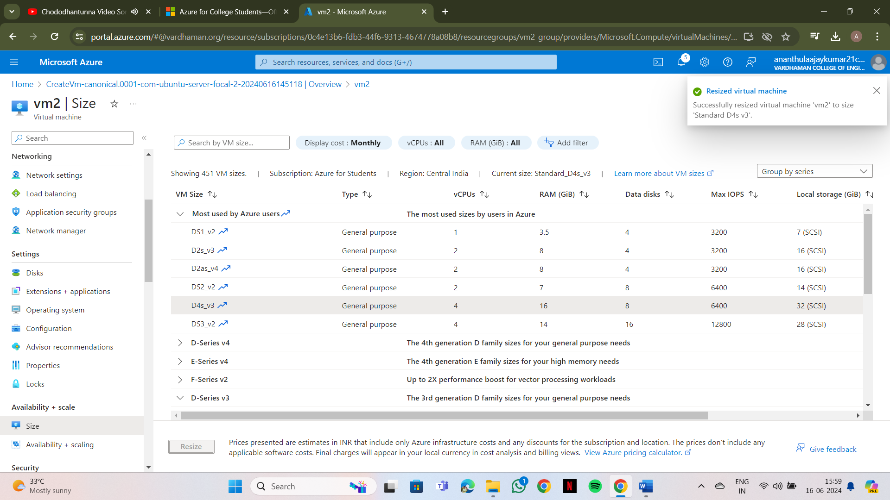**Step-6: click on disk name and select your preferred ram size, save it.**

**Output: The above experiment was completed and executed successfully**

**Q5) Create a Virtual machine and do lock for VM in AZURE.**

**Step-1: Create a virtual machine (ubuntu or windows).**

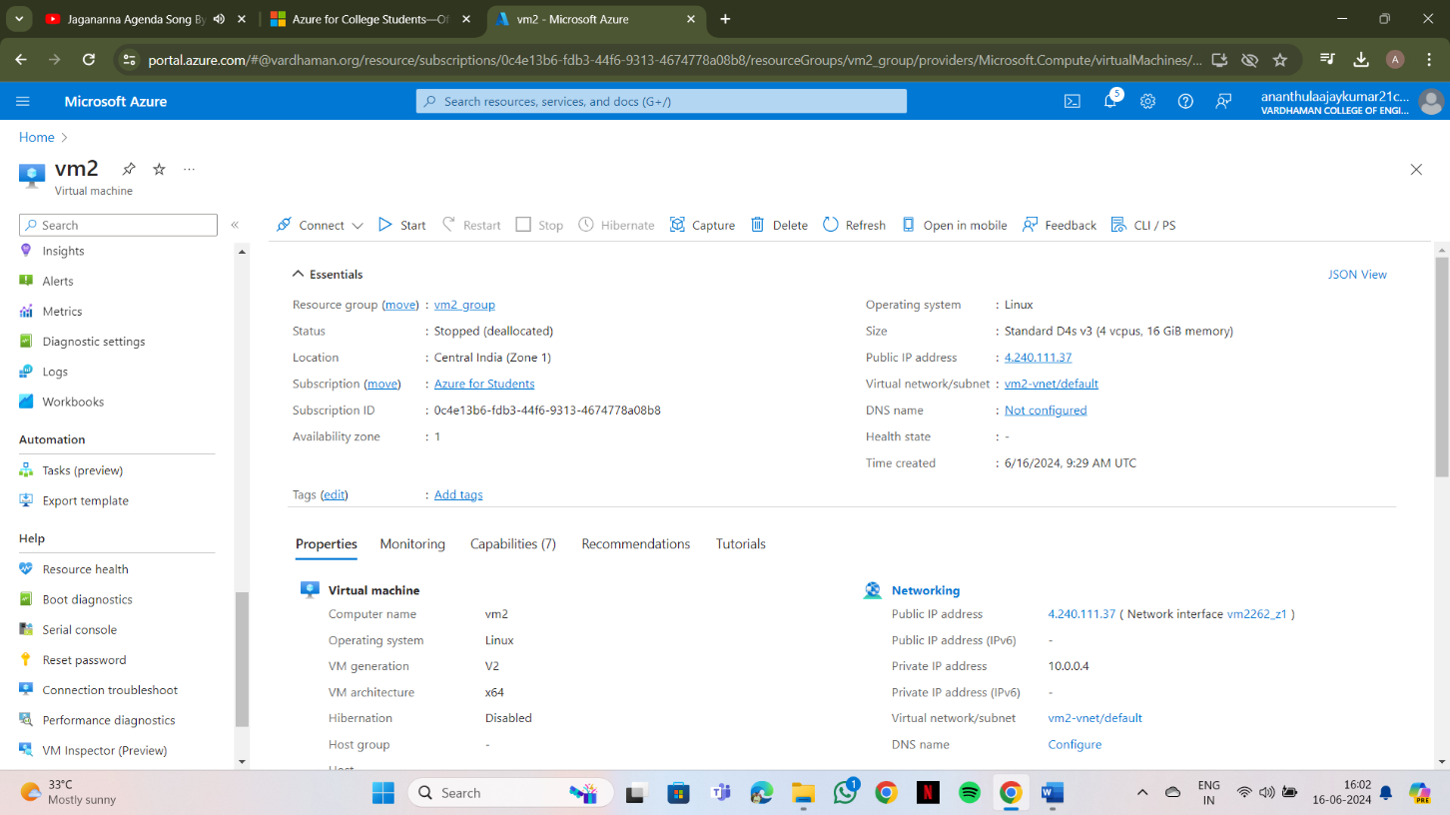

**Step-2: On the left side there will be settings and click on locks, give lock name and select lock type.**

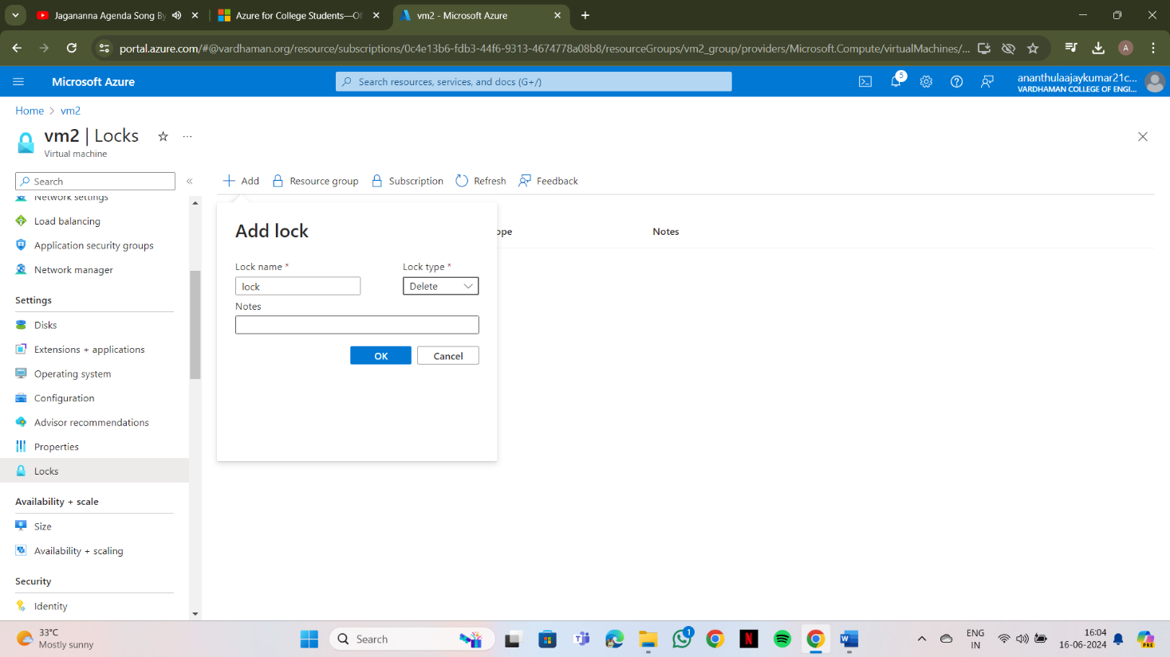

**Step-3: click on ok.**

**Similarly, you can do for Resource group and subscriptions.**

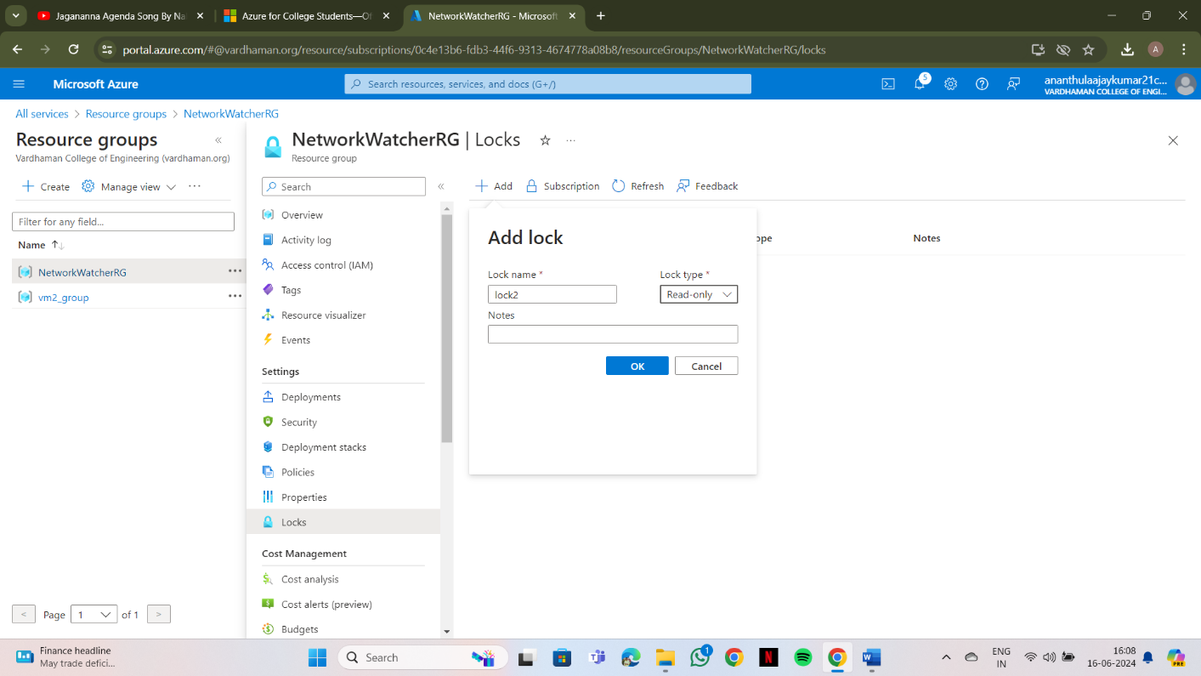

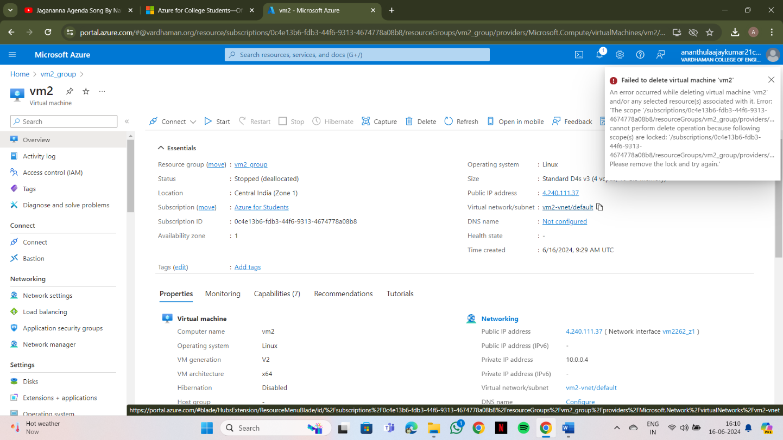**Note: After creating the lock, you need to delete it for deleting VM.**

**Output: The above experiment was completed and executed successfully.**

**Q6) Create Ubuntu VM and run a python program in it.**

**Step-1: Create a ubuntu virtual machine using SSH key same as previous experiment.**

**Step-2: Login with your username and type python3, write your python program and execute it.**

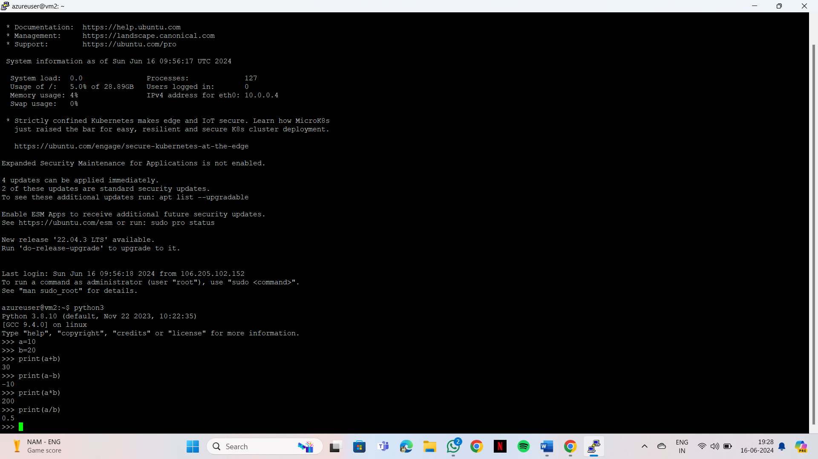

**Output: The above experiment was completed and executed successfully.**

**Q7) Create a Ubuntu VM and transfer files using WinScp.**

**Step-1: Create a ubuntu virtual machine using SSH as previous experiment and copy public IP address.**

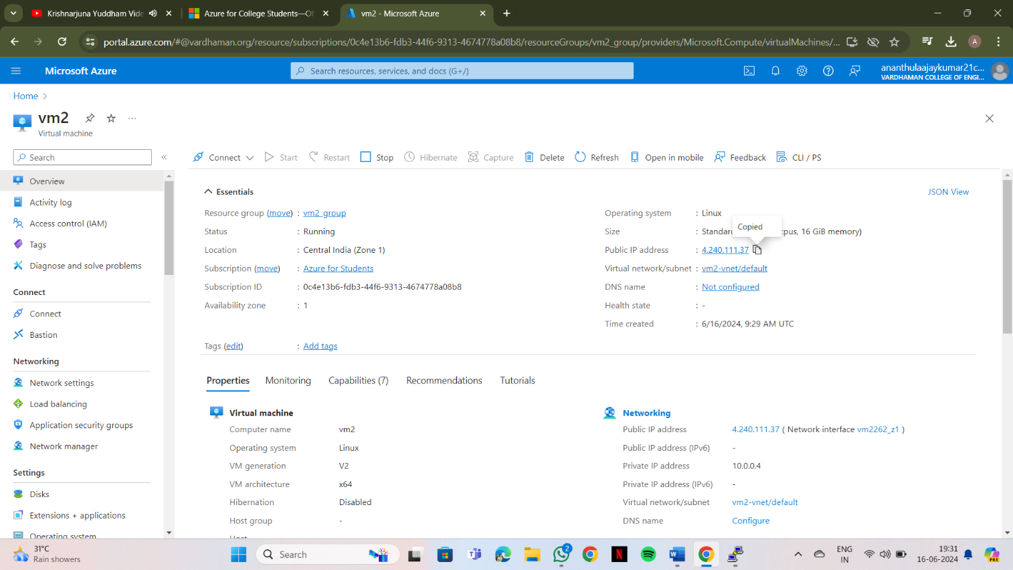

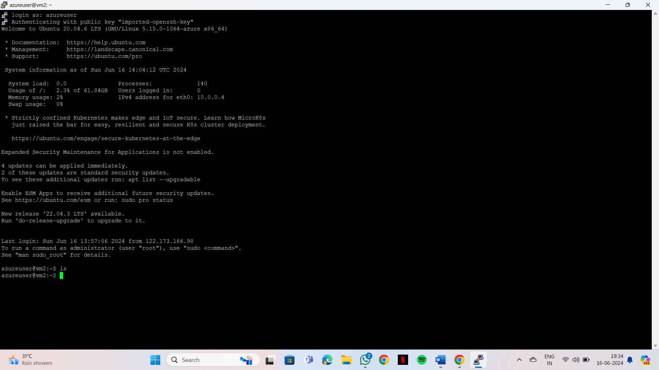**Step-2: Login into your ubuntu VM using PUTTY and type ls command as you can see nothing.**

**Step-3: Open WinScp at right bottom you can see Advanced option>SSH>Authentication->In that drag private key file and click on ok.**

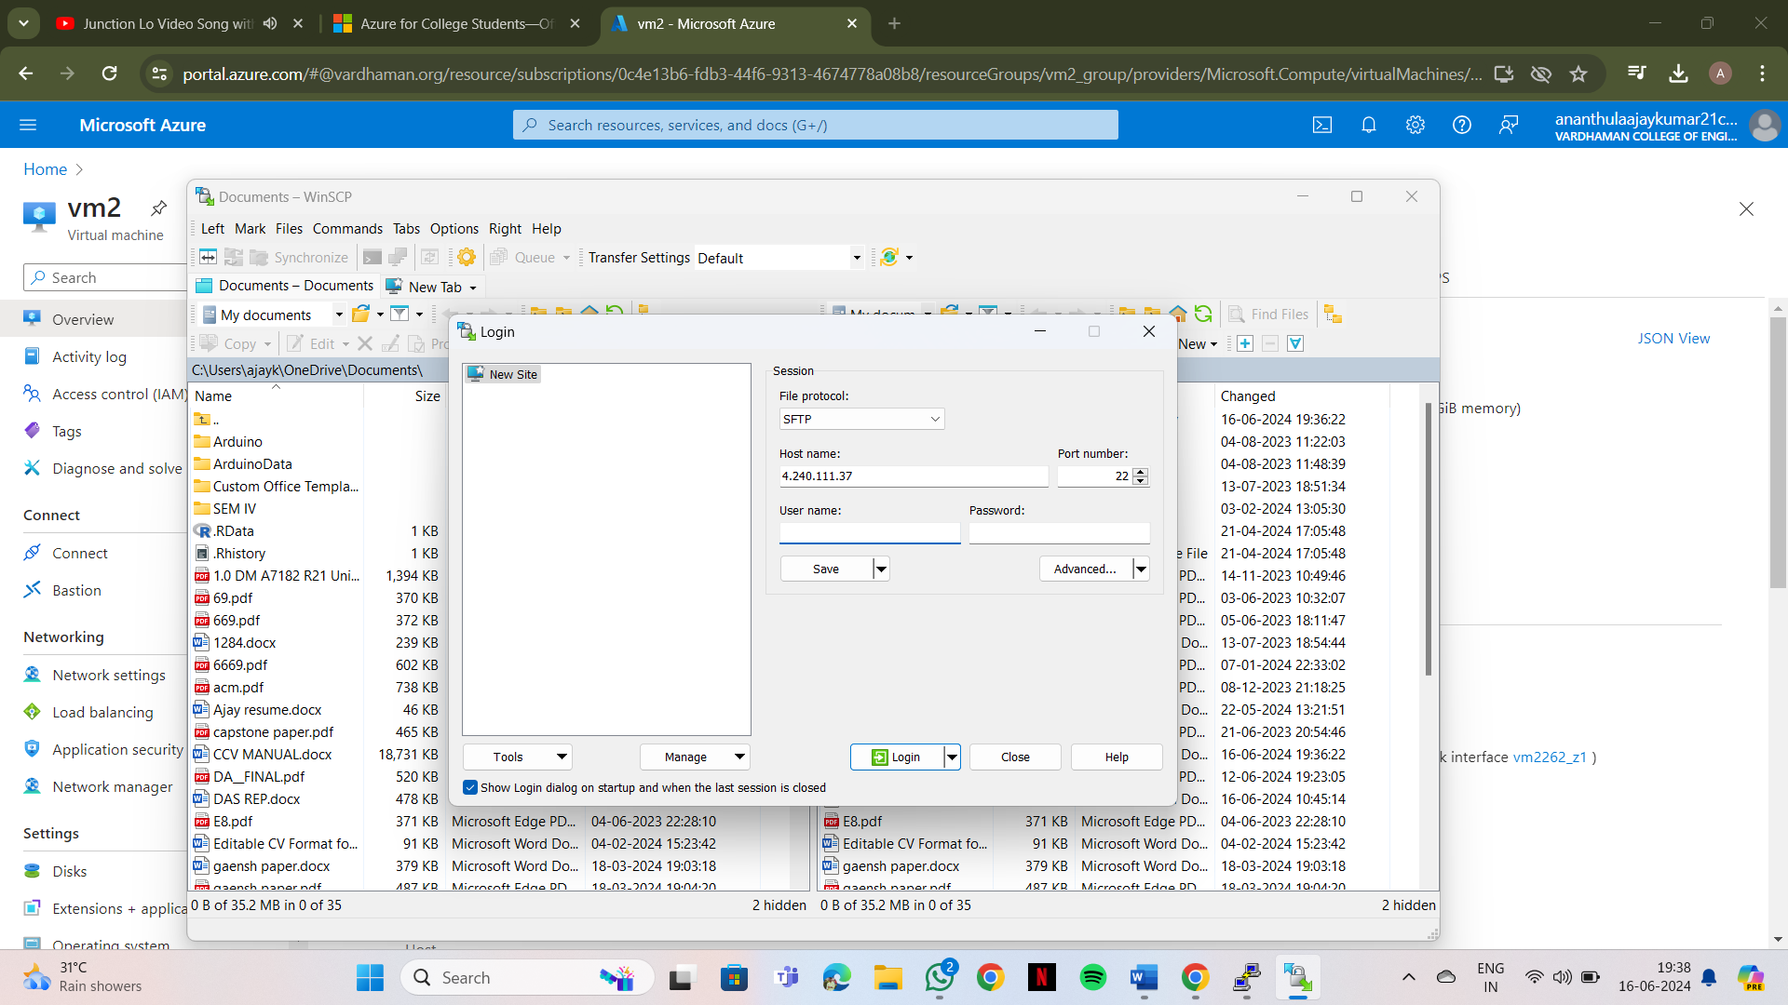**At last Login into your account using public IP address and username in WinScp.**

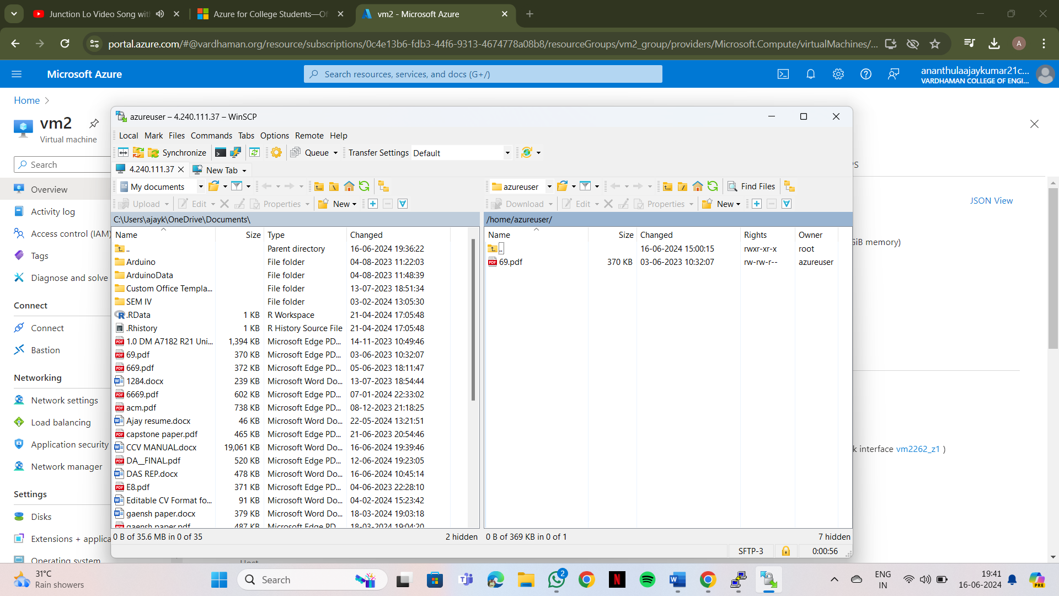 **Now, you can drag your files from your desktop to ubuntu VM in WinScp.**

**Step-4: Now again type ls command as you can see file inside ubuntu VM.**

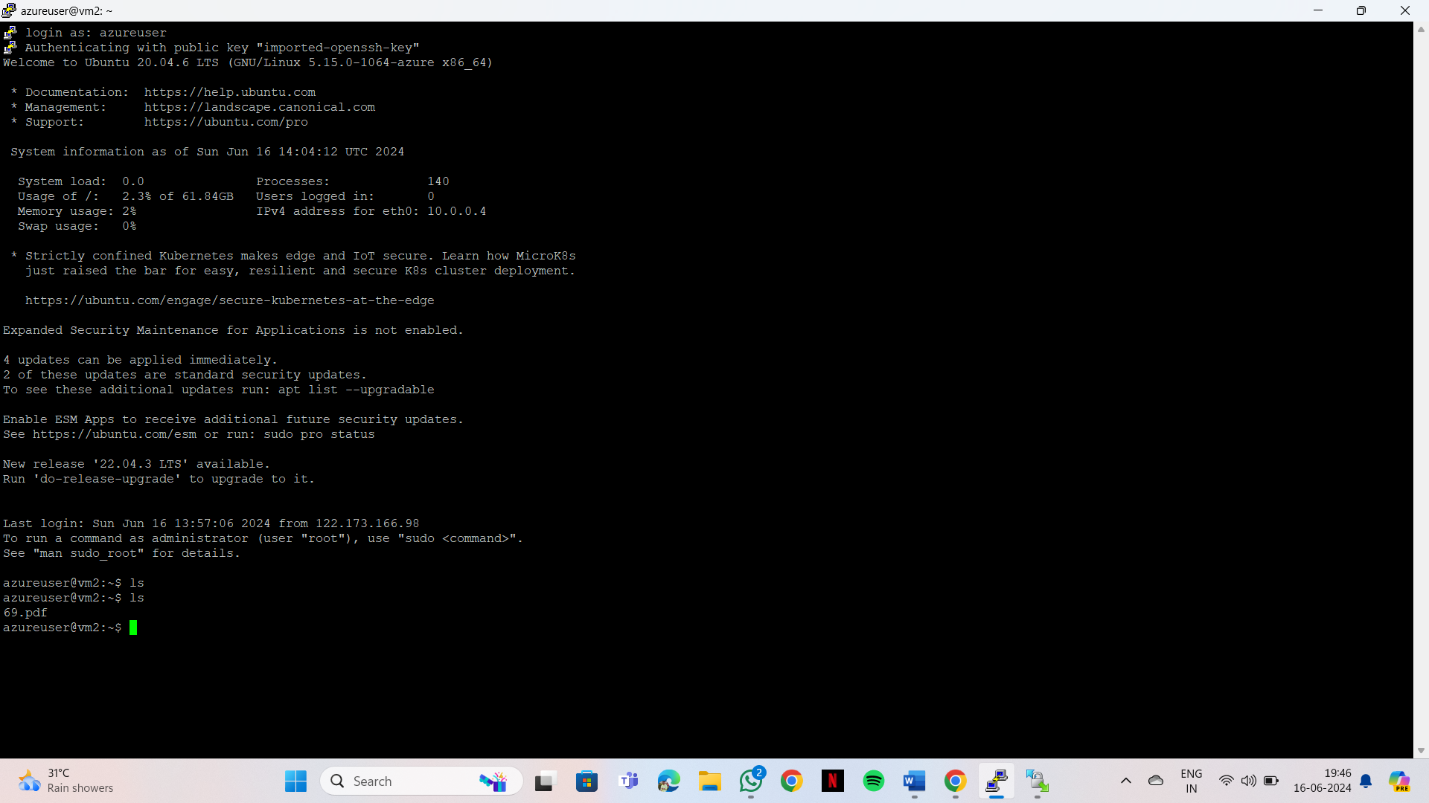

**Output: The above experiment was completed and executed successfully.**

**Q8) How to make Linux server as web server in AZURE.**

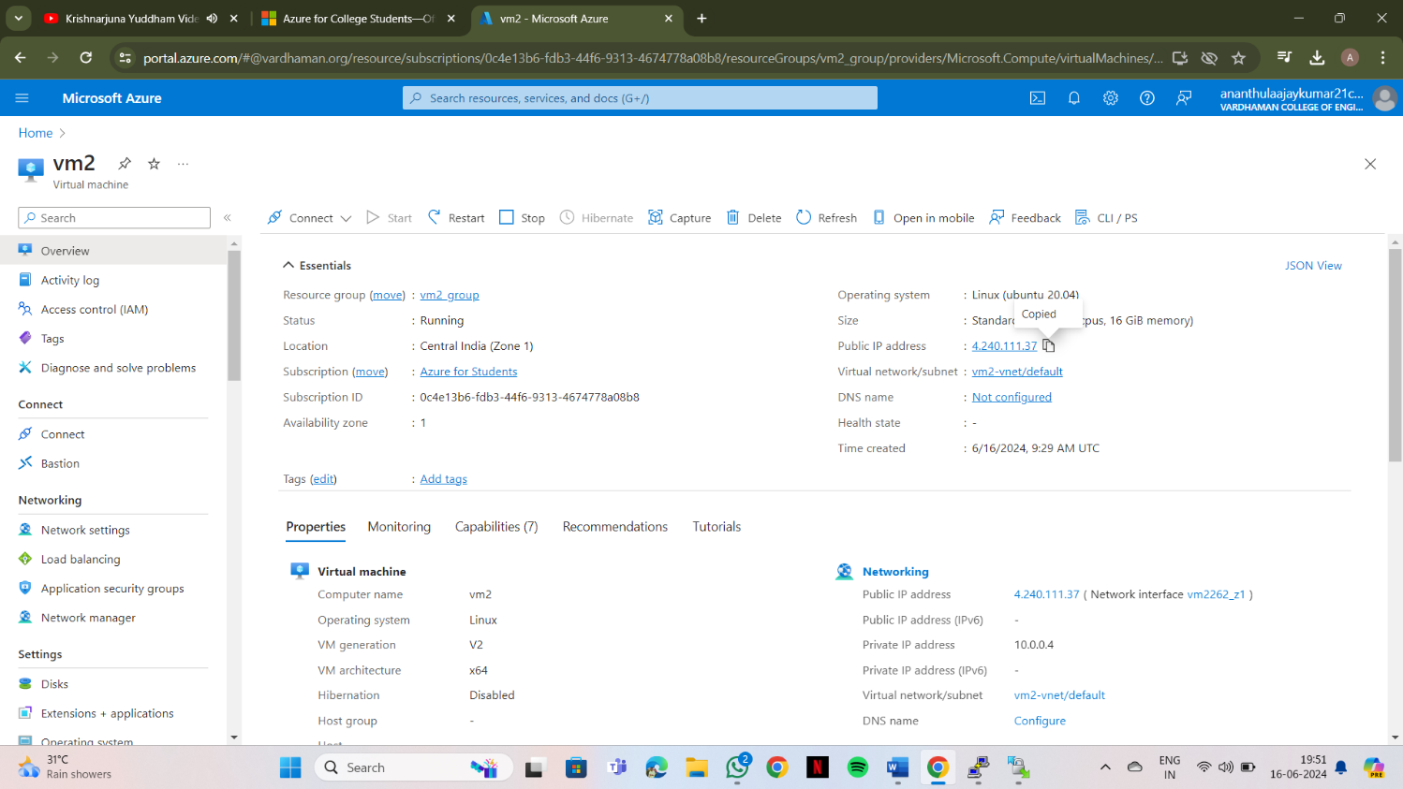**Step-1: Create a ubuntu virtual machine using SSH as previous experiment and copy public IP address.**

**Step-2:Login into your Ubuntu VM using your username and type the following commands. $sudo su**

**$sudo apt-get update**

**After typing the two command, now install web server using the below command**

**$sudo apt-get install nginx**

**After installing in VM, paste the public ip address in desktop browser and you can see.**

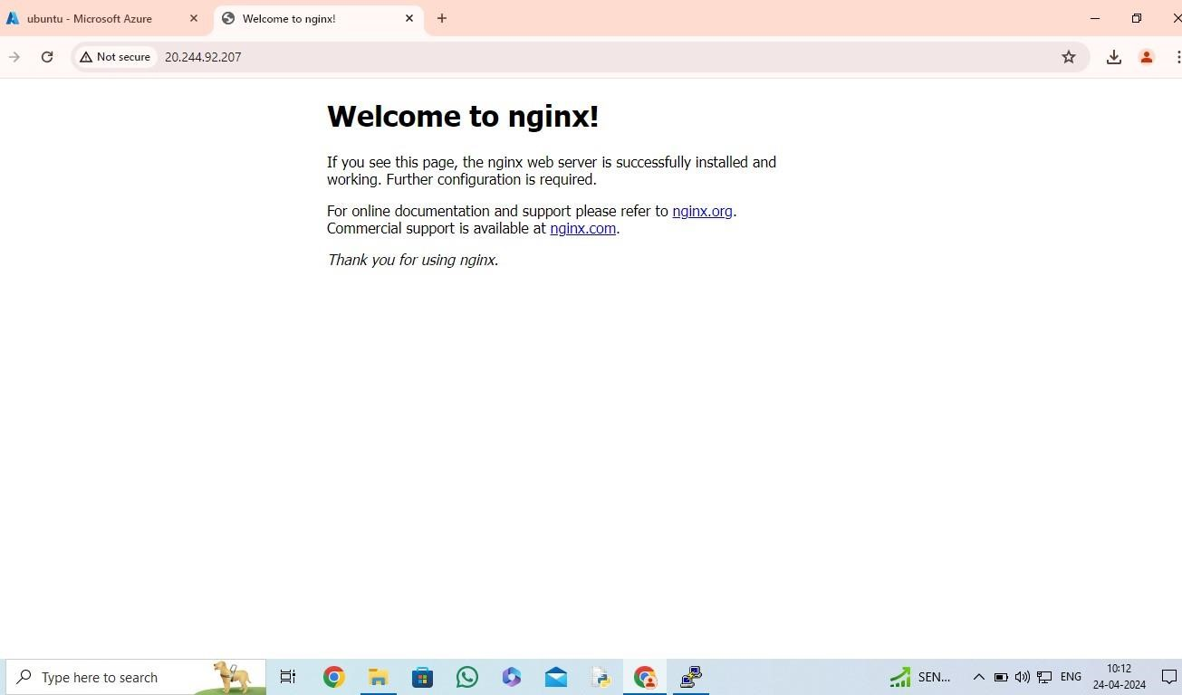

**Step-3: To remove following information and keep new information in that page type the following command and refresh the browser page.**

**$cd /var/www/html**

**$rm index.nginx-debian.html**

**$echo “Welcome to CSM “>index.html**

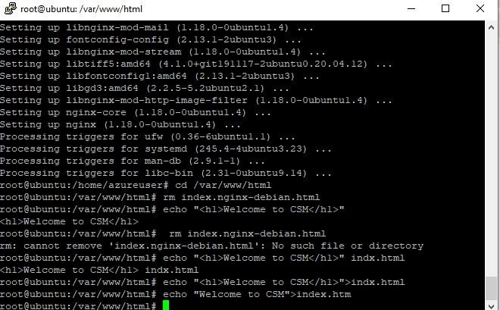

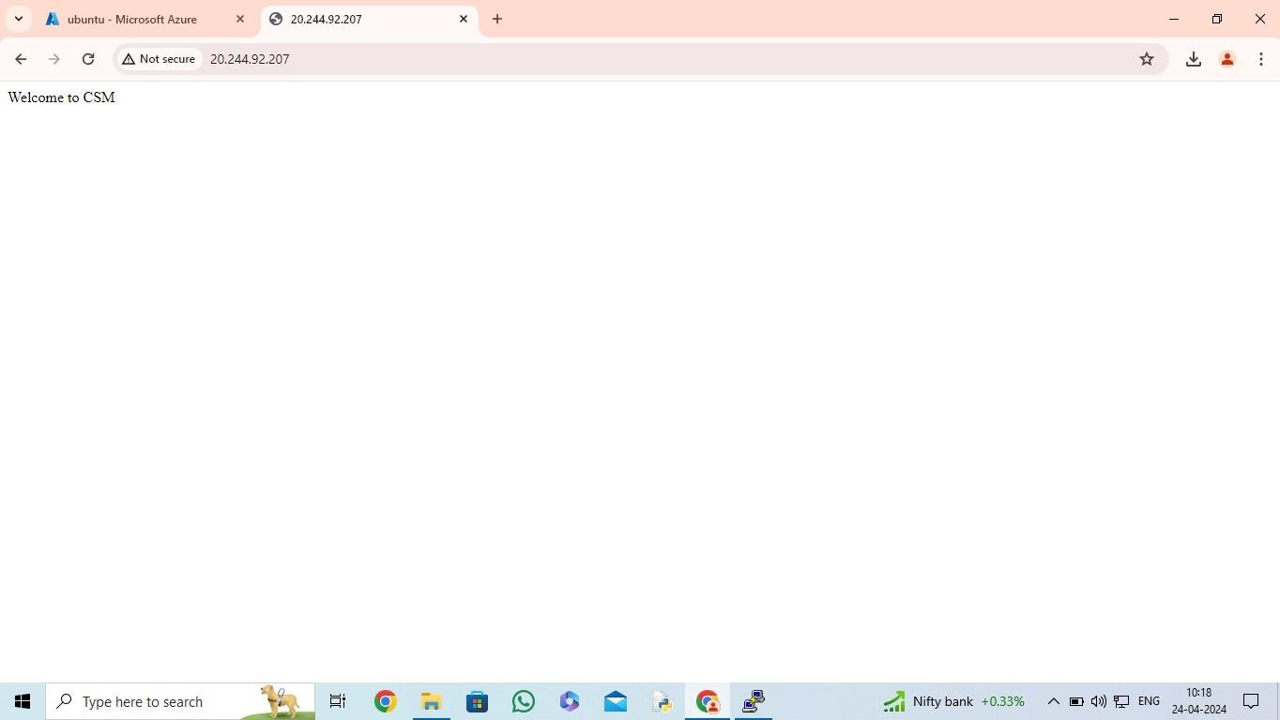

**Output: The above experiment was completed and executed successfully.**

**Q9) Setup and configure AZURE web server for windows server(IIS).**

**Step-1: Create and login windows VM same as previous experiment and copy public IP address.**

**Step-2: When remote desktop will start(windows vm) you can see there will be Sever Manager will be opened and in that you can see Configure this local server , Click on “Add roles and features”.**

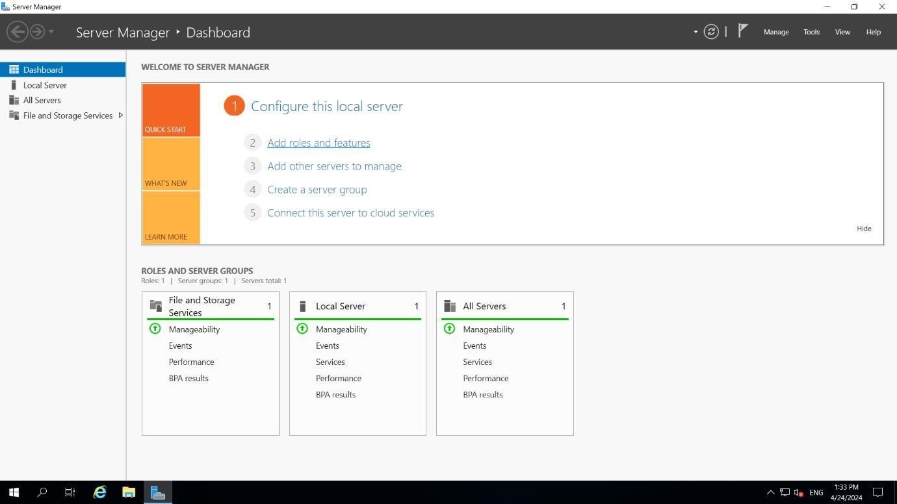

**Step-3: Click on next, next and in Server Roles select Web Server(IIS) click on add feature ,click on next, next till you can get install button and click on install .**

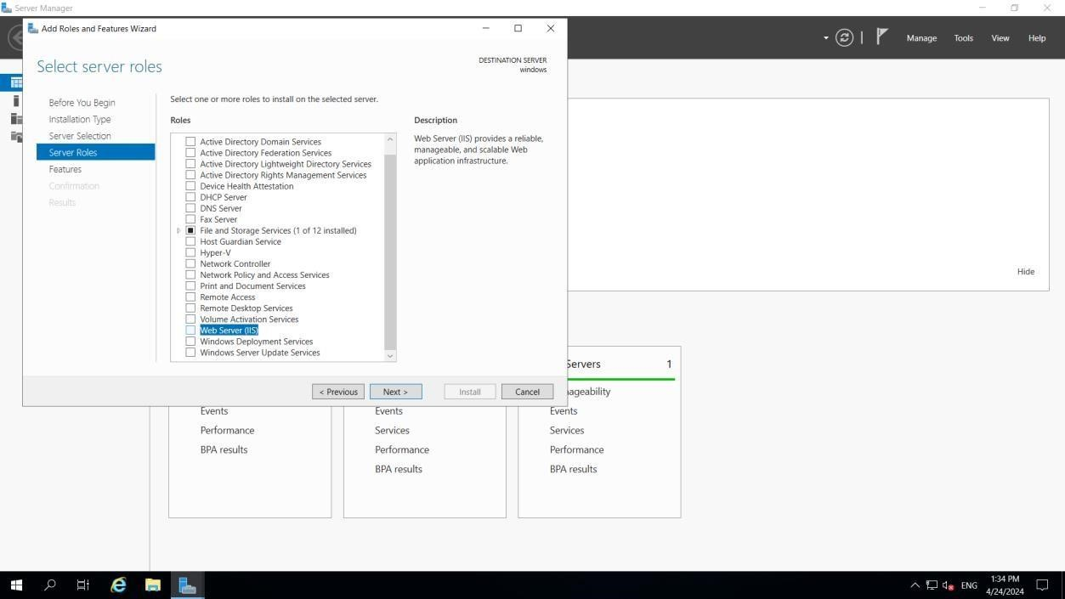

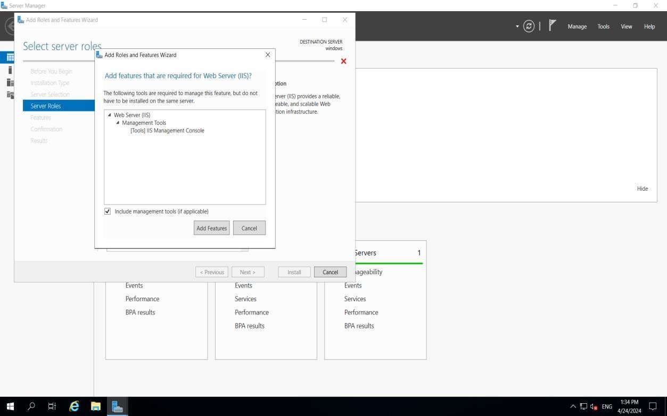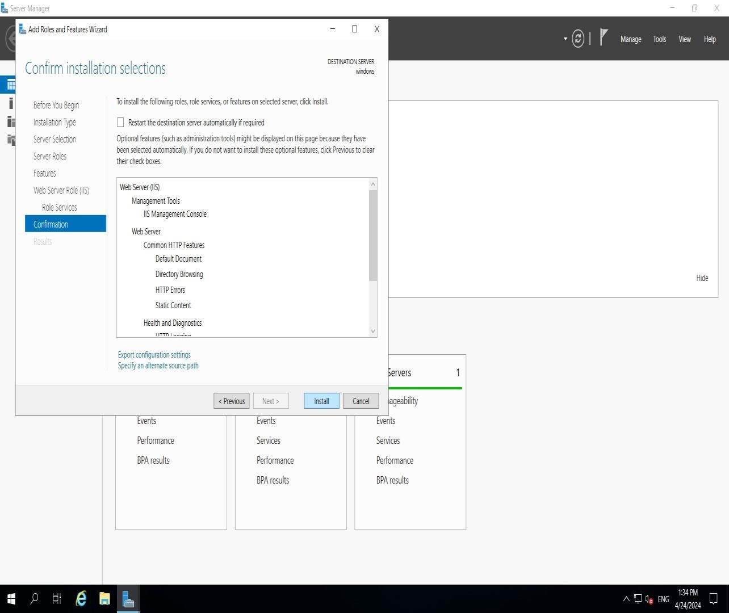

**Step-4: paste the public ip address in desktop browser and you can see.**

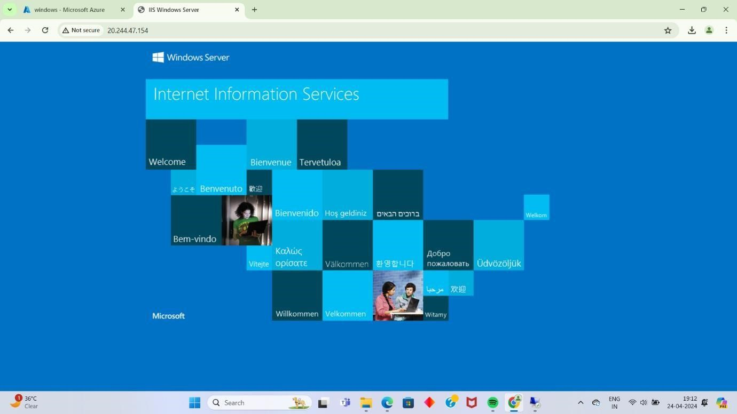

**Now to remove this all information first of all create index.html in desktop and that should paste in the specified location of remote desktop VM that is ThisPC>windows(c)- >inetup->wwwroot and remove iistart png.**

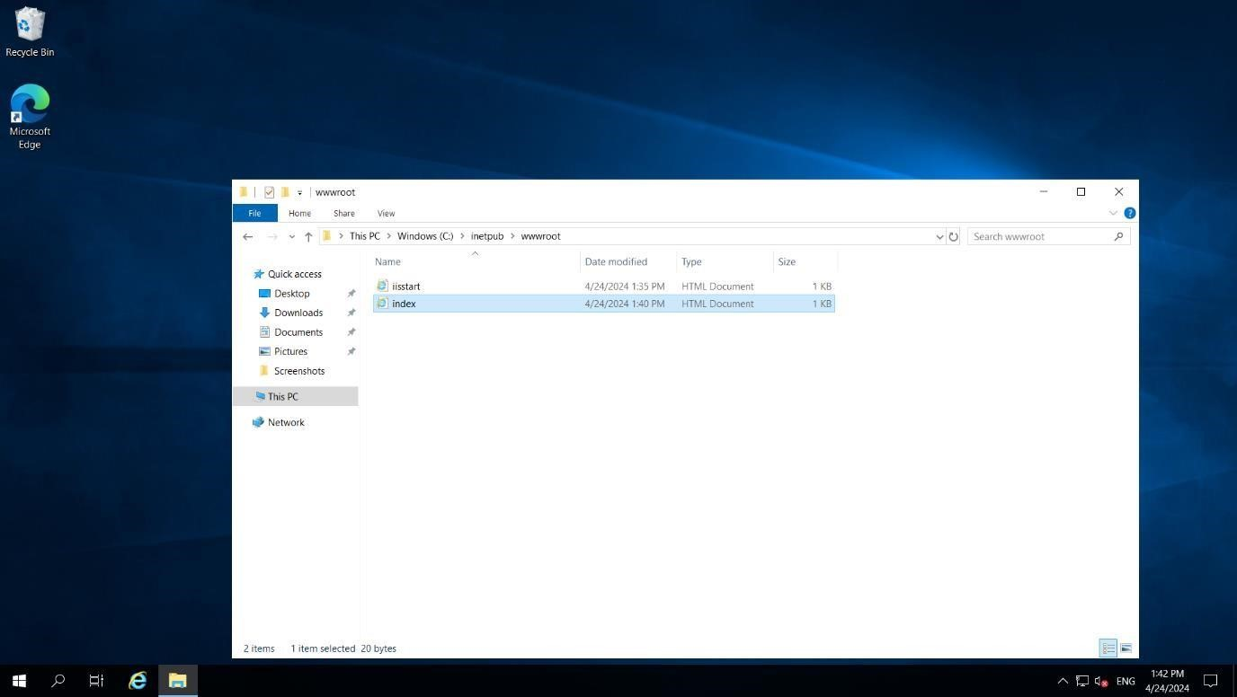

**Step-5: Refresh the browser page.**

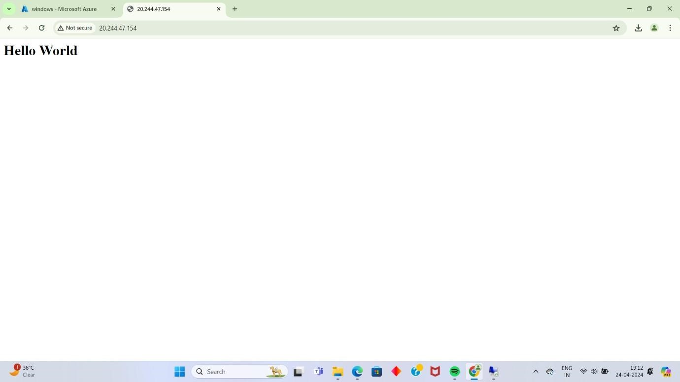

**Output: The above experiment was completed and executed successfully.**

**Q10) How we are adding new users, login credentials, changing owner, create authorized key files.**

**Step-1: Create a ubuntu virtual machine using SSH as previous experiment.**

**Step-2: Login into your Ubuntu VM using your username and type the following commands.**

**To add new user in Linux server:**  **$sudo useradd -**

**Ajay To set new password:**

**$sudo password Ajay@0311**

**Enter new password and Retype password.**  **To modify login credentials: $sudo usermod -aG sudo Ajay To switch the user:**

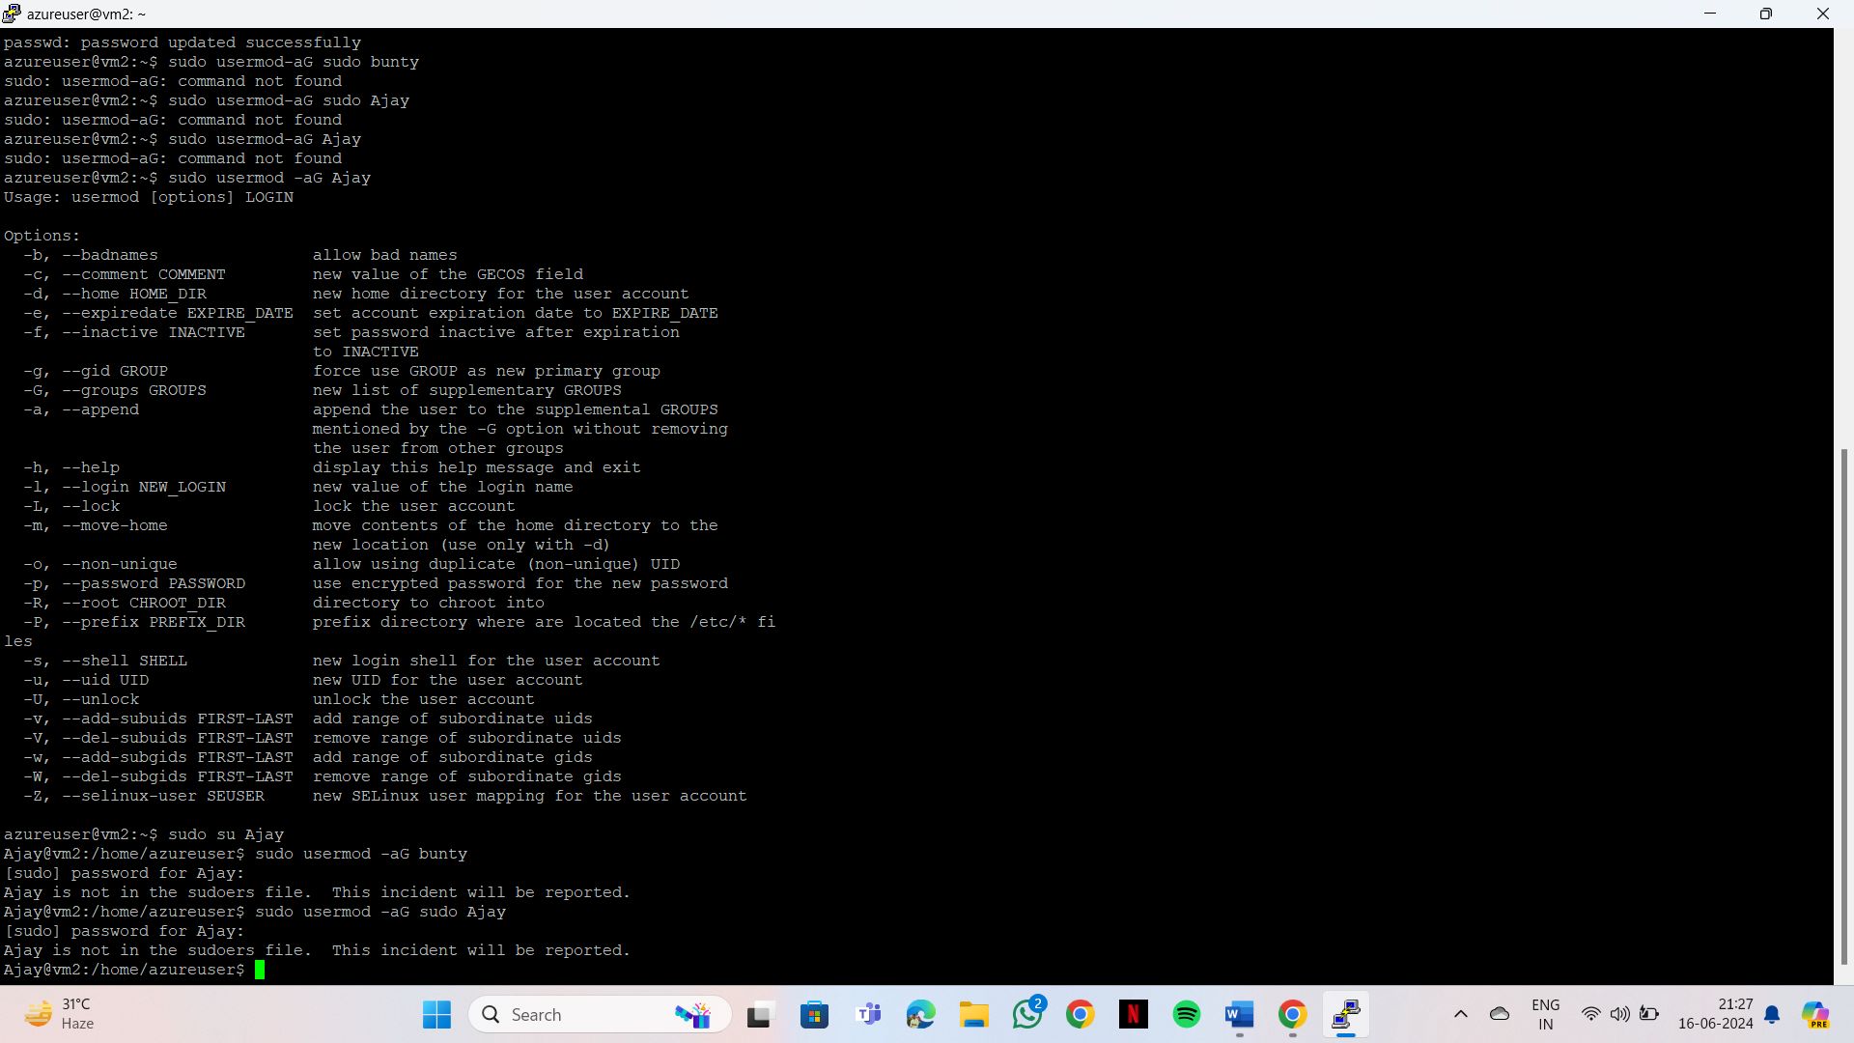**$sudo su Ajay**

**Output: The above experiment was completed and executed successfully.**

**Q11) Create a Windows VM and transfer files from desktop to remote desktopVM.**

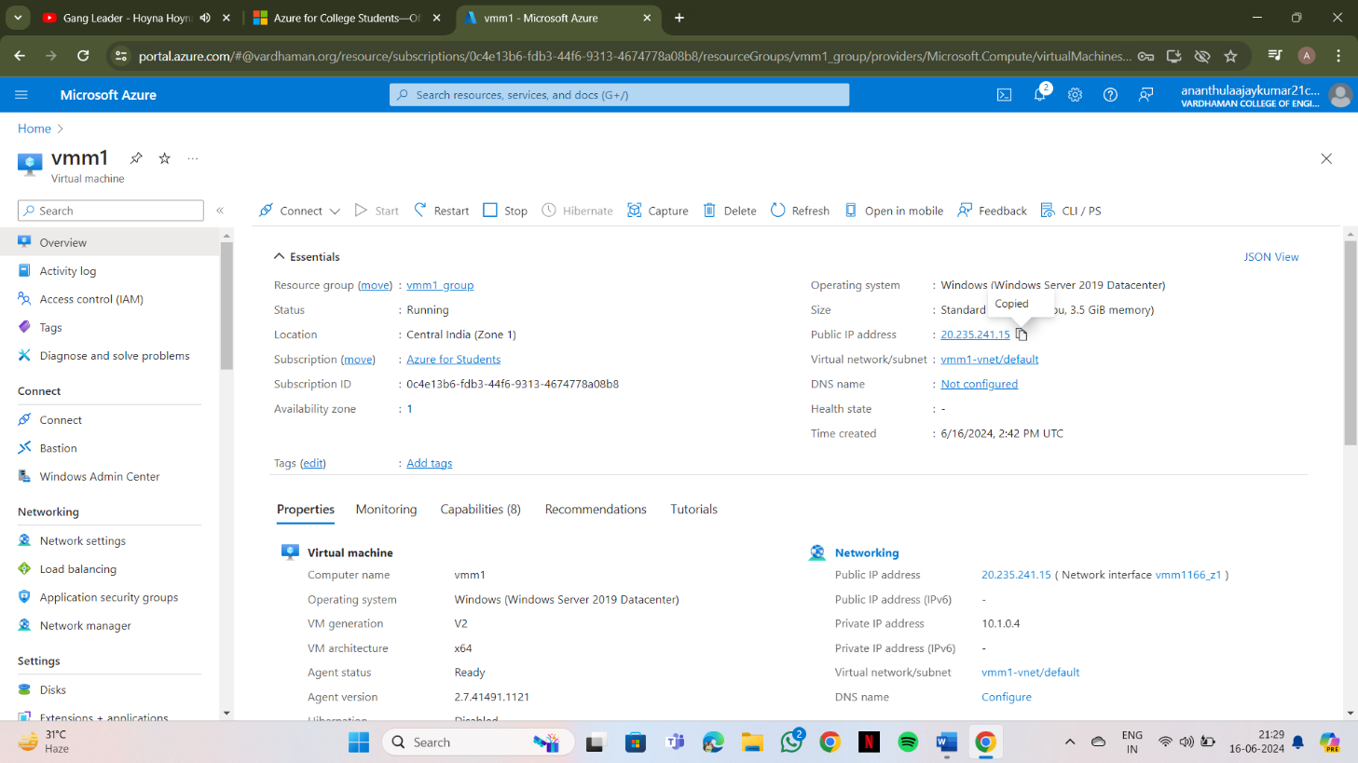**Step-1: Create Windows VM same as previous experiments and copy public IP Address.**

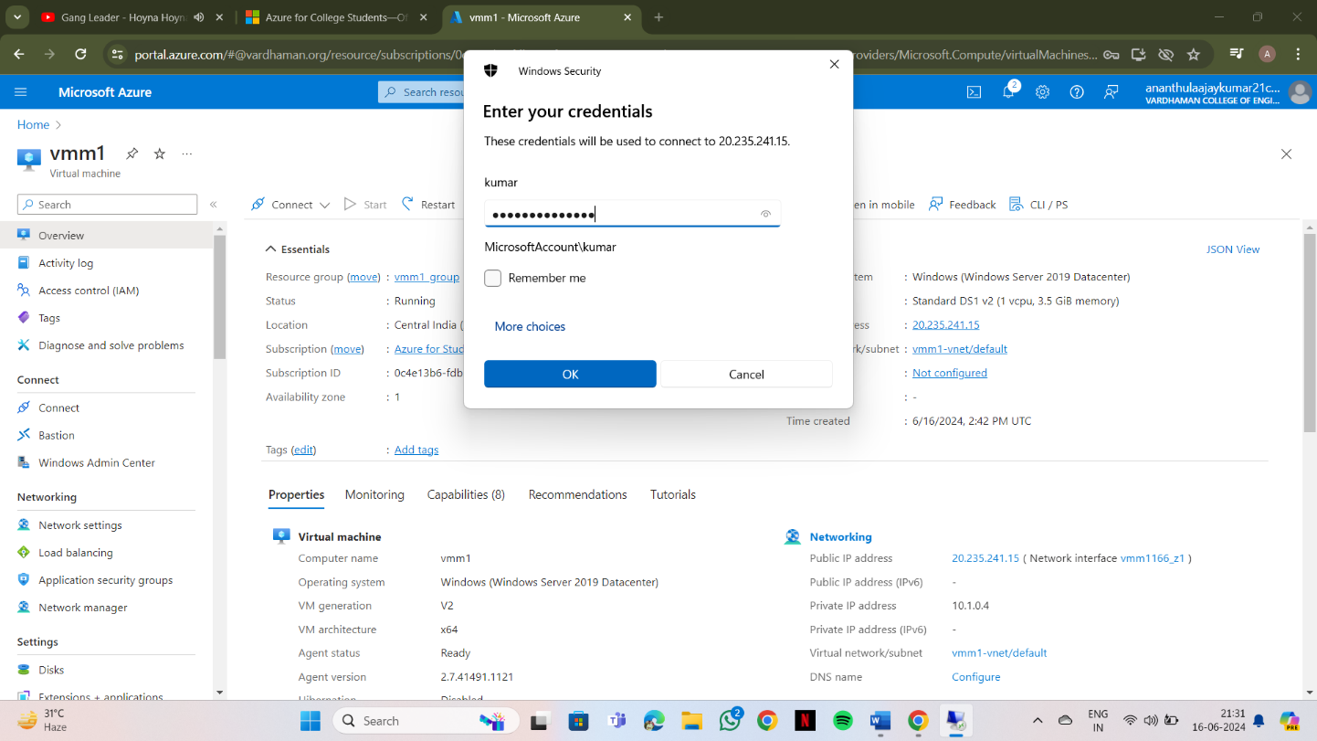**Step-2: Login into your account using username and password using remote desktop.**

**Step-3: Minimize the Remote desktop and copy file from desktop.**

**Right click in remote desktop and click on paste.**

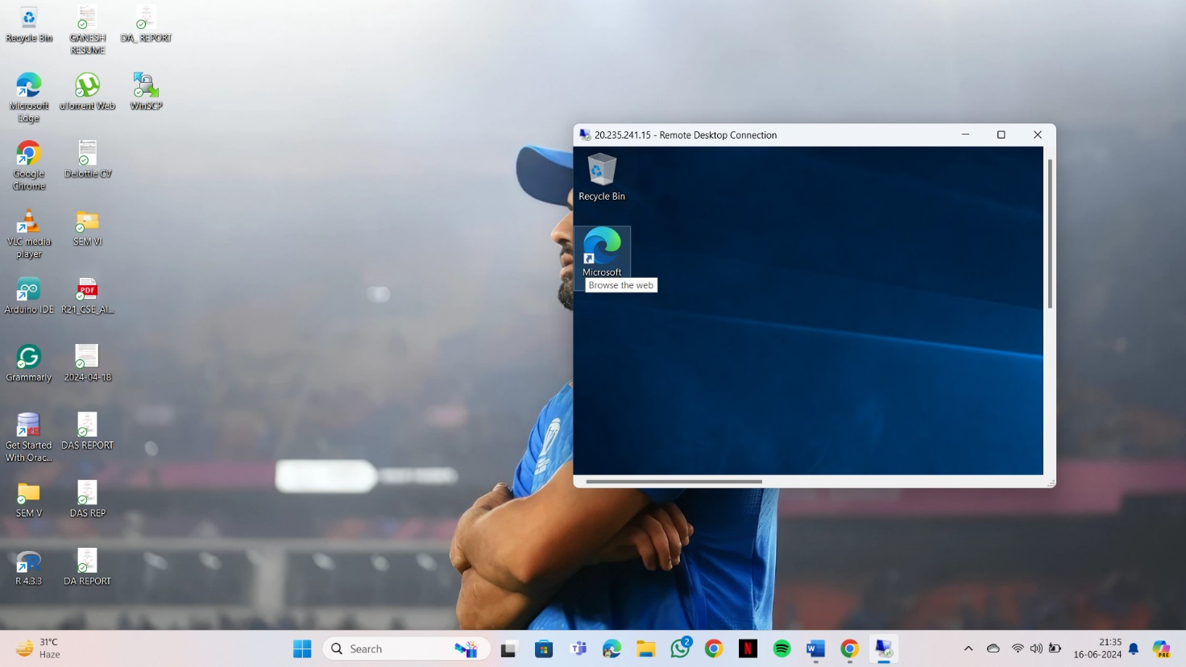

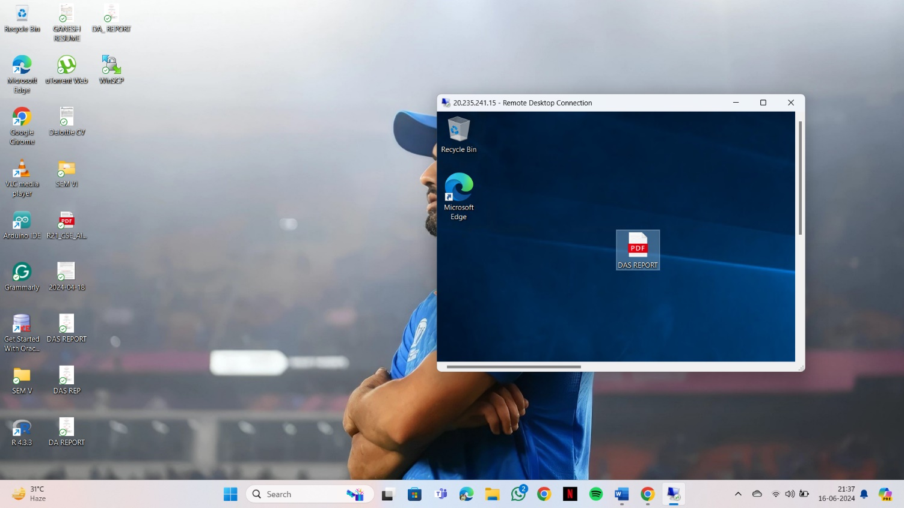

**Output: The above experiment was completed and executed successfully.**

**Q12) Move Ubuntu server files from one resource to another resource**

**Steps:-**

1. **Open Resource groups in Microsoft Azure account and click on create**
2. **Give a name and create two resource groups**

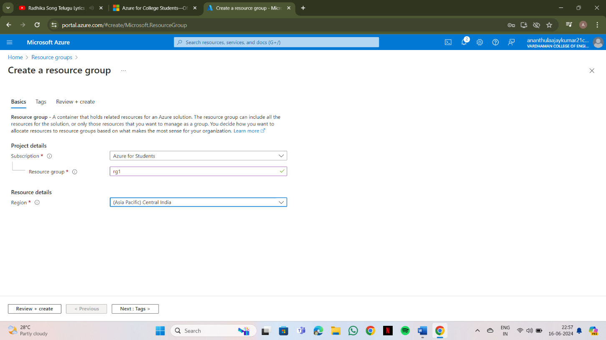

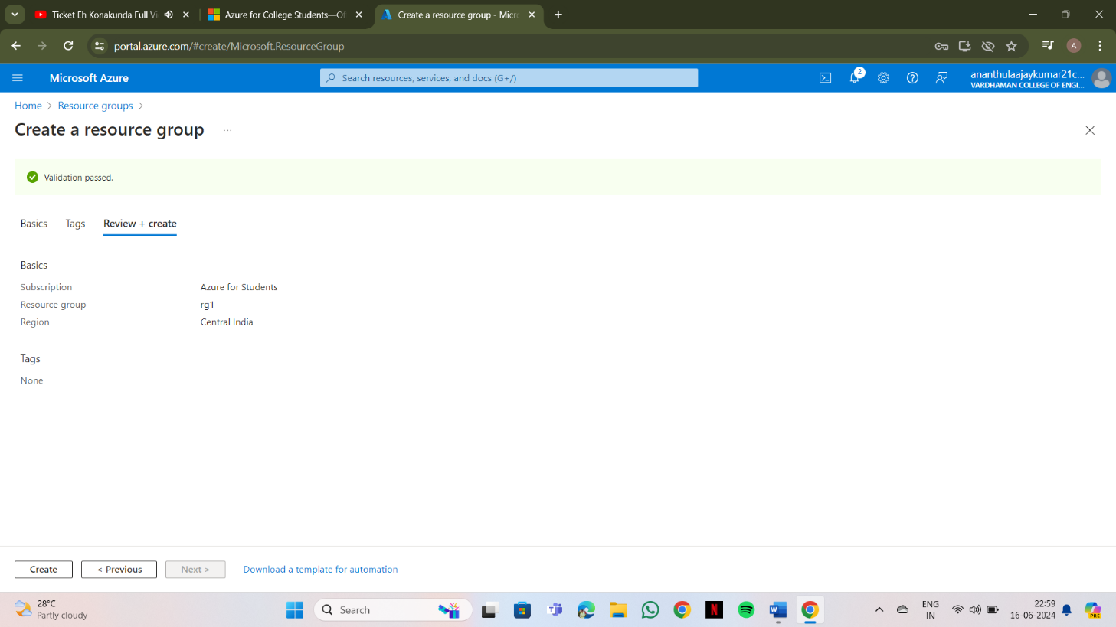

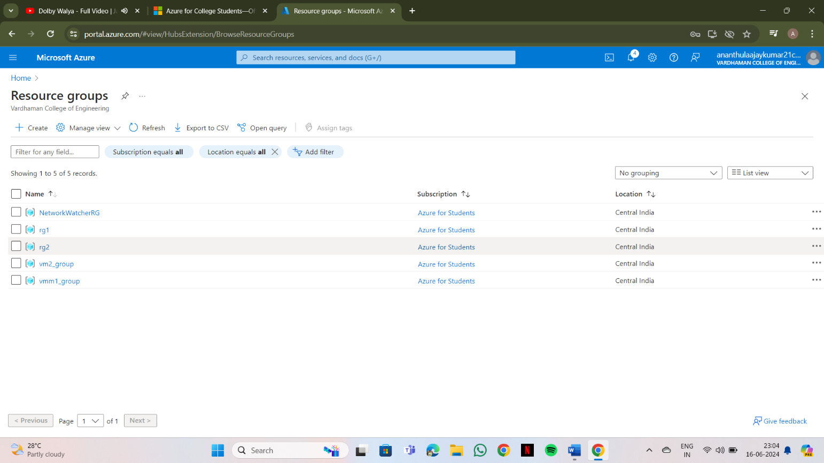

1. 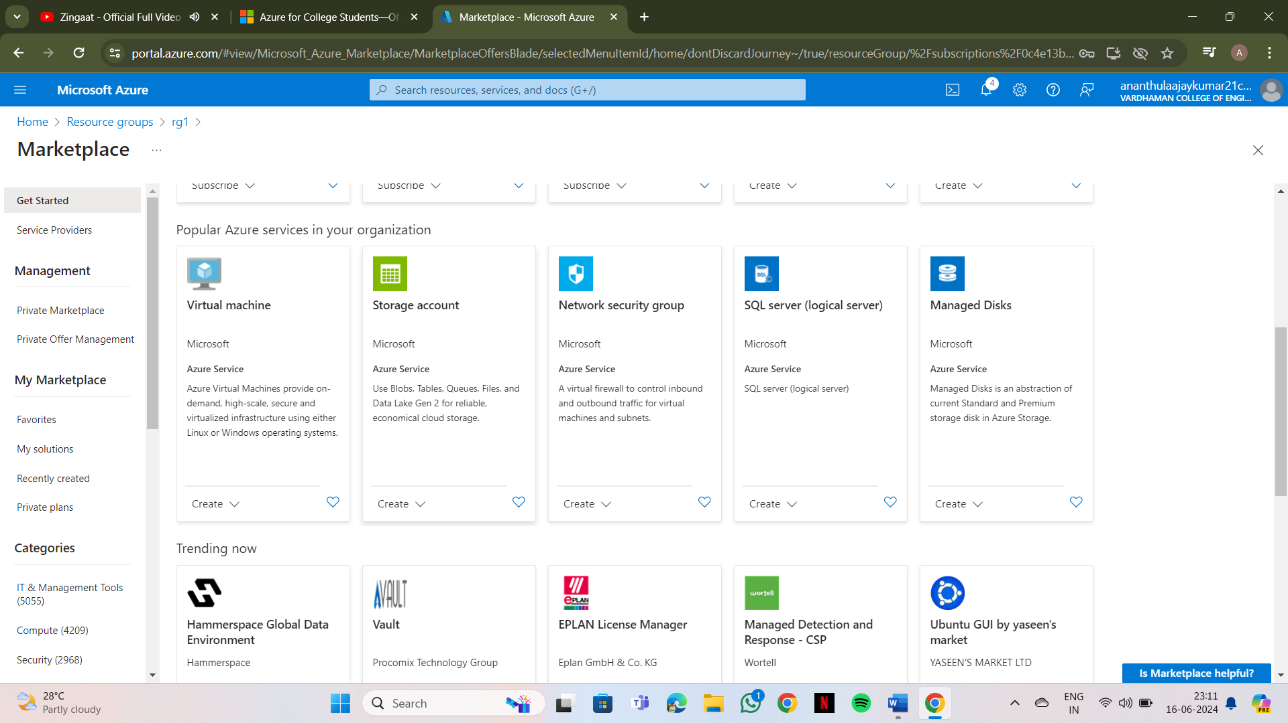**Open RG1 and click on create**

1. 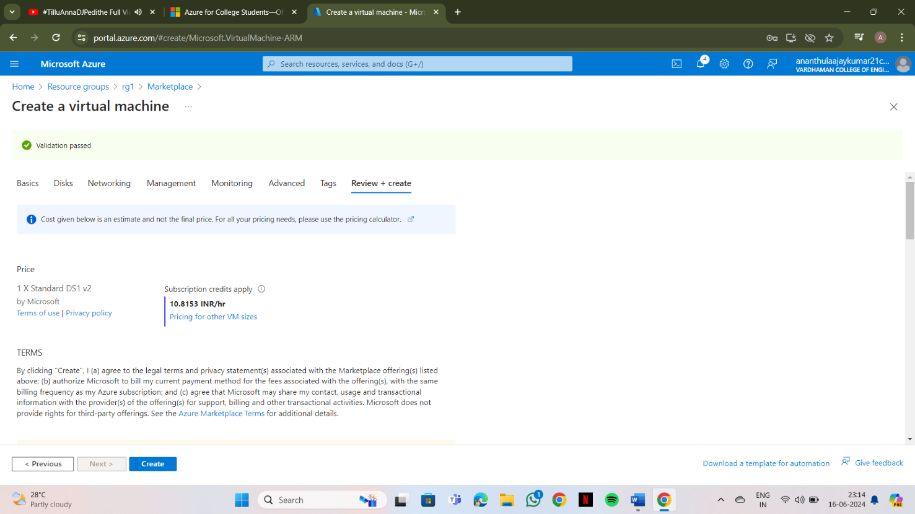**Select Virtual machine and click on create**

1. **Create a VM with username and password & click on "Review+ create"**

1. 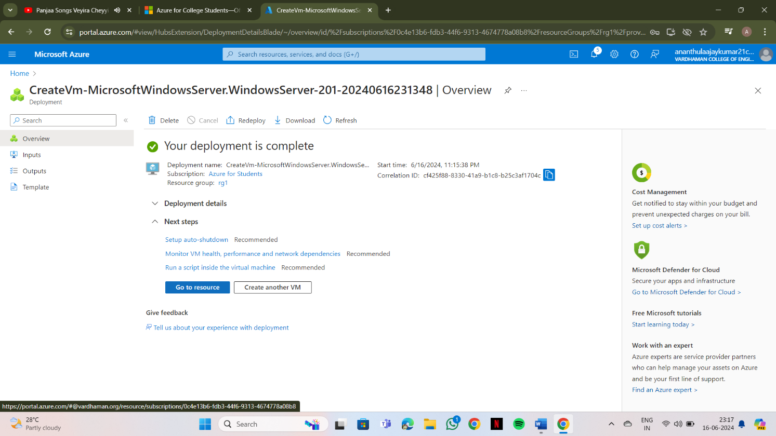**Click on create**

1. 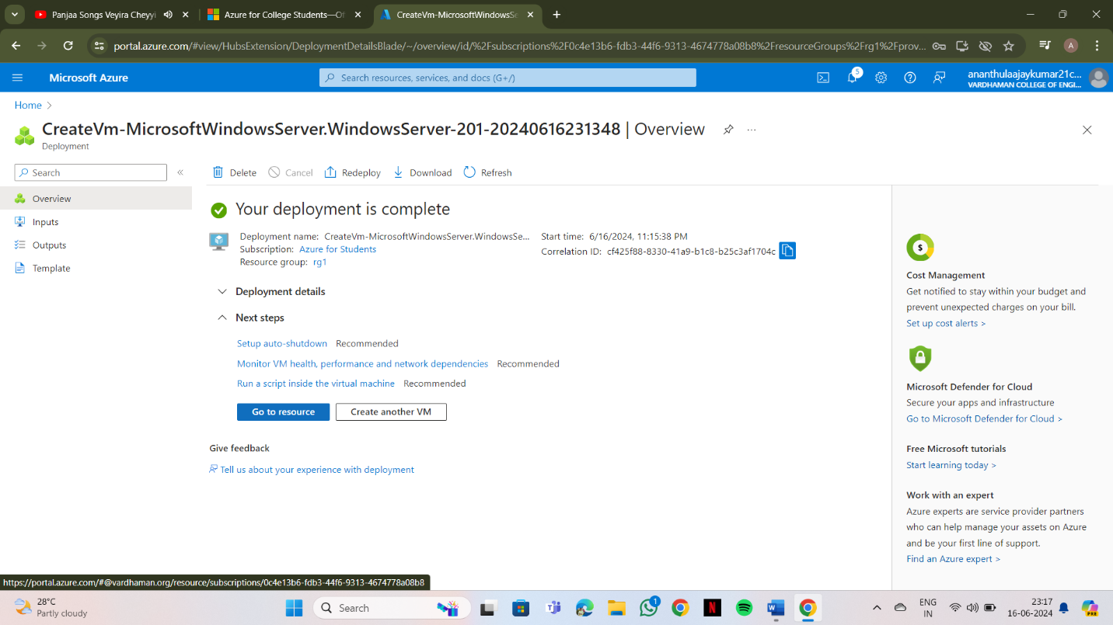**click on "Go to resource"**
2. 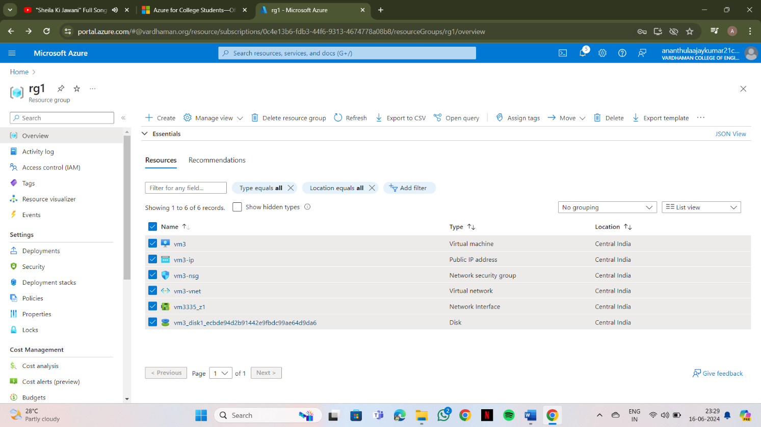**Select all resources & click on "move" on the top**
3. 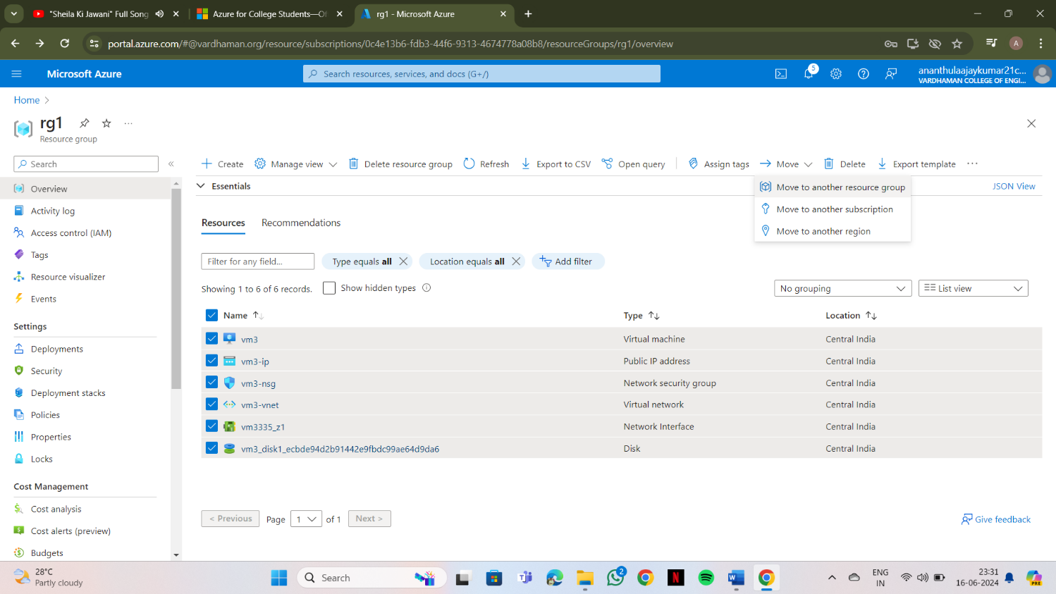**Click on move to another resource group**
4. 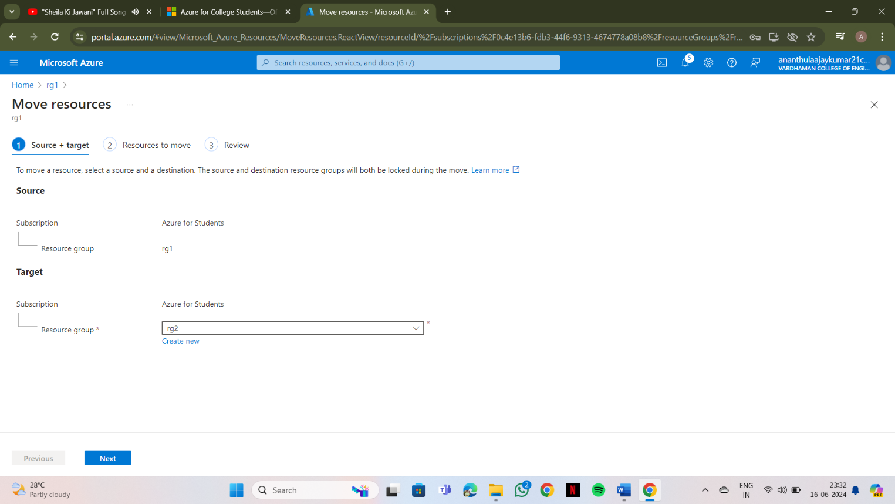**Give the target Resource group i.e., RG2 & click on next**

1. 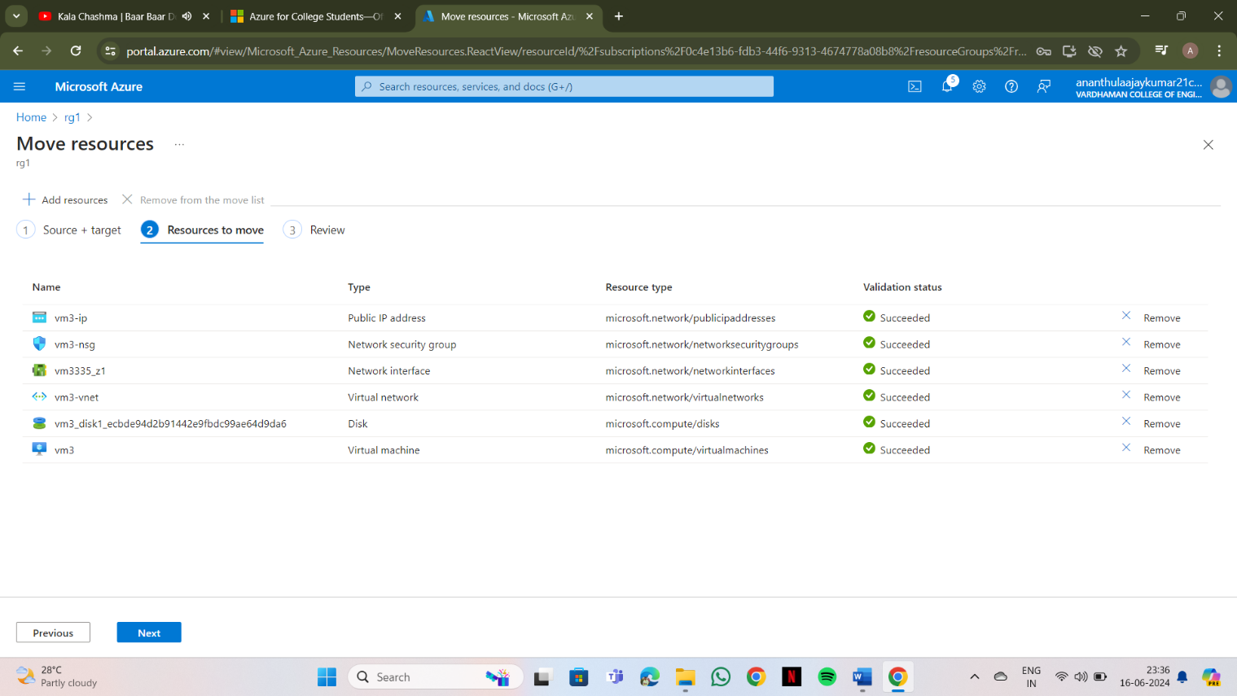**After all validation status "Succeeded" click on next**

1. 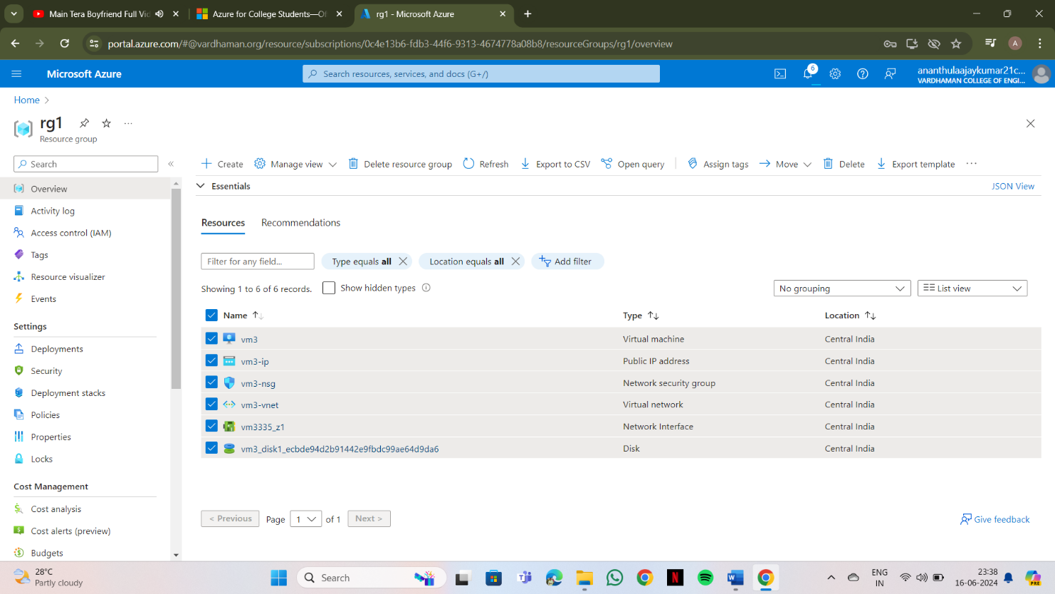**Click on "move" then all the resources from the RG1 moves to RG2**

1. 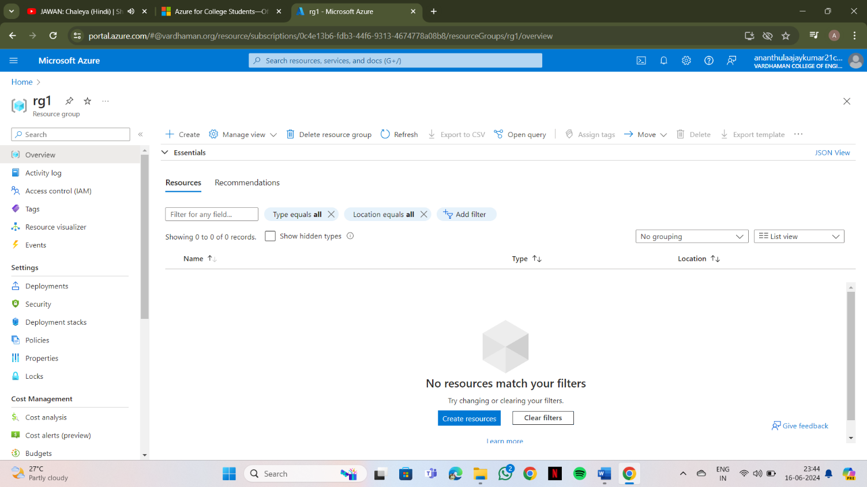**To check if the resources are moved to RG2, open RG2, All the resources can be seen**

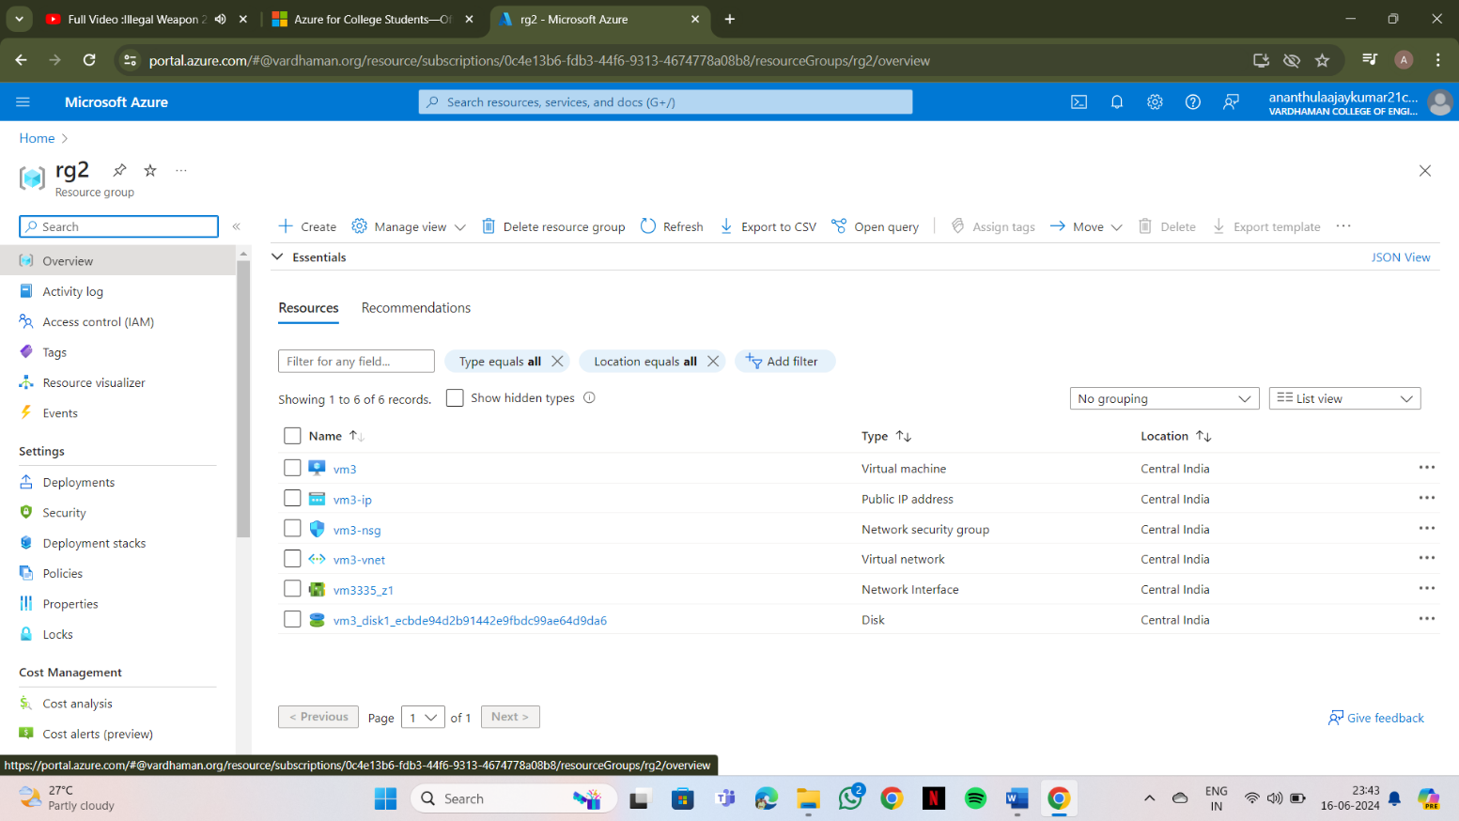

**Output: The above experiment was completed and executed successfully.**

**Q13) How to create Storage Account, container and upload/delete objects?**

**Steps:-**

1. 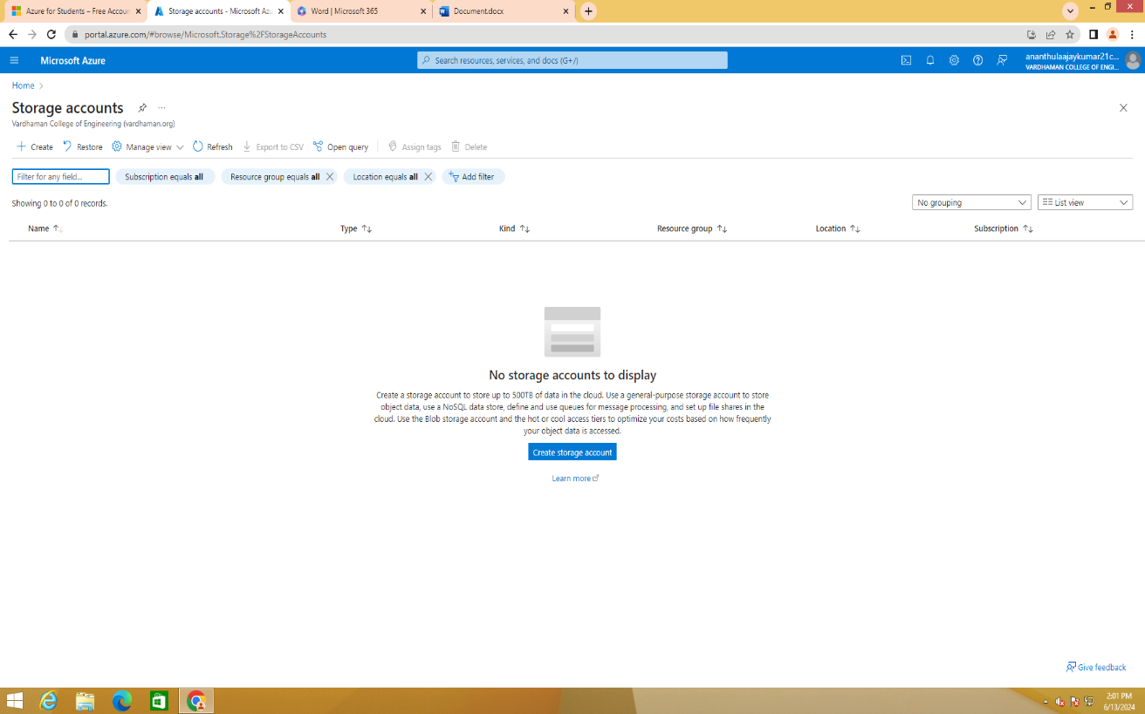**Open Microsoft Azure portal and click on storage accounts**

1. 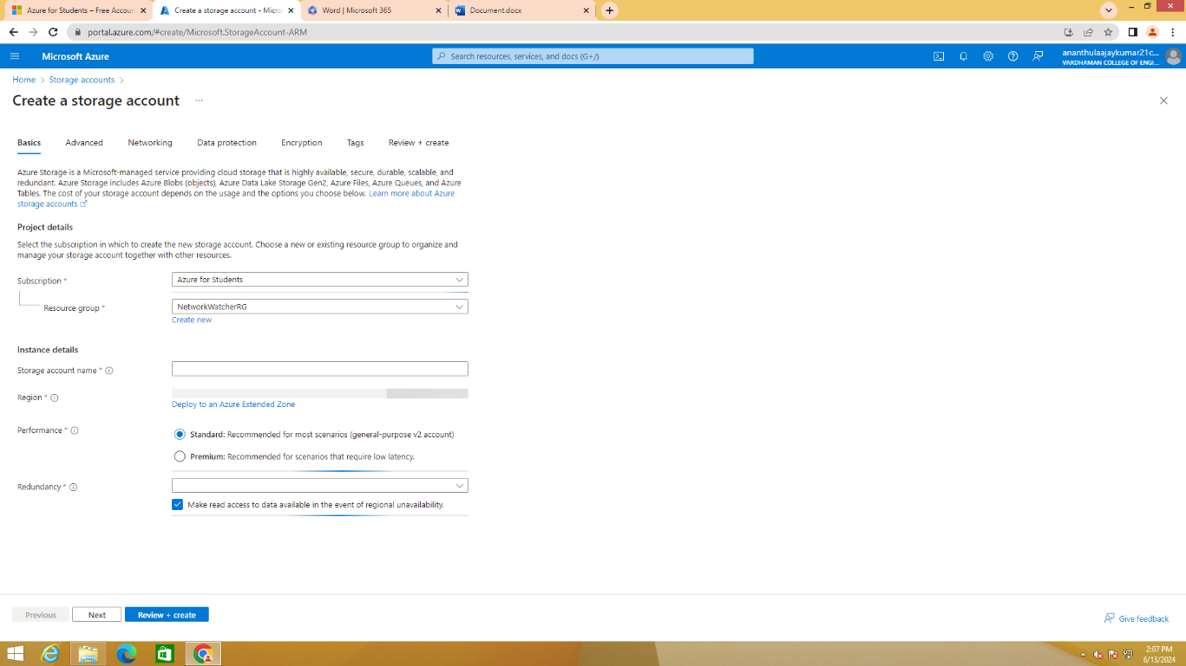**Click on create, select LRS/GRS in redundancy**

1. 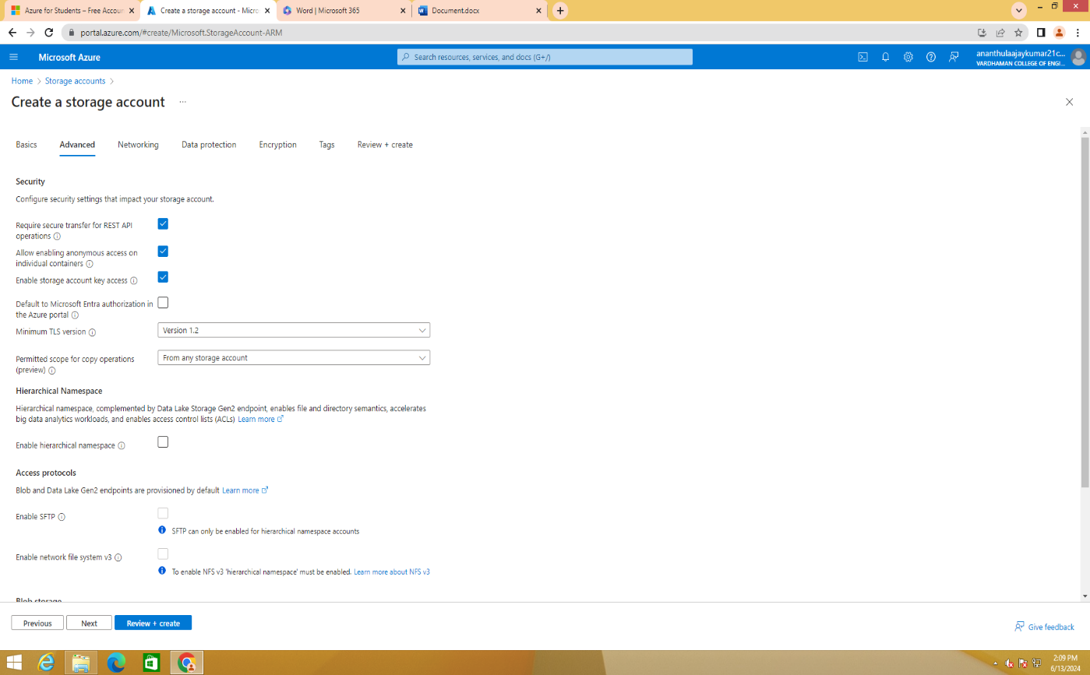**Click on next, Tick "Allow enabling anonymous access on individual containers**

1. **Click on Review+create and click on create**

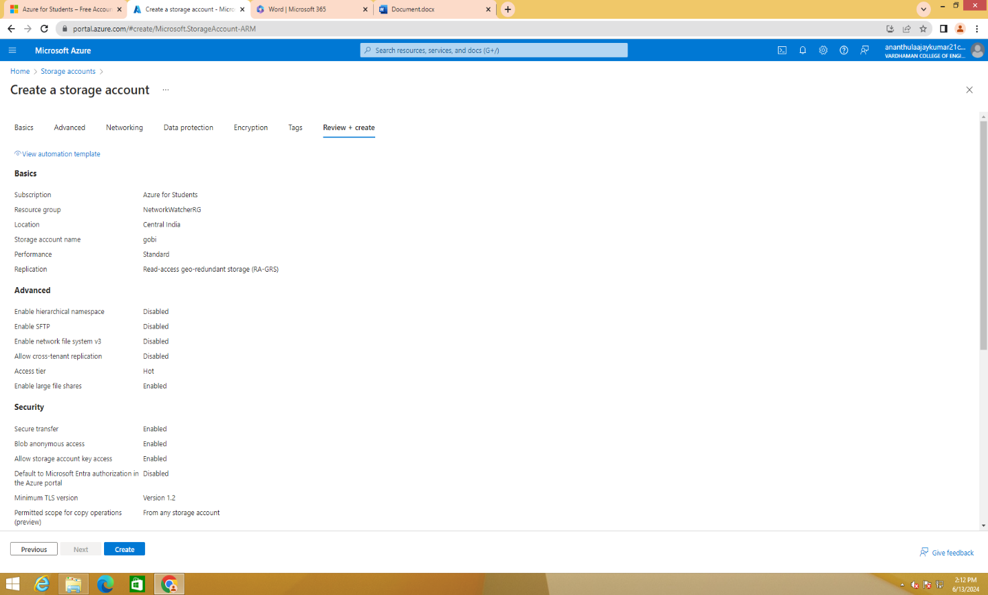

1. **Open Storage Account which you have created**

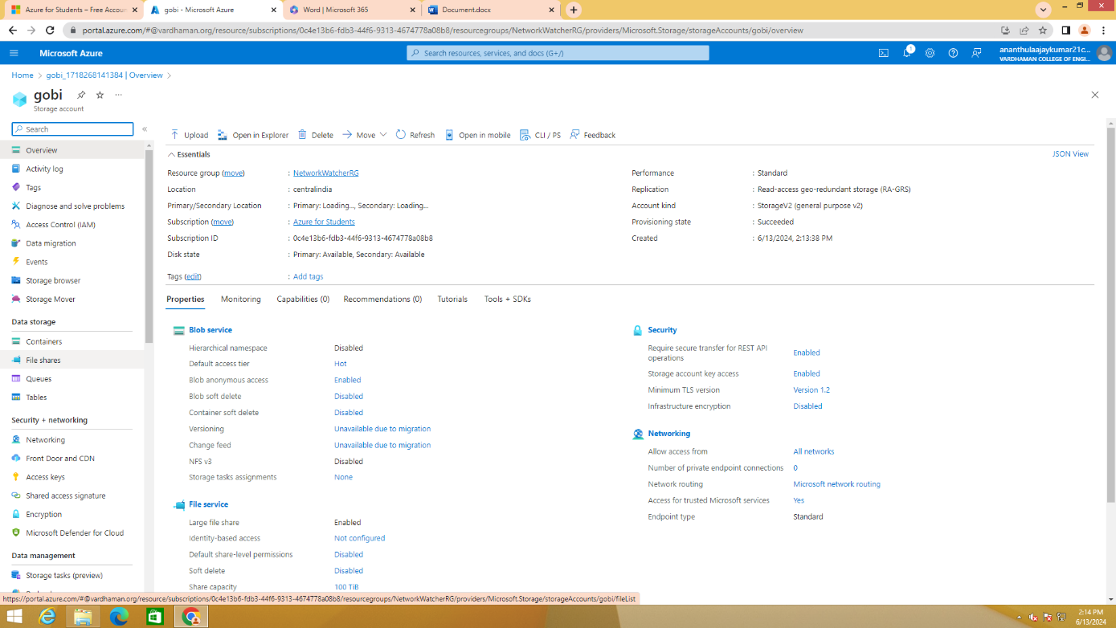

1. **Click containers under Data Storage on the left side and click on "+ Container**

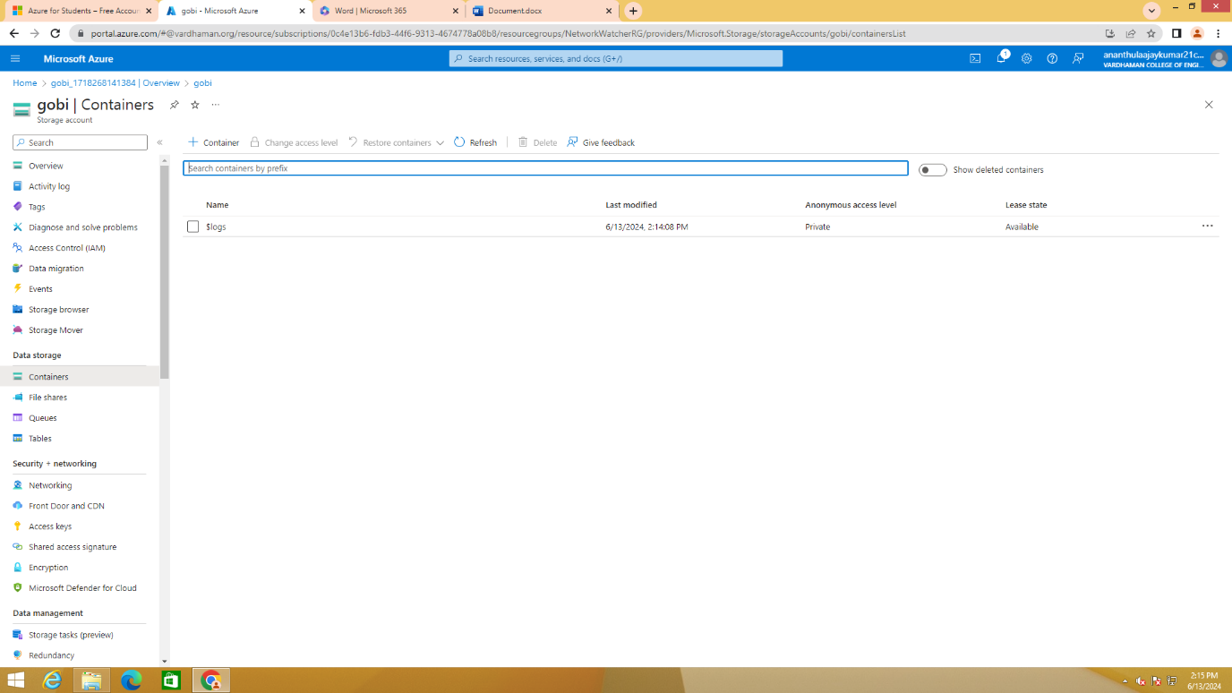

1. **Give a name & select "blob" in Anonymous access level and click on create**

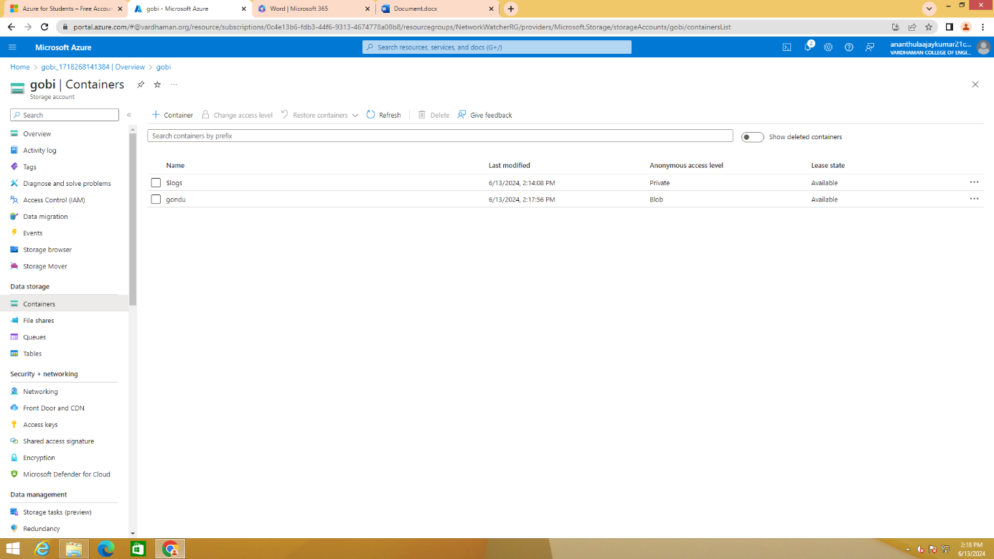

1. **Click on upload**

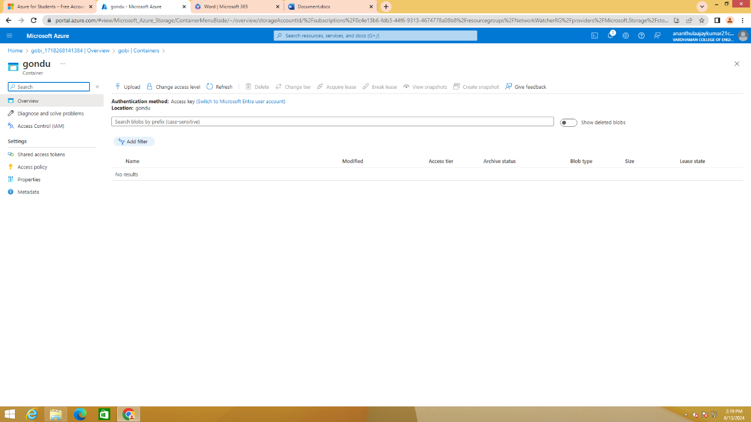

1. **Click on "Browse for files"**

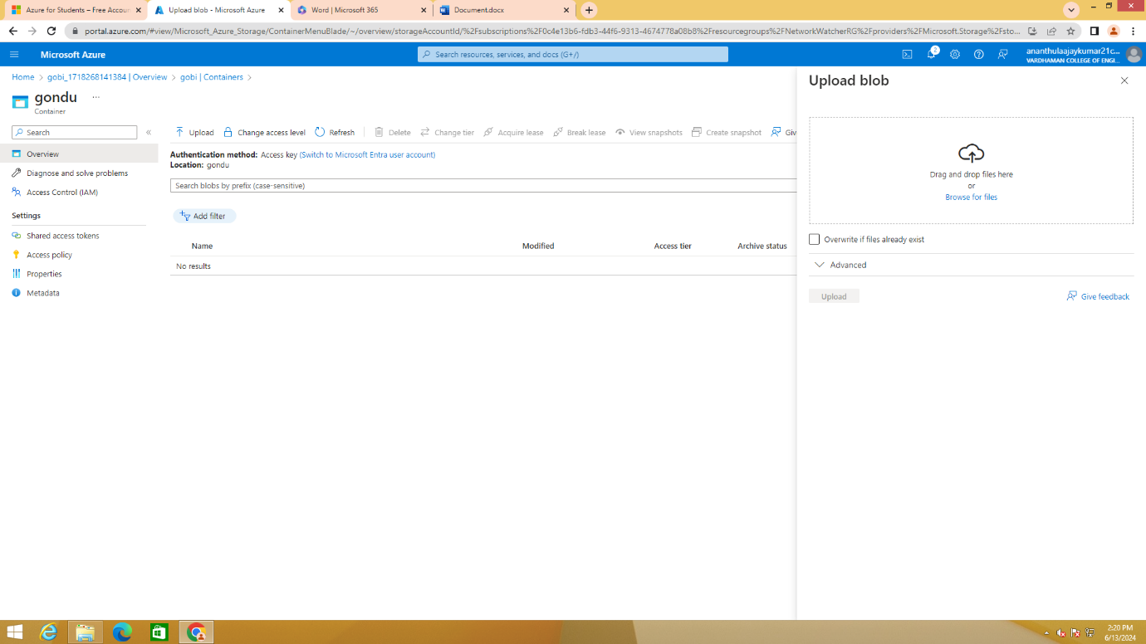

1. **Upload any file/image/audio/video/pdf**

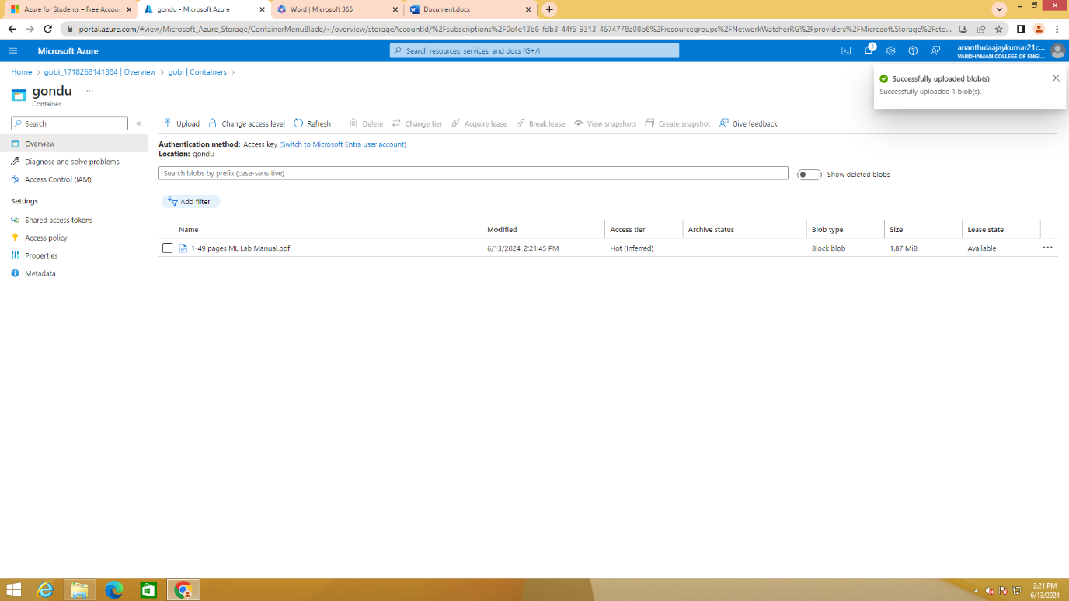

1. **Click on the file which you have uplaoded**

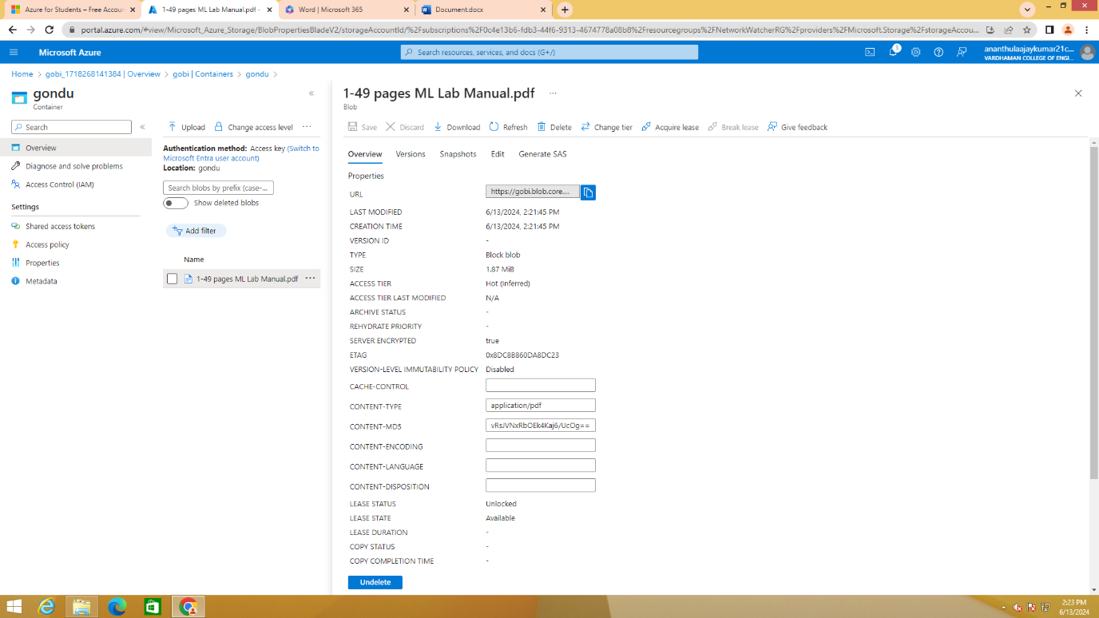

1. **Copy the URL**

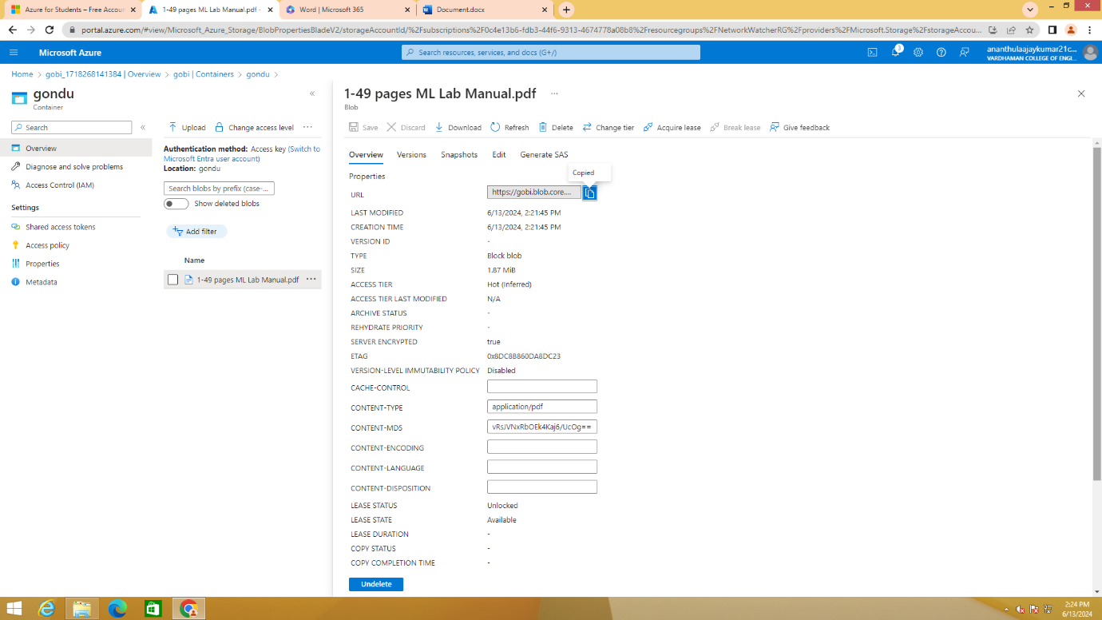

1. **Paste the URL in any browser**

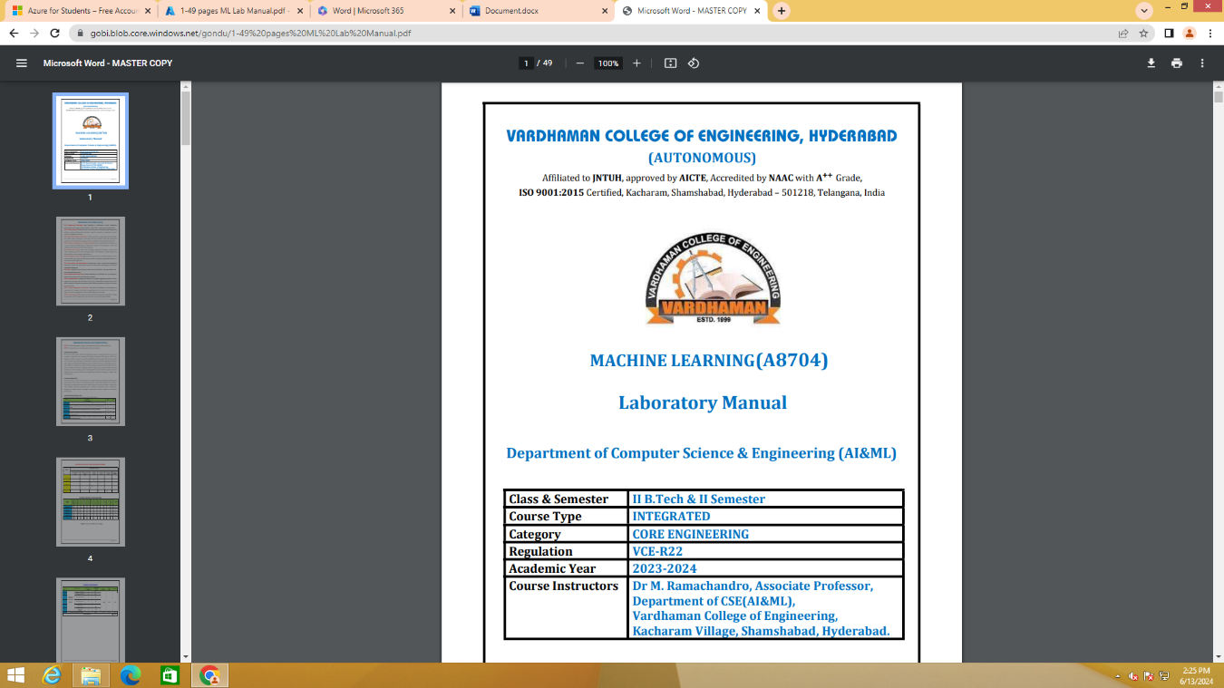

1. **To change the access level, click on Change access level**

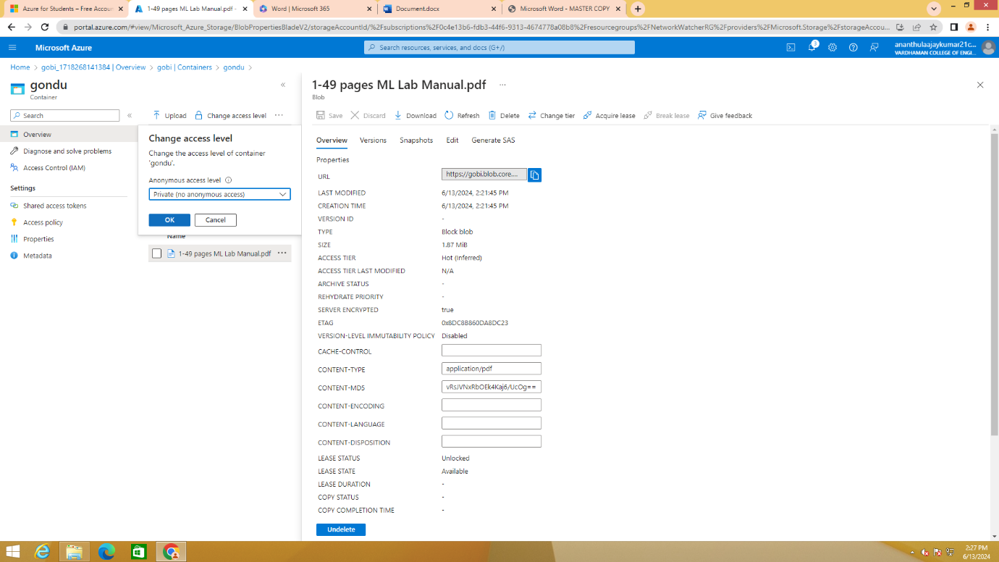

1. 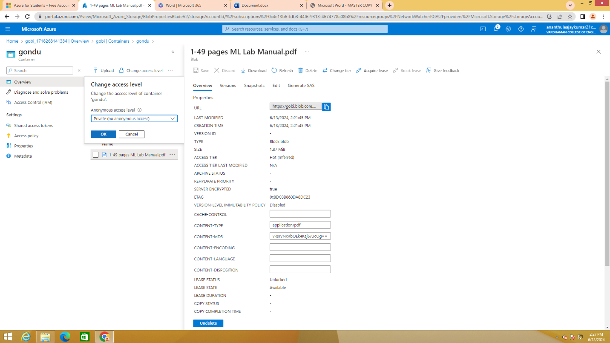**Select any Anonymous access level and click on OK**

1. 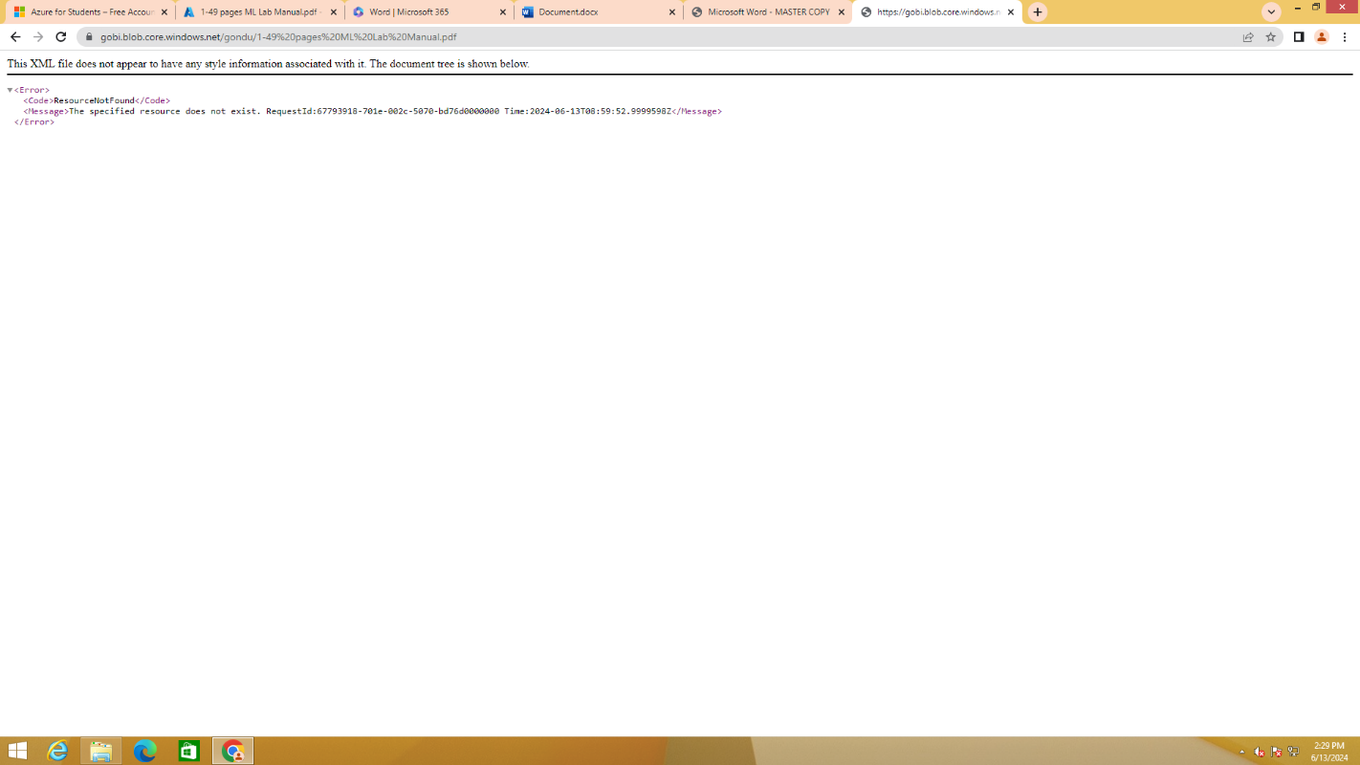**Again copy the URL of the file which you have uploaded previuosly and paste it any browser**

1. 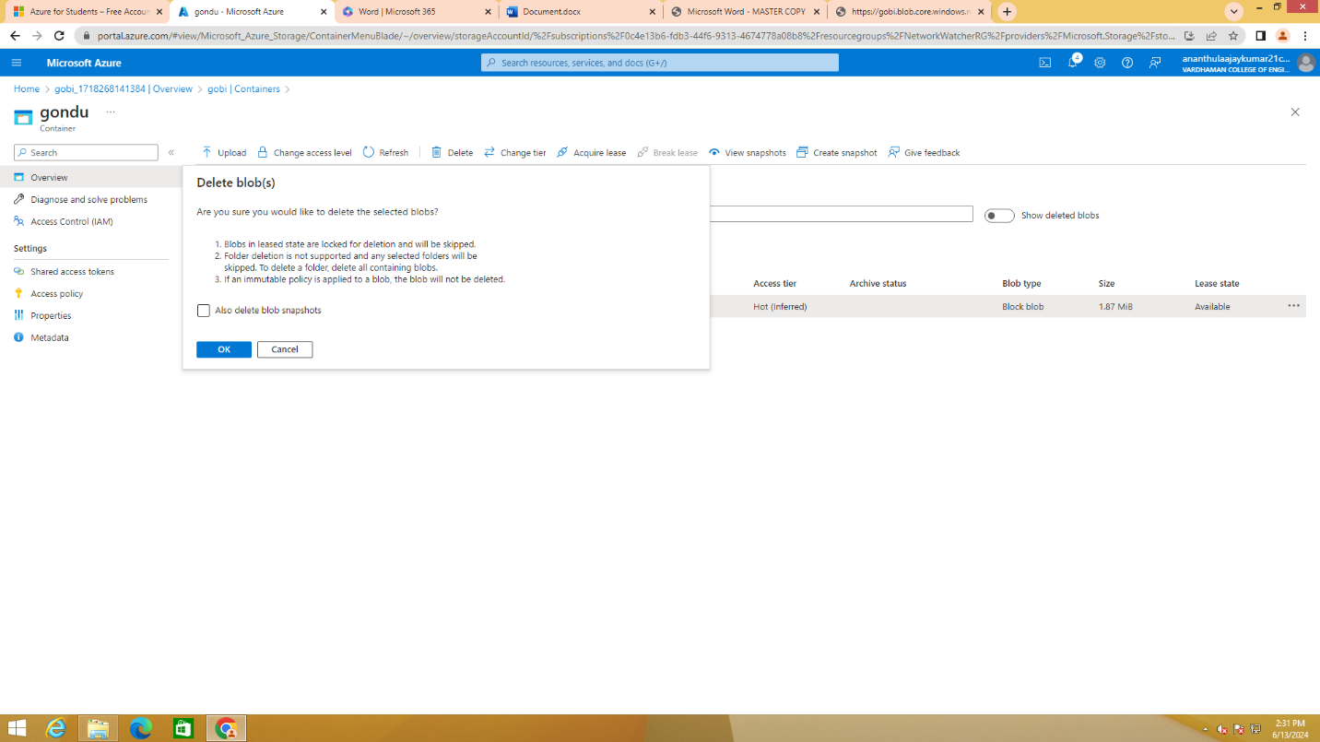**To delete a blob, select the blob and click on delete**
2. **To view the deleted blobs, click on "show deleted blobs"**
3. 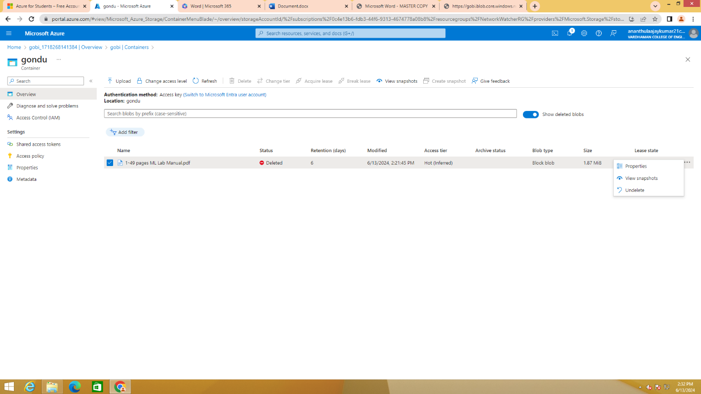**To undo deleted blob: select the blob, click on more and click on undelete**

**Output: The above experiment was completed and executed successfully.**

**Q14) How to add data disks to linux server in azure data center**

**Steps:-**

1. **Create a Virtual name with VM name as "UbuntU" with username &password**

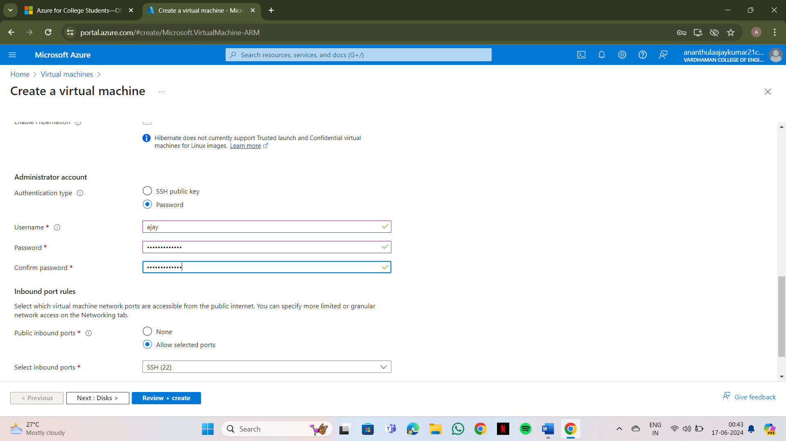

1. **click on "Next:Disks>"**
2. **Select**

**OS disk size -------30GB**

**OS disk type ------Premium SSD(LRS)**

**enable "Delete with VM"**

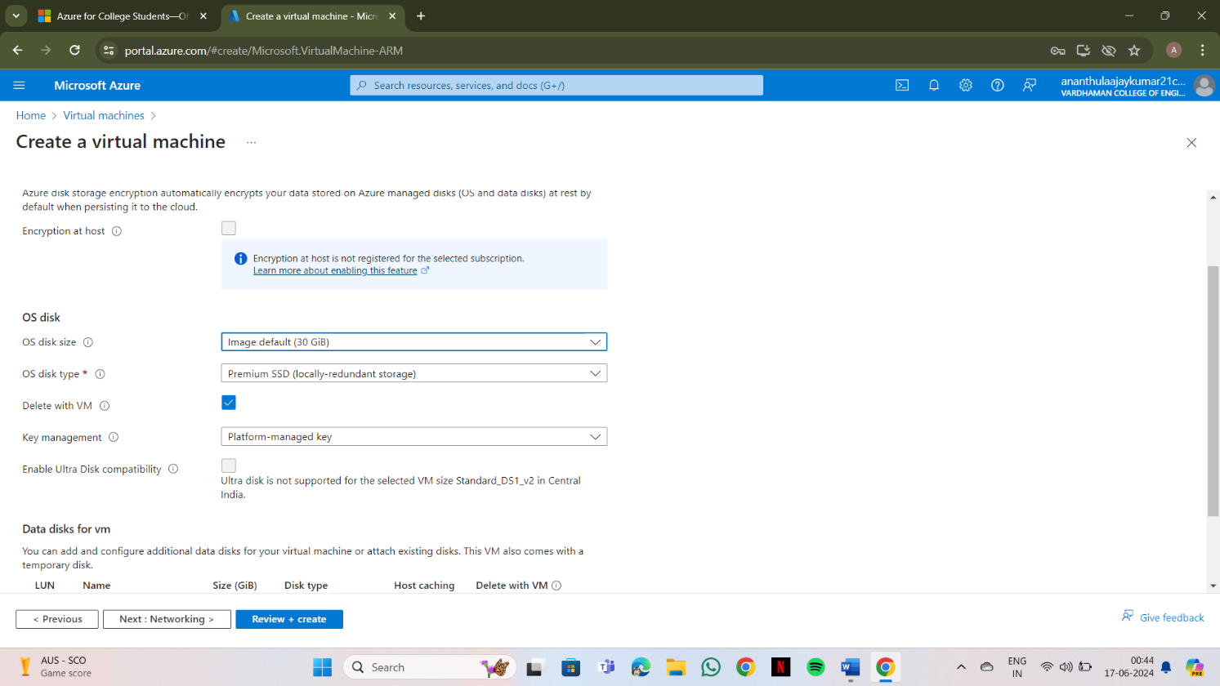

1. **Click on "Create & attach a new disk"**
2. **Select**

**Source type -------None(empty disk), Size -------1024GB, Key manager ------- Platform managed key, Enable shared disk -------NO and finally click on OK**

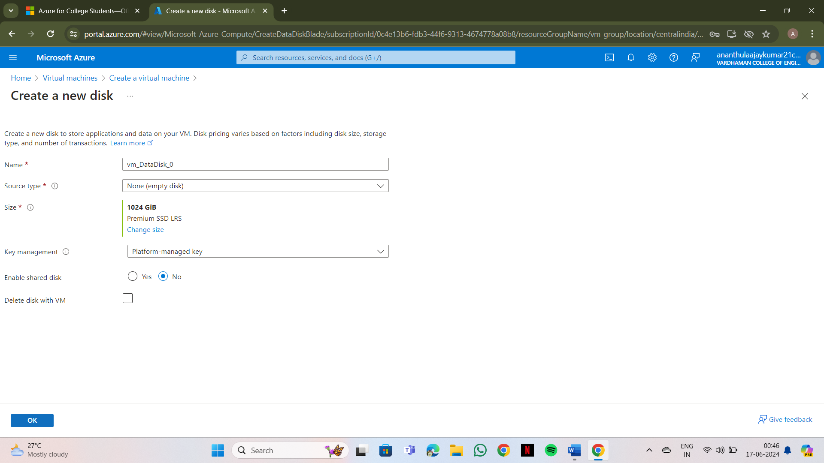

1. **Select**

**Storage type -------Premium SSD(LRS), Custom disk size (GB) ------5**

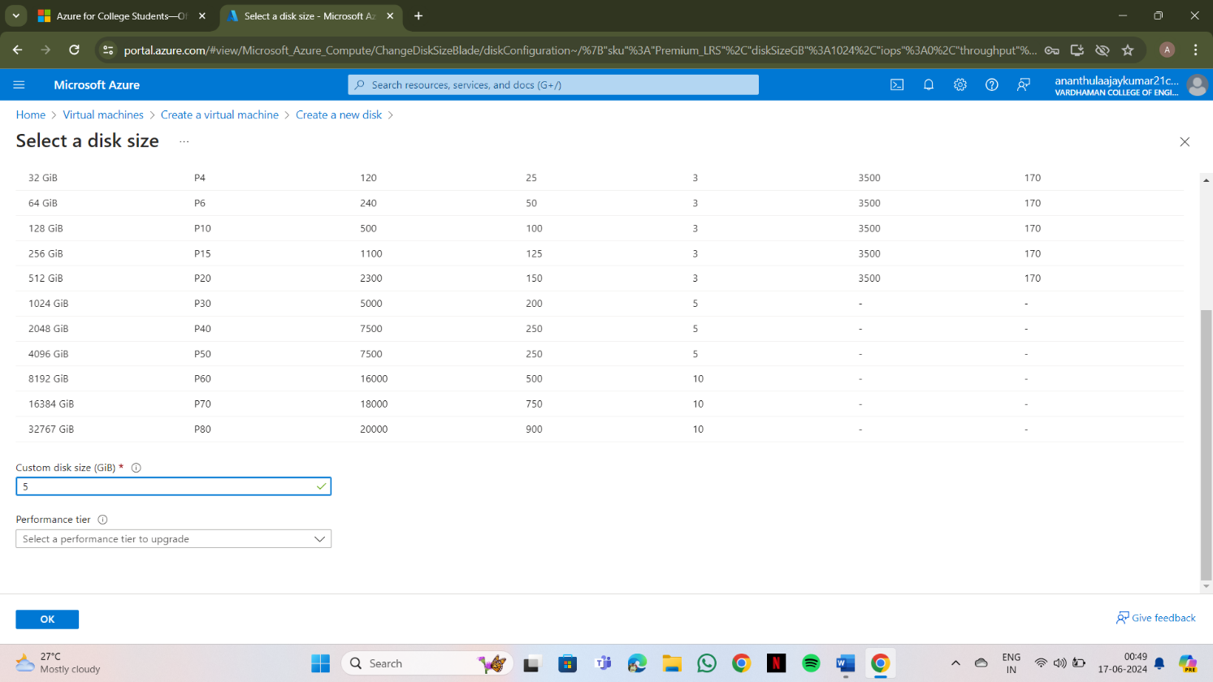 **click on OK**

1. **Click on "Review+create" & click on create**
2. **Click on "Go to resource group"**

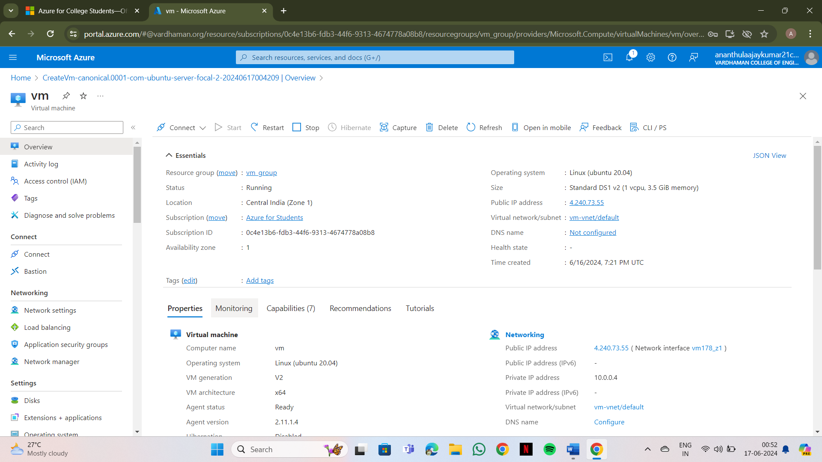

1. **Copy public IP Address**

**10)Open "PUTTY" & paste the IP adress and click on "open"**

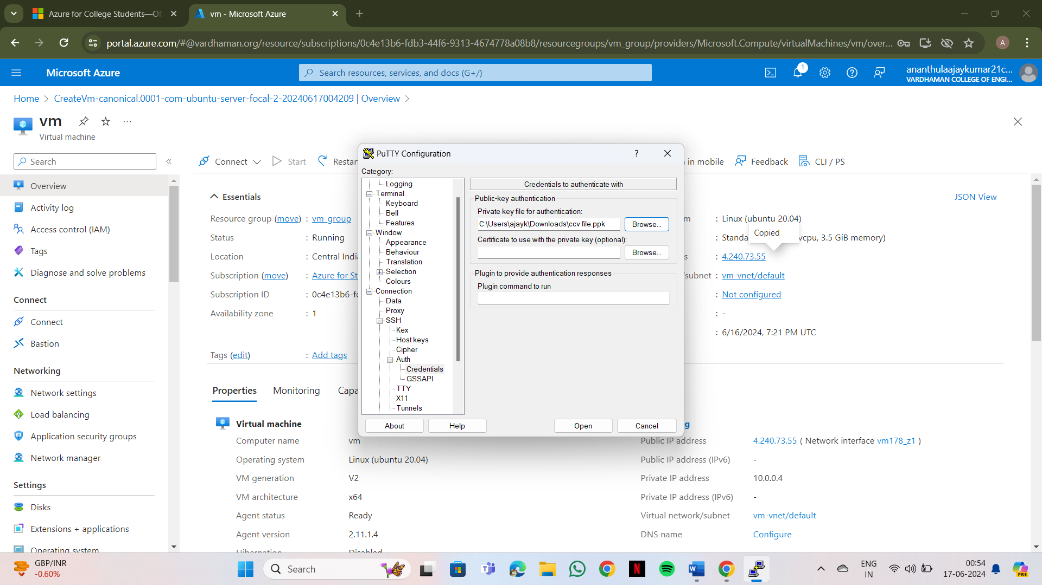

1. **Login into it with username and password**

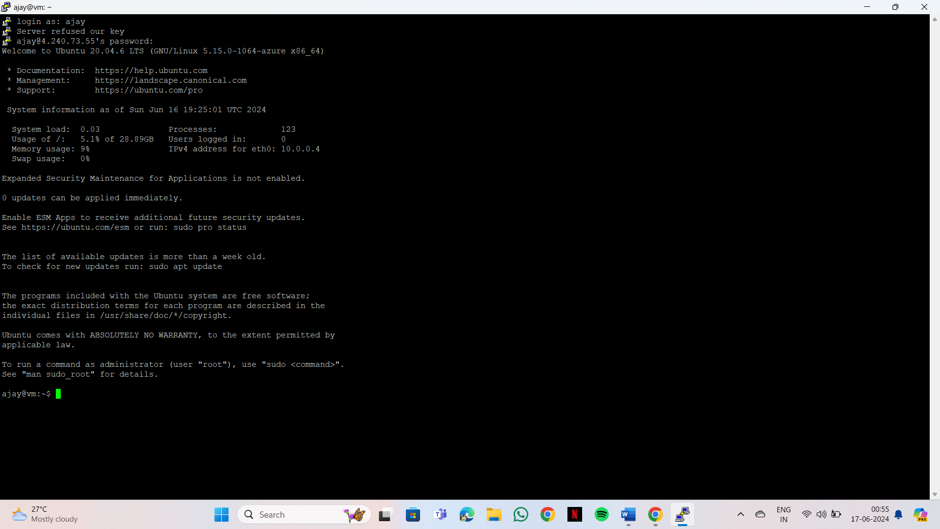

1. **Type the below commands**

**$ df -hT**

**$ lsblk**

**$ sudo filoe -s/dev/sdc**

**$ sudo mkfs -t ext4 /dev/sdc**

**$ mkdir test**

**$ sudo mount /dev/sdc/ test**

**$ cd test**

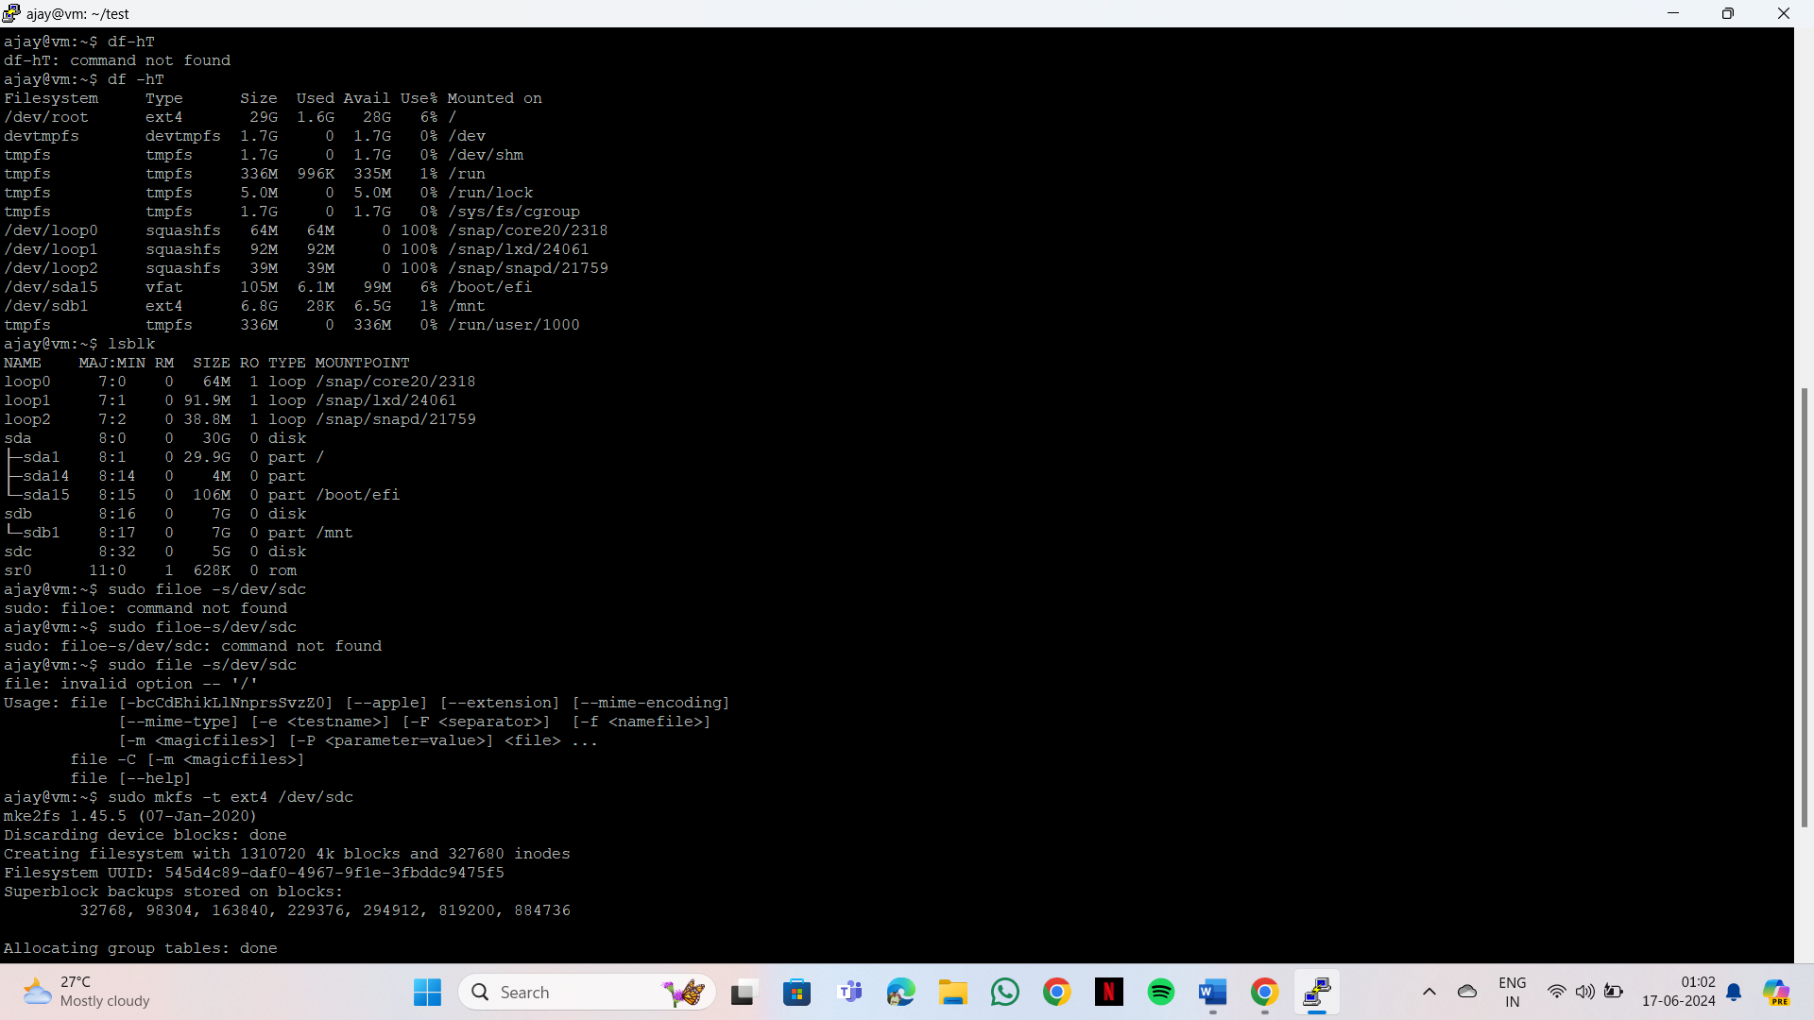

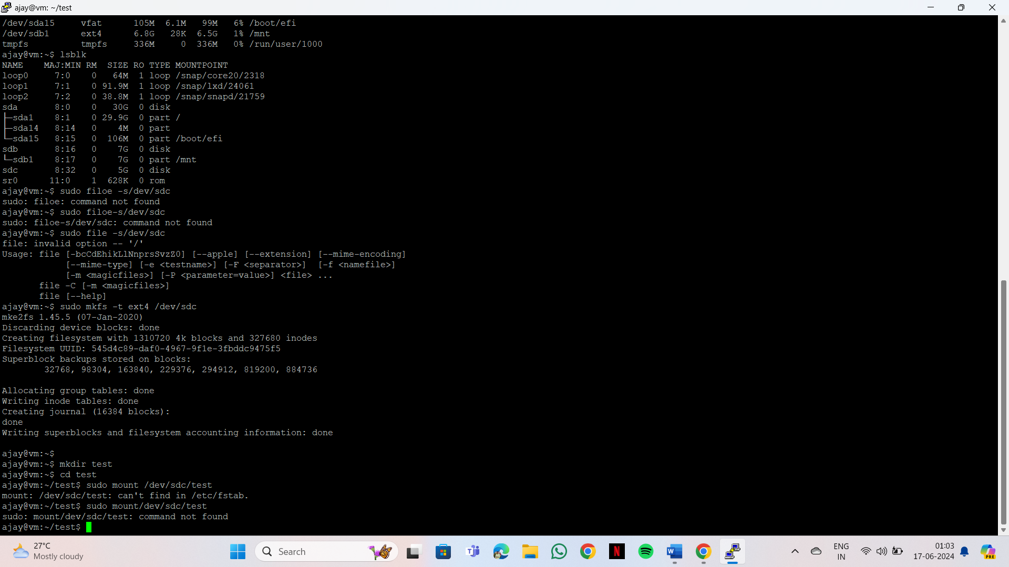

**13)open the VM and move to disks**

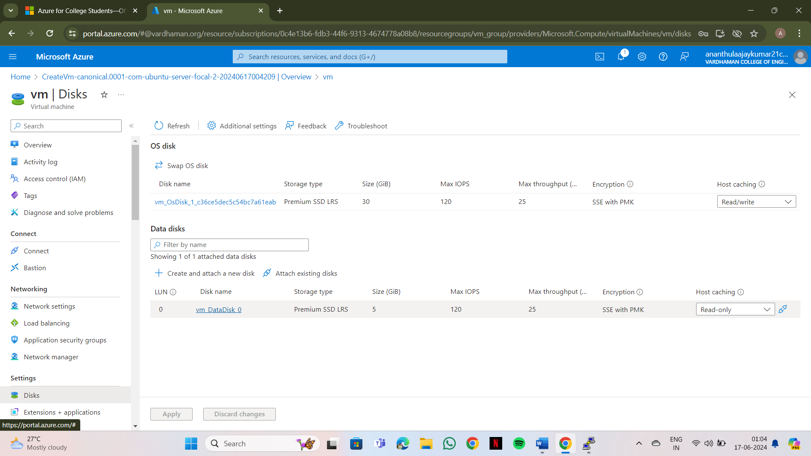

**14)Click on detach and click on apply**

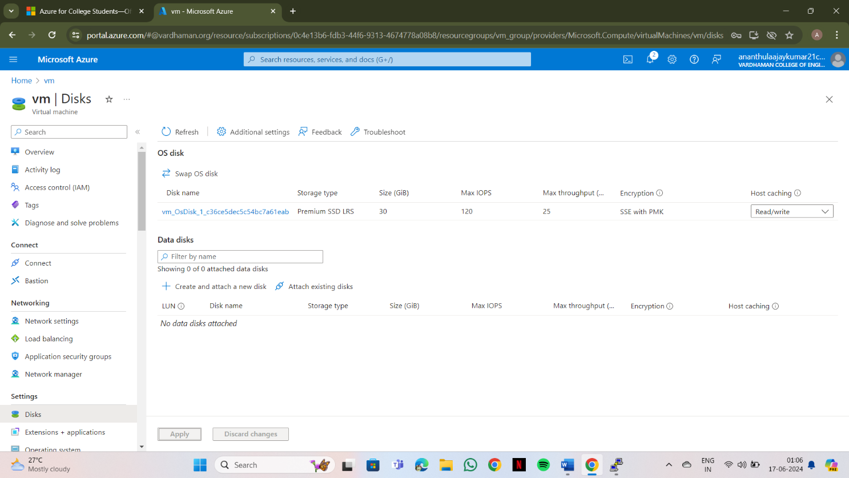

**Output: The above experiment was completed and executed successfully.**

**Q15) How to connect data disk to windows server in azure data center**

**Steps:-**

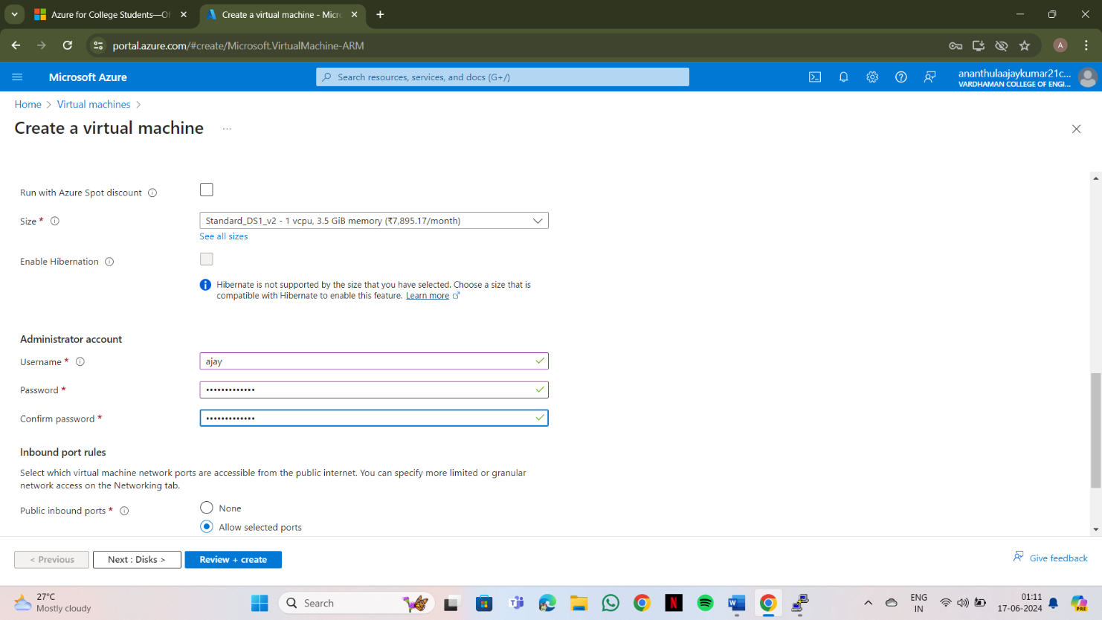**1)Create a Virtual name with VM name as "Windows" with username &password**

**2**)**click on “Next:Disk>”**

1. **Click on "Create & attach a new disk"**

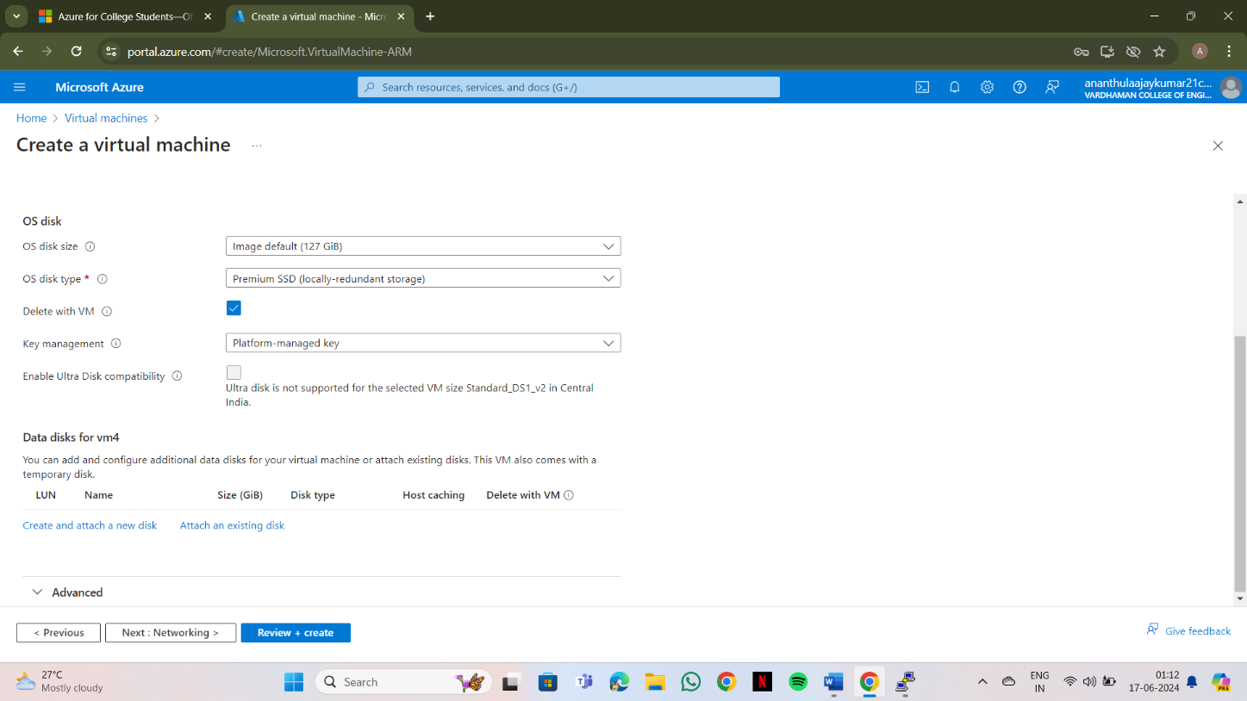

1. **click on “change size”**

**5)select**

**OS Disk Size -------- 10GB**

**Enable “Delete with VM”**

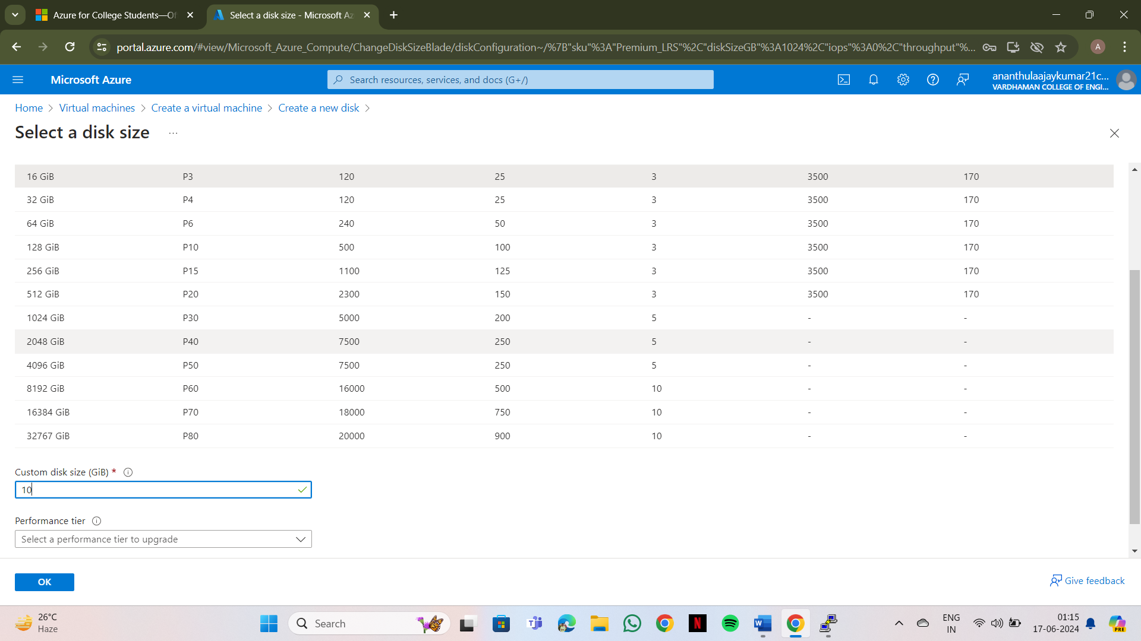

1. **Select**

**Source type -------None(empty disk), Size -------1024GB, Key manager ------- Platform managed key, Enable shared disk -------NO and finally click on OK**

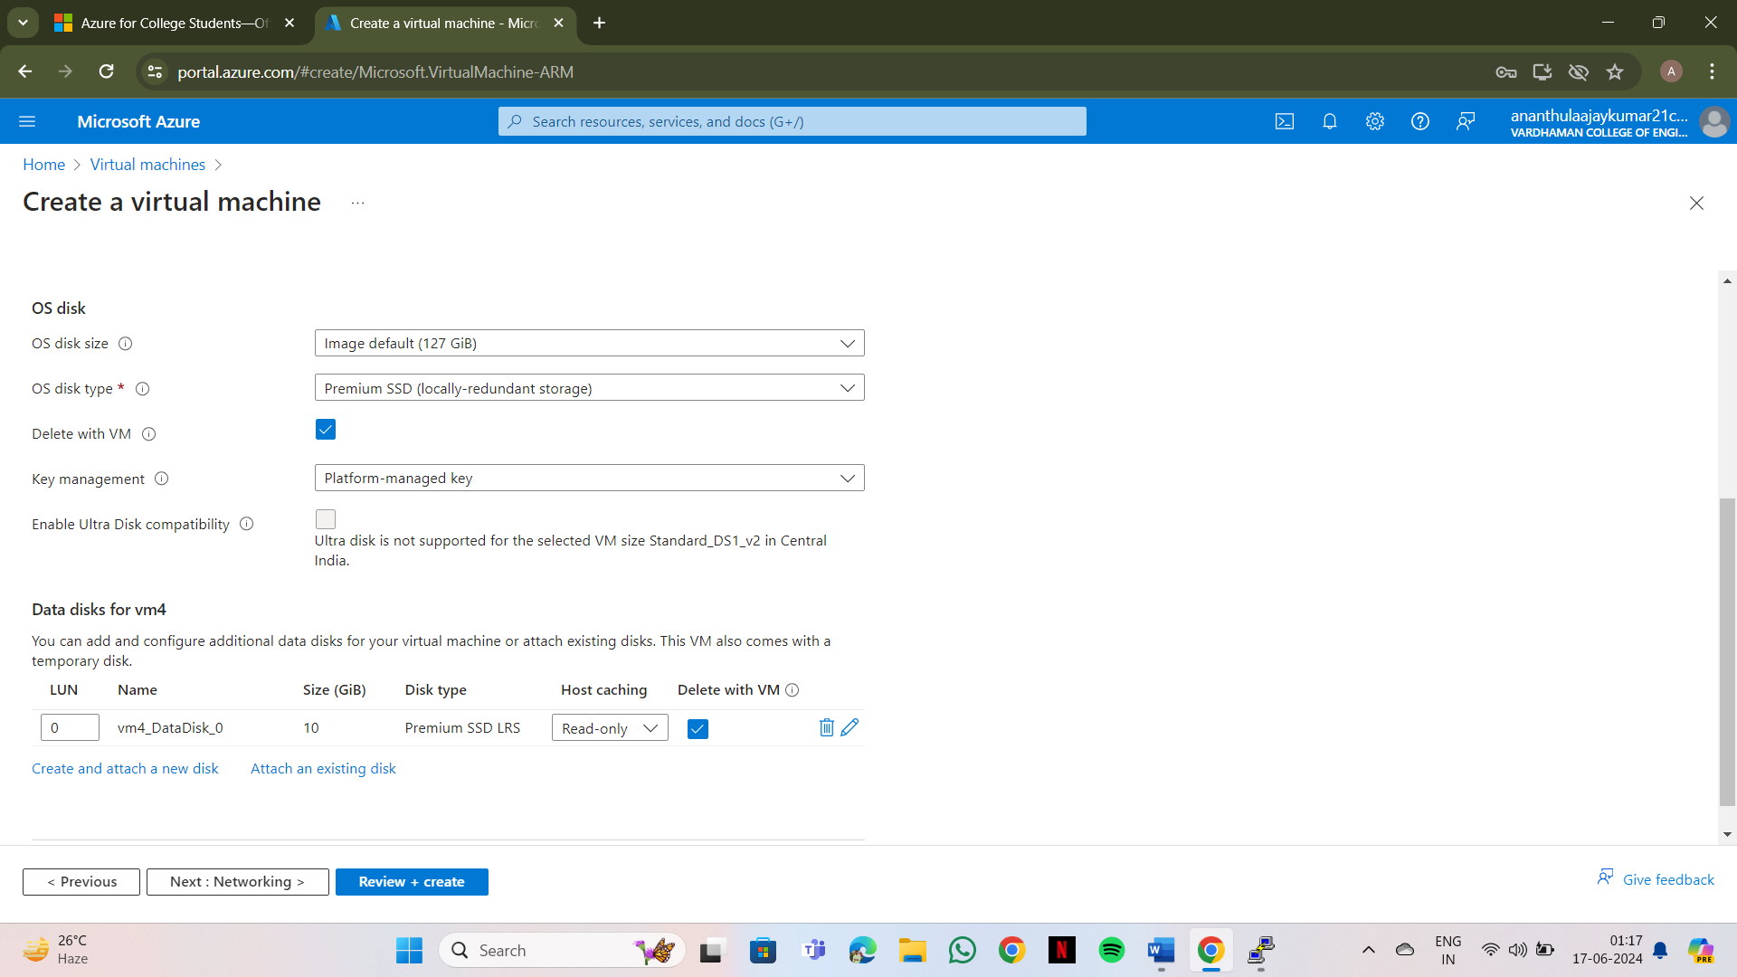

1. **Click on "Review+create" & click on create**
2. **Click on "Go to resource group"**
3. **Copy public IP Address**

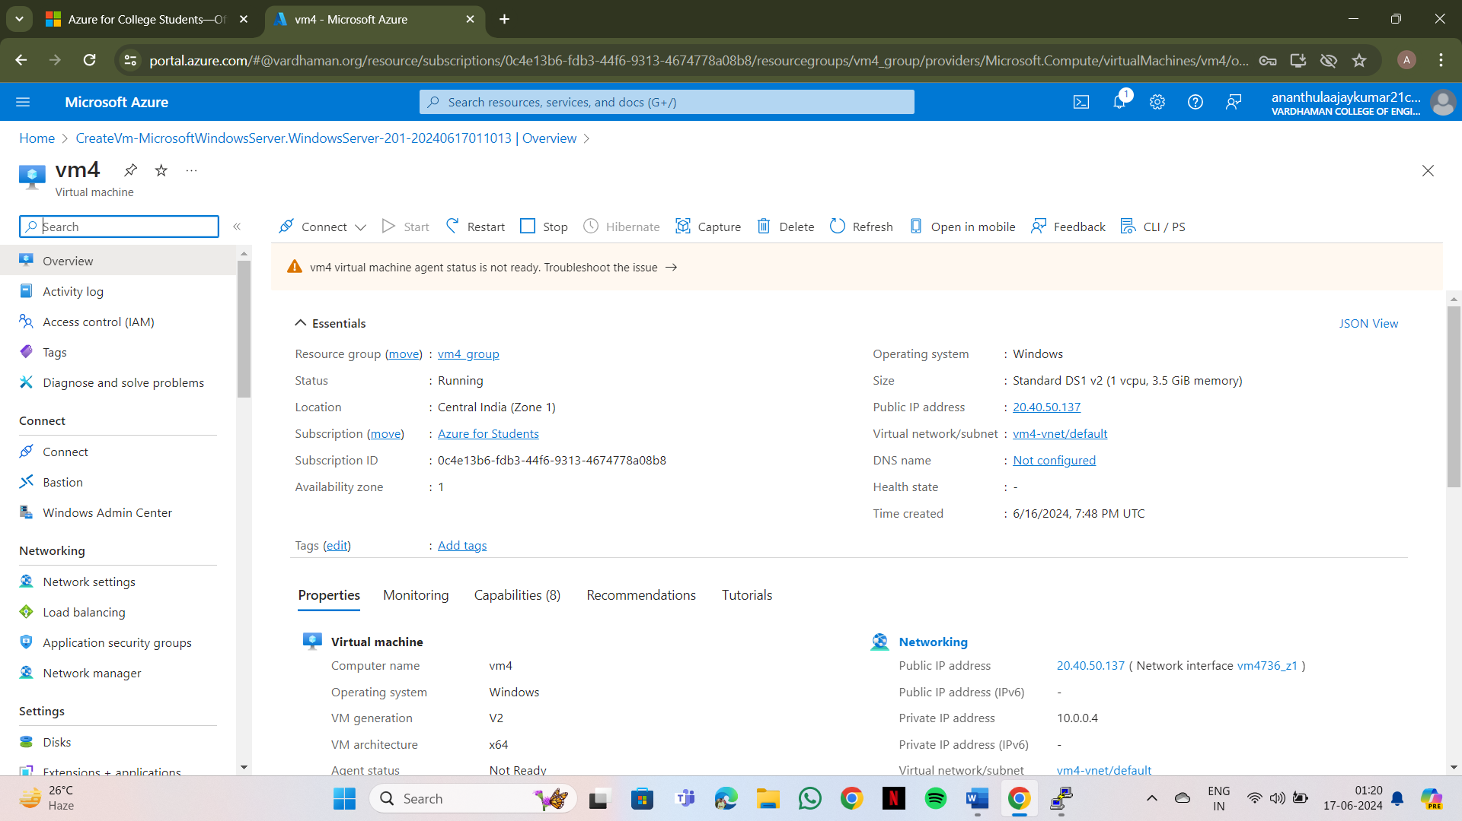

**10)Open “remote Disk Connection” & paste the IP address and connect**

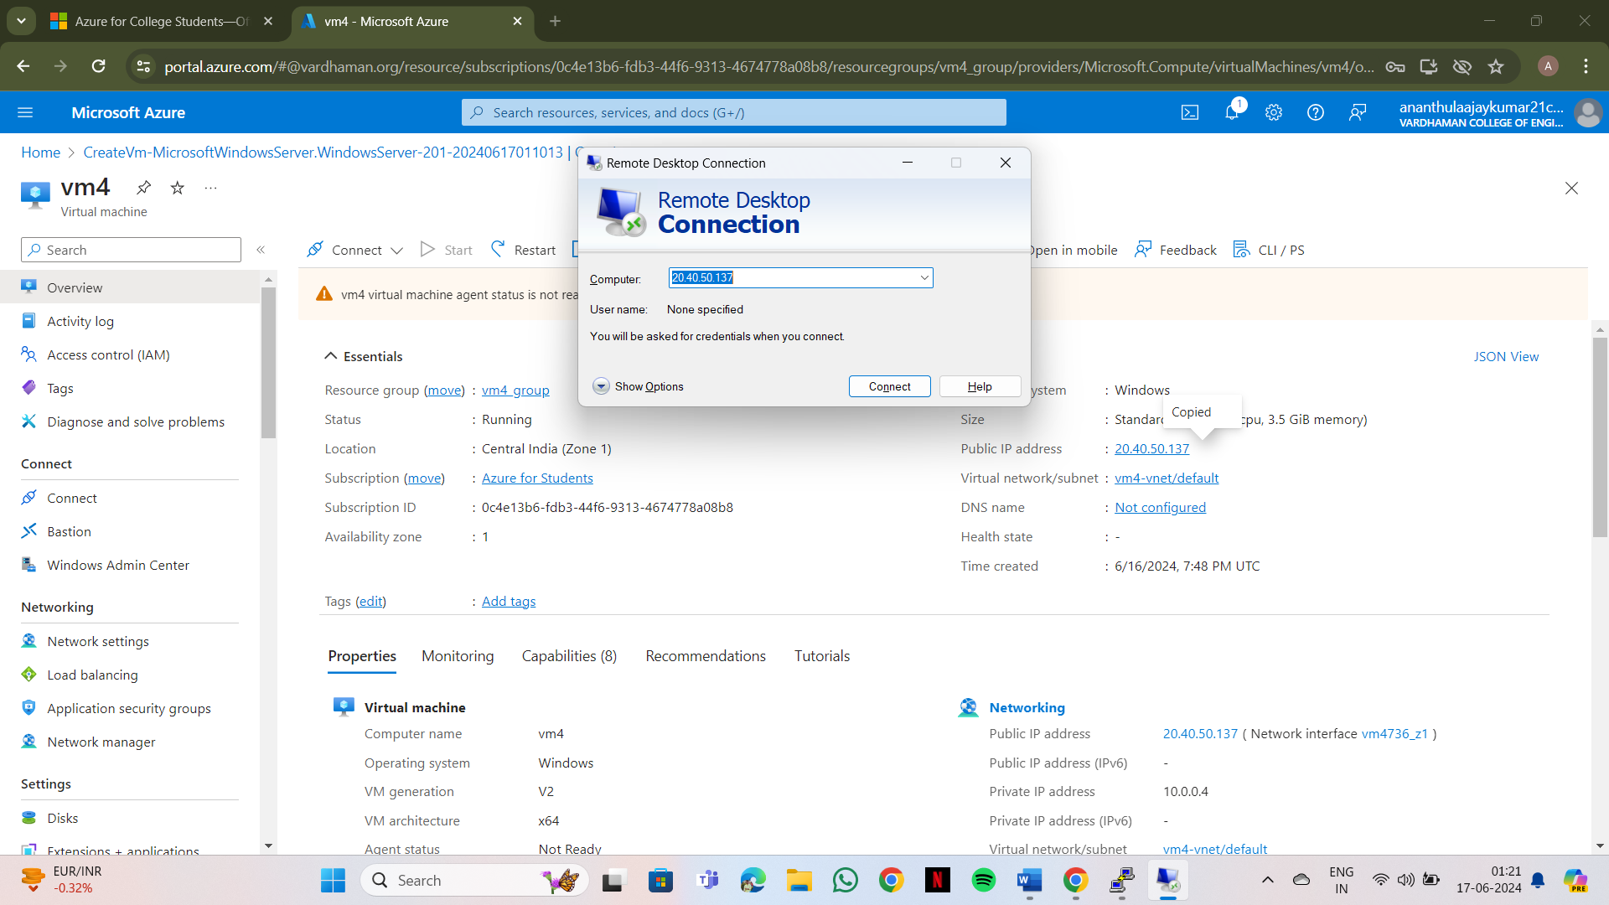

1. **Login Into it with given username and password**

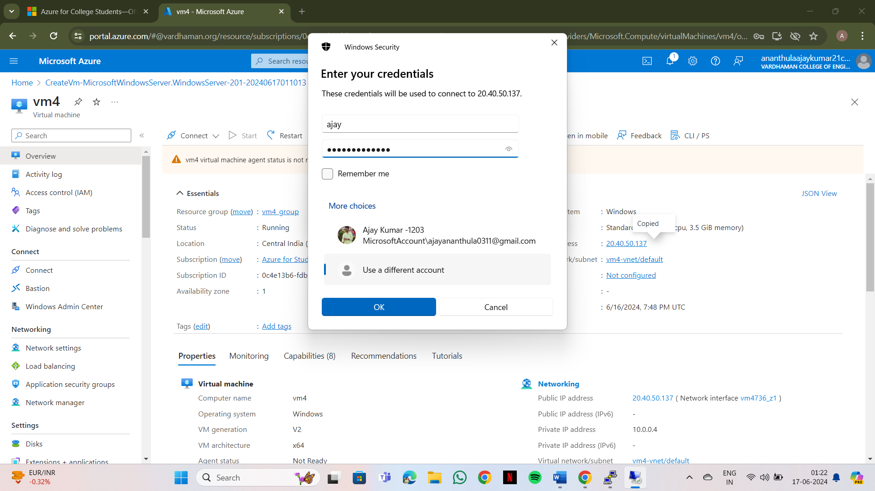

1. **After entering the credentials then click “yes” you will be getting a windows data disk account in system**

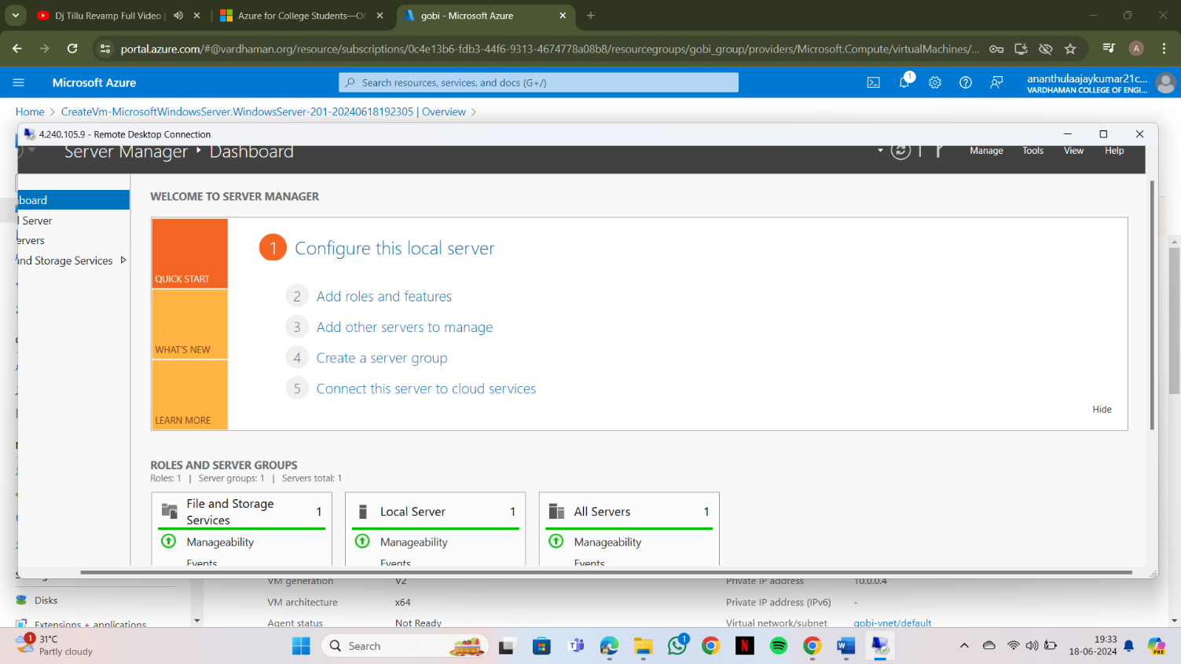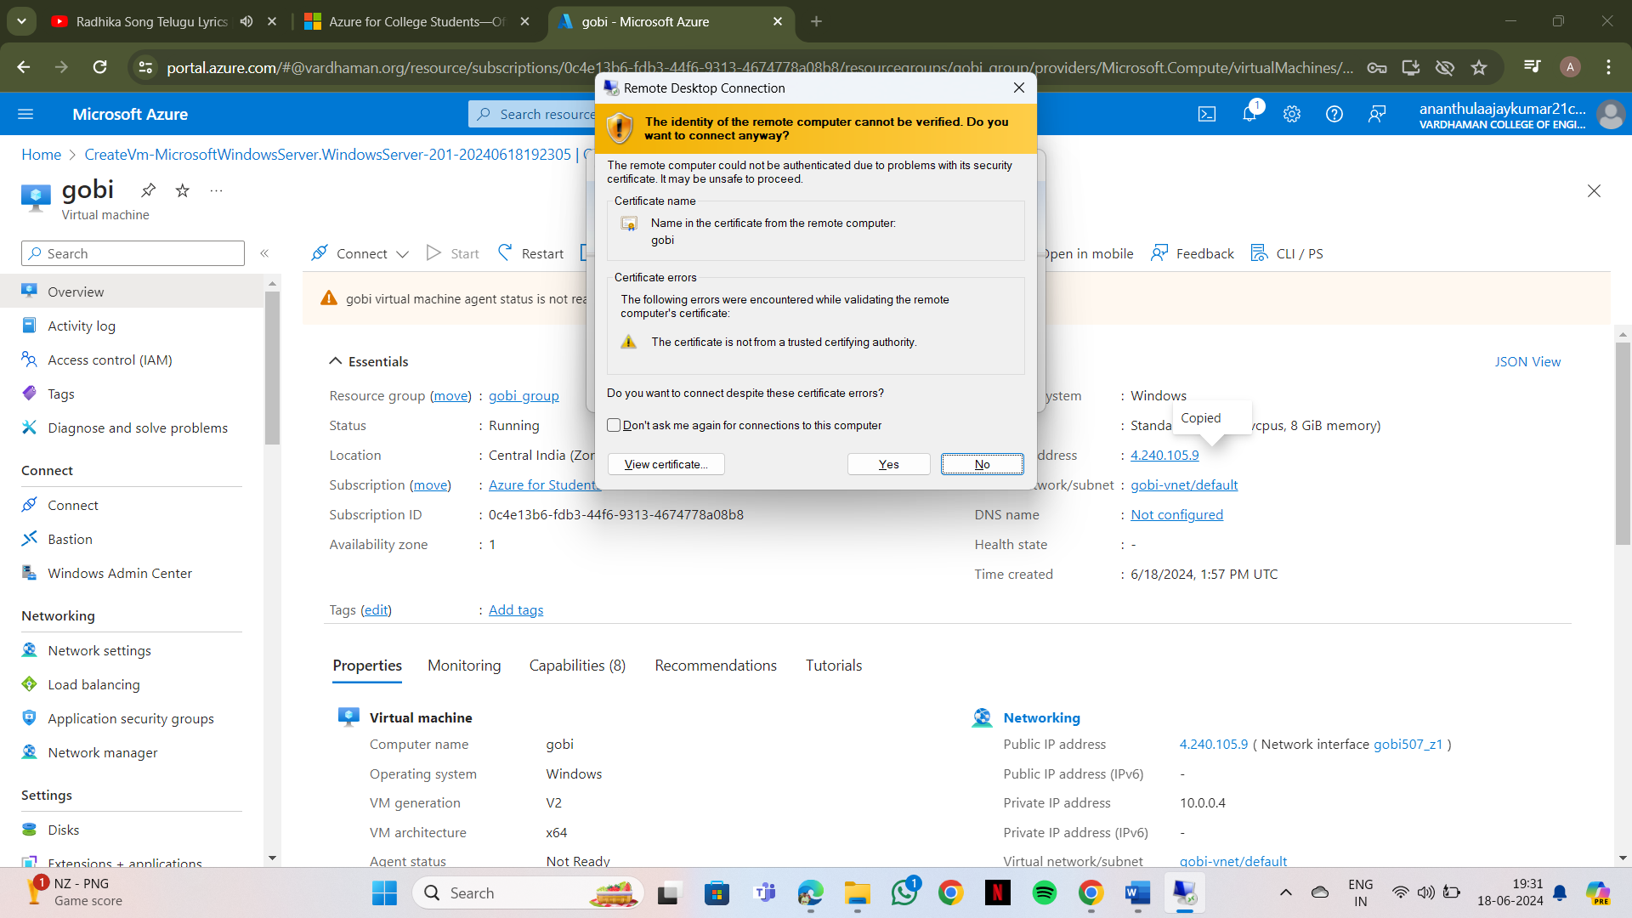

**13)open “VM” ,on left side go to disks**

**14)the disk you created at right corner you will be getting a detach**

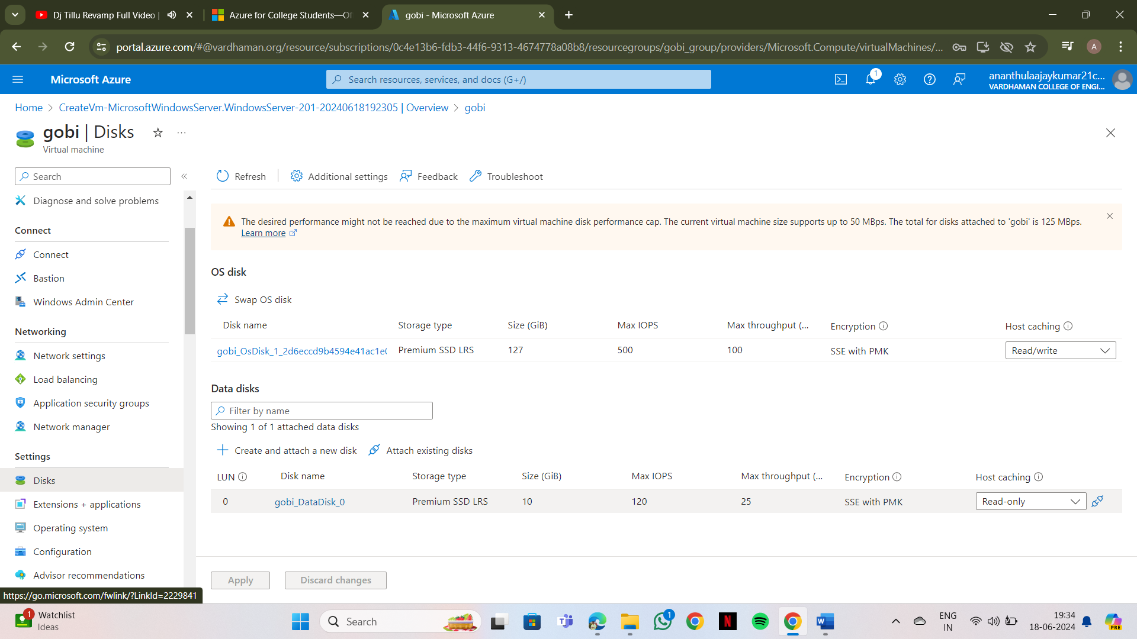

**15)By clicking on detach the connection will be removed and no data disk are present**

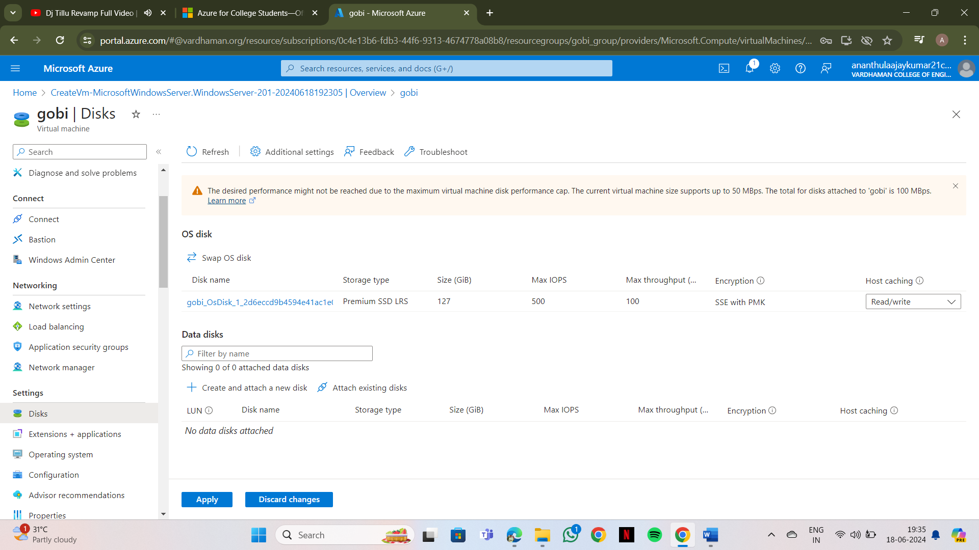

**Output: The above experiment was completed and executed successfully.**